Mushying WMS Base Info

|  |  |  |  |
| --- | --- | --- | --- |
| **编号** | **时间** | **页面** | **描述** |
| 1 | 2016-10-13 | BIN TYPE【Storage location Type】 | 追加一个Max　SKU　QTY |
| 2 | 2016-10-13 | Zone | 追加一个Goods Type |
| 3 | 2016-10-13 | Item Data | 将Zone调整为Goods Type |
| 4 | 2016-10-13 | loaction | 调整位置，已新类型为主 |
| 5 | 2016-10-13 | WorkingAreaPosition | 其中location Cluster 更新为function Areas |
| 6 | 2016-10-13 | 删除Clients | Container ,zone,Bin type,loacation Clusters,Working Areas , racks,location,functional Areas , Destination Location,SKU type Grade页面 |
| ~~7~~ | ~~2016-10-13~~ | ~~Loaction Type中设置Loaction Cluster~~ | ~~直接Bin中定义一个Locations Cluster~~ |
| 8 | 2016-10-13 | Racks设定 | 追加一个流水号（4位） |
| 9 | 2016-10-14 | WorkingAreaPosition | 其中location Cluster 更新为function Areas |
| 10 | 2016-10-14 | loaction | 调整位置，已新类型为主 |
| 11 | 2016-10-14 | Racks设定 | 调整 |
| 12 | 2016-10-14 | RACKTYPE | 追加一个RackType |
| 13 | 2016-10-14 | ItemTYPE | 追加一个ItemType |
| 14 | 2016-11-08 | Zone-ItemGroup | 追加 Zone-ItemGroup |
|  |  |  |  |

目录

1 Clients【客户】 6

1.1 List 6

1.2 Create 7

1.3 Detail 9

1.4 Edit 10

1.5 Delete 12

2 Warehouse【仓库】 13

2.1 List 13

2.2 Create 15

2.3 Detail 17

2.4 Edit 19

2.5 Delete 21

2.6 Warehouse Clients Setting 22

3 Data Dictionary 25

3.1 List 25

3.2 Create 27

3.3 Detail 29

3.4 Edit 31

3.5 Delete 33

4 Container Type 34

4.1 List 34

4.2 Create 36

4.3 Detail 38

4.4 Edit 40

4.5 Delete 42

5 Container 43

5.1 List 43

5.2 Create 45

5.3 Detail 47

5.4 Edit 49

5.5 Delete 51

6 ZONE 52

6.1 List 52

6.2 Create 53

6.3 Detail 55

6.4 Edit 56

6.5 Delete 58

7 BIN TYPE【Storage location Type】 59

7.1 List 59

7.2 Create 60

7.3 Detail 62

7.4 Edit 63

7.5 Delete 65

8 Locations Clusters 66

8.1 List 66

8.2 Create 67

8.3 Detail 69

8.4 Edit 70

8.5 Delete 72

9 Working Areas 73

9.1 List 73

9.2 Create 74

9.3 Detail 76

9.4 Edit 77

9.5 Delete 79

9.6 Working Areas Positions 80

10 Racks【Bay】 83

10.1 List 83

10.2 Create 84

10.3 Detail 86

10.4 Edit 87

10.5 Delete 89

11 BIN 【Loctation】 90

11.1 List 90

11.2 Create 93

11.3 Detail 97

11.4 Edit 100

11.5 Delete 104

12 Functional Areas 106

12.1 List 106

12.2 Create 107

12.3 Detail 109

12.4 Edit 110

12.5 Delete 112

13 Fixed location Assignment 113

13.1 List 113

13.2 Create 115

13.3 Detail 117

13.4 Edit 119

13.5 Delete 121

14 Unit Load Type 122

14.1 List 122

14.2 Create 123

14.3 Detail 125

14.4 Edit 126

14.5 Delete 128

15 Capacity 129

15.1 List 129

15.2 Create 130

15.3 Detail 133

15.4 Edit 135

15.5 Delete 137

16 Destination Location 139

16.1 List 139

16.2 Create 141

16.3 Detail 143

16.4 Edit 144

16.5 Delete 146

17 SKU Type Grade 148

17.1 List 148

17.2 Create 149

17.3 Edit 151

17.4 Delete 153

18 Item Units 153

18.1 List 153

18.2 Create 155

18.3 Detail 157

18.4 Edit 159

18.5 Delete 161

19 Item Data 162

19.1 List 162

19.2 Create 166

19.3 Detail 170

19.4 Edit 173

19.5 Delete 177

20 BOM【Bills of Material】 179

20.1 List 179

20.2 Create 181

20.3 Detail 183

20.4 Edit 184

20.5 Delete 185

21 Rack Type 187

21.1 List 187

21.2 Create 188

21.3 Detail 188

21.4 Edit 189

21.5 Delete 189

22 Item Type 190

22.1 List 190

22.2 Create 190

22.3 Edit 191

22.4 Detail 191

22.5 Delete 191

23 Item Group 192

23.1 List 192

23.2 Create 193

23.3 Edit 193

23.4 Detail 193

23.5 Delete 193

24 Drop Zone 194

24.1 List 194

24.2 Create 194

24.3 Edit 195

24.4 Detail 195

24.5 Delete 195

# Clients【客户】

## List

1. 画面

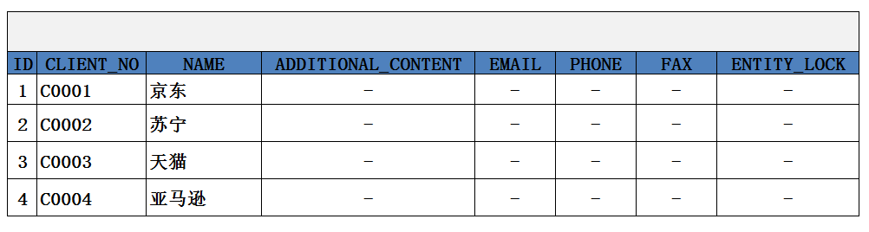

1. 功能：显示所有Clients记
2. 方法

|  |
| --- |
| GET /System/Clients |

1. 示例

|  |
| --- |
| {  "clients_search response ": {  "client_List": [  {  "client_no": "C0001",  "name": "京东",  "email": 1261,  "phone": "0512-88669999",  "fax":"0512-8866999*" ,  "additional_content":  "entity_lock": "not locked"  }  ],  "total": 1,  }  } |

## Create

1. 页面

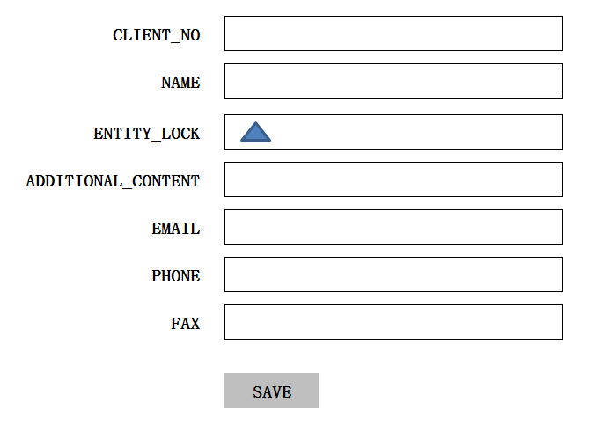

1. 功能: 新建一条Client记录
2. 方法

|  |
| --- |
| POST /System/Clients |

4、输入参数

|  |  |  |  |  |
| --- | --- | --- | --- | --- |
| **参数名称** | **类型** | **是否必须** | **示例值** | **描述** |
| CLIENT_NO | String | 是 | C001 | 客户编码 |
| NAME | String | 是 | 京东 | 客户名称 |
| EMAIL | String | 否 | 1261@sina.com | Email |
| PHONE | String | 否 | 0512-8866999* | 电话号码 |
| FAX | String | 否 | 0512-8866999* | 传真 |
| ADDITIONAL_CONTENT | String | 否 | Other | 其它附加的信息 |

5、示例

|  |
| --- |
| {  "id": “d75b38d24bd847789ee936af8db2873f”，  "client_no": "C0001",  "name": "京东",  "email": 1261,  "phone": "0512-88669999",  "fax":"0512-8866999*" ,  "additional_content": "aaaaaaa"  "entity_lock": "100",  "VERSION" : 1,  “CREATED_BY”: {  “id”: “0123456789abcdef0123456789abcdef”,  “username”: “admin”  },  “MODIFIED_BY”: {  “id”: “0123456789abcdef0123456789abcdef”,  “username”: “admin”  },  “MODIFIED_DATE”: “2012-01-01T12:00:00Z”,  “MODIFIED_ DATE”: “2012-01-01T12:00:00Z”  } |

## Detail

1. 页面

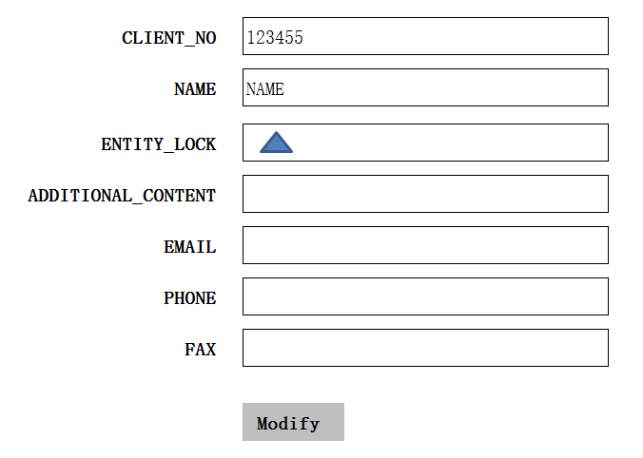

1. 功能:获取一条Client记录
2. 方法

|  |
| --- |
| GET /System/Clients/{client_no} |

1. 示例

|  |
| --- |
| {  "id": “d75b38d24bd847789ee936af8db2873f”，  "client_no": "C0001",  "name": "京东",  "email": 1261,  "phone": "0512-88669999",  "fax":"0512-8866999*" ,  "additional_content":  "entity_lock": "100"  } |

## Edit

1. 画面

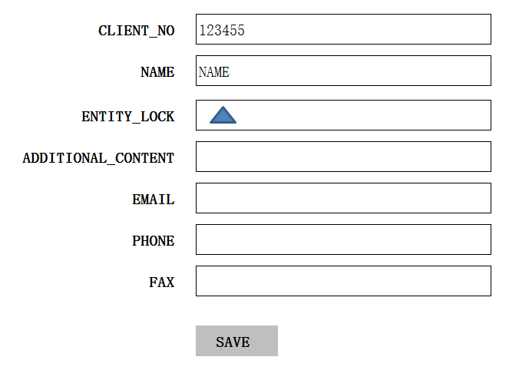

1. 功能：修改一条Client记录
2. 方法：

|  |
| --- |
| PUT /System/Clients/{client_no} |

4、输入参数

|  |  |  |  |  |
| --- | --- | --- | --- | --- |
| **参数名称** | **类型** | **是否必须** | **示例值** | **描述** |
| CLIENT_NO | String | 是 | C001 | 客户编码 |
| NAME | String | 是 | 京东 | 客户名称 |
| EMAIL | String | 否 | 1261@sina.com | Email |
| PHONE | String | 否 | 0512-8866999* | 电话号码 |
| FAX | String | 否 | 0512-8866999* | 传真 |
| ADDITIONAL_CONTENT | String | 否 | Other | 其它附加的信息 |

1. 示例：

|  |
| --- |
| {  "id": “d75b38d24bd847789ee936af8db2873f”，  "client_no": "C0001",  "name": "京东",  "email": 1261,  "phone": "0512-88669999",  "fax":"0512-8866999*" ,  "additional_content": "aaaaaaa"  "entity_lock": "100",  "VERSION" : VERSION +1,  “CREATED_BY”: {  “id”: “0123456789abcdef0123456789abcdef”,  “username”: “admin”  },  “MODIFIED_BY”: {  “id”: “0123456789abcdef0123456789abcdef”,  “username”: “admin”  },  “MODIFIED_DATE”: “2012-01-01T12:00:00Z”,  “MODIFIED_ DATE”: “2012-01-01T12:00:00Z”  } |

## Delete

1. 功能:删除一条Client记录
2. 方法

|  |
| --- |
| DELETE /System/Clients/{client_no} |

3、示例

|  |
| --- |
| {  "id": “d75b38d24bd847789ee936af8db2873f”，  "client_no": "C0001",  "name": "京东",  "email": 1261,  "phone": "0512-88669999",  "fax":"0512-8866999*" ,  "additional_content": "aaaaaaa"  "entity_lock": "101",  "VERSION" : VERSION +1,  “CREATED_BY”: {  “id”: “0123456789abcdef0123456789abcdef”,  “username”: “admin”  },  “MODIFIED_BY”: {  “id”: “0123456789abcdef0123456789abcdef”,  “username”: “admin”  },  “MODIFIED_DATE”: “2012-01-01T12:00:00Z”,  “MODIFIED_ DATE”: “2012-01-01T12:00:00Z”  } |

# Warehouse【仓库】

## List

1. 页面

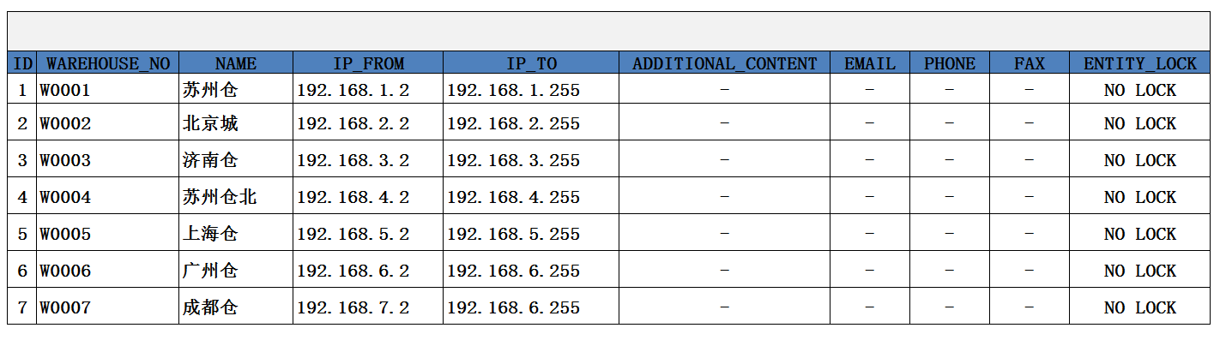

1. 功能：显示所有WareHouse记录
2. 方法

|  |
| --- |
| GET /System/WareHouse |

1. 示例

|  |
| --- |
| {  " wareHouse _search response ": {  " wareHouse_List": [  {  " wareHouse_no": "W0001",  "name": "仓库1",  "entity_lock": "not locked"，  "email": 1261,  "phone": "0512-88669999",  "fax":"0512-8866999*" ,  "IP_FROM":"192.168.1.2",  "IP_TO":"192.168.1.255"  } ,  {  " wareHouse_no": "W0001",  "name": "仓库1",  "entity_lock": "not locked"，  "email": 1261,  "phone": "0512-88669999",  "fax":"0512-8866999*" ,  "IP_FROM":"192.168.2.2",  "IP_TO":"192.168.2.255"  }  ],  "total": 2,  }  } |

## Create

1. 页面

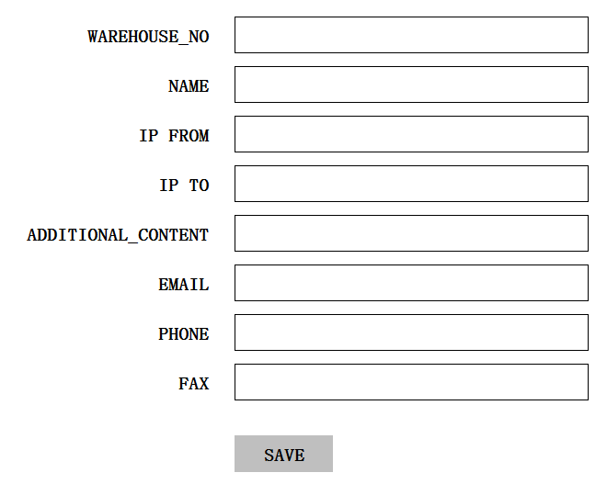

1. 功能：新建一条WareHouse记录
2. 方法

|  |
| --- |
| POST /System/WareHouse |

4、输入参数

|  |  |  |  |  |
| --- | --- | --- | --- | --- |
| **参数名称** | **类型** | **是否必须** | **示例值** | **描述** |
| WareHouse _NO | String | 是 | W0001 | 仓库编码 |
| NAME | String | 是 | 仓库01 | 仓库名称 |
| ADDITIONAL_CONTENT | String | 否 | Other | 其它附加的信息 |
| EMAIL | String | 否 | 1261@sina.com | Email |
| PHONE | String | 否 | 0512-8866999* | 电话号码 |
| FAX | String | 否 | 0512-8866999* | 传真 |

5、示例

|  |
| --- |
| {  "id": “d75b38d24bd847789ee936af8db2873f”，  " warehouse:"W001",  "name": "仓库01  "additional_content": "aaaaaaa"  "entity_lock": "100",  "VERSION" : 1,  "email": 1261,  "phone": "0512-88669999",  "fax":"0512-8866999*" ,  "IP_FROM":"192.168.1.2",  "IP_TO":"192.168.1.255"  “CREATED_BY”: {  “id”: “0123456789abcdef0123456789abcdef”,  “username”: “admin”  },  “MODIFIED_BY”: {  “id”: “0123456789abcdef0123456789abcdef”,  “username”: “admin”  },  “MODIFIED_DATE”: “2012-01-01T12:00:00Z”,  “MODIFIED_ DATE”: “2012-01-01T12:00:00Z”  } |

## Detail

1. 页面

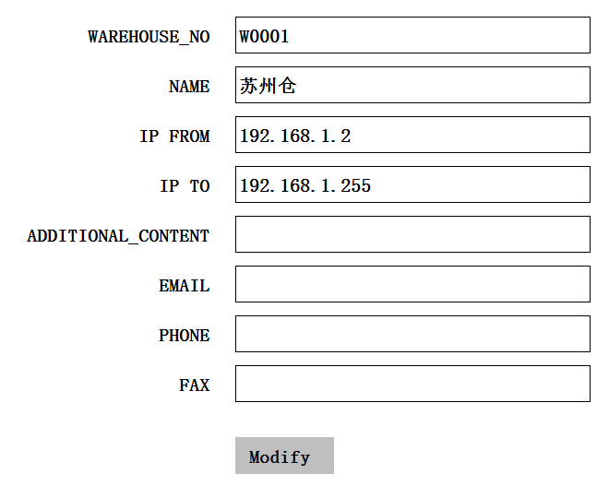

1. 功能:获取一条WareHouse记录
2. 方法

|  |
| --- |
| GET /System/ WareHouse/{id} |

1. 示例

|  |
| --- |
| {  "id": “d75b38d24bd847789ee936af8db2873f”，  "warehouse_no": "W0001",  "name": "仓库1",  "email": 1261,  "phone": "0512-88669999",  "fax":"0512-8866999*" ,  "IP_FROM":"192.168.1.2",  "IP_TO":"192.168.1.255"  "additional_content":  "entity_lock": "100"  } |

## Edit

1. 画面

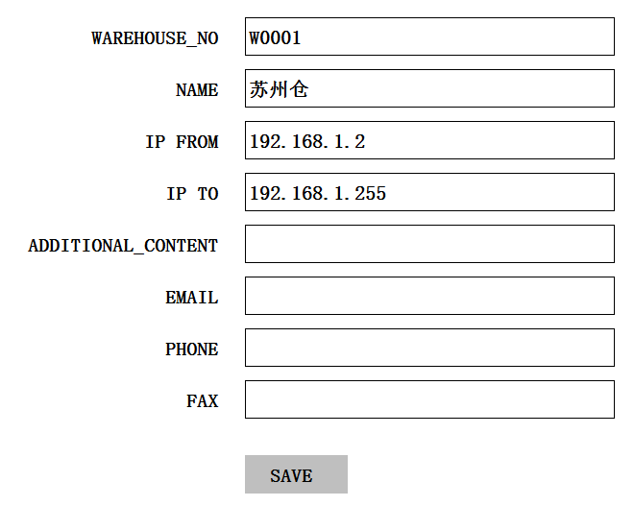

1. 功能：编辑一条WareHouse记录
2. 方法：

|  |
| --- |
| PUT /System/WareHouse/{WareHouse_no} |

4、输入参数

|  |  |  |  |  |
| --- | --- | --- | --- | --- |
| **参数名称** | **类型** | **是否必须** | **示例值** | **描述** |
| WareHouse_NO | String | 是 | W001 | 仓库编码 |
| NAME | String | 是 | 仓库01 | 仓库名称 |
| EMAIL | String | 否 | 1261@sina.com | Email |
| PHONE | String | 否 | 0512-8866999* | 电话号码 |
| FAX | String | 否 | 0512-8866999* | 传真 |
| ADDITIONAL_CONTENT | String | 否 | Other | 其它附加的信息 |

5、示例：

|  |
| --- |
| {  "id": “d75b38d24bd847789ee936af8db2873f”，  "WareHouse_no": "W0001",  "name": "仓库",  "email": 1261,  "phone": "0512-88669999",  "fax":"0512-8866999*" ,  "additional_content": "aaaaaaa"  "entity_lock": "100",  "IP_FROM":"192.168.1.2",  "IP_TO":"192.168.1.255"  "VERSION" : VERSION +1,  “CREATED_BY”: {  “id”: “0123456789abcdef0123456789abcdef”,  “username”: “admin”  },  “MODIFIED_BY”: {  “id”: “0123456789abcdef0123456789abcdef”,  “username”: “admin”  },  “MODIFIED_DATE”: “2012-01-01T12:00:00Z”,  “MODIFIED_ DATE”: “2012-01-01T12:00:00Z”  } |

## Delete

1. 功能:删除一条WareHouse记录
2. 方法

|  |
| --- |
| DELETE /System/ WareHouse /{ WareHouse_no} |

3、示例

|  |
| --- |
| {  "id": “d75b38d24bd847789ee936af8db2873f”，  " WareHouse_no": "W0001",  "name": "仓库01",  "email": 1261,  "phone": "0512-88669999",  "fax":"0512-8866999*" ,  "additional_content": "aaaaaaa"  "entity_lock": "101",  "VERSION" : VERSION +1,  “CREATED_BY”: {  “id”: “0123456789abcdef0123456789abcdef”,  “username”: “admin”  },  “MODIFIED_BY”: {  “id”: “0123456789abcdef0123456789abcdef”,  “username”: “admin”  },  “MODIFIED_DATE”: “2012-01-01T12:00:00Z”,  “MODIFIED_ DATE”: “2012-01-01T12:00:00Z”  } |

## Warehouse Clients Setting

1. 页面

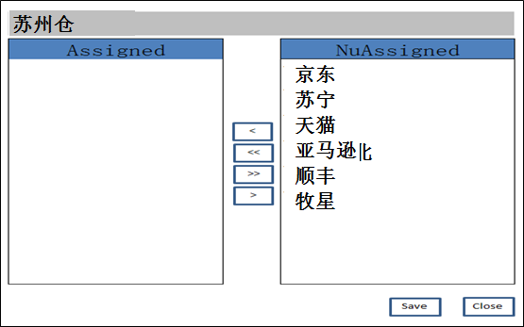

1. 功能点1: Unassigned列表中显示未加载的客户

方法：

|  |
| --- |
| GET /WareHouse_Clients/{warehouse_no} |

示例

|  |
| --- |
| {  client_List": [  “client_id”: {  “id”: “0123456789abcdef0123456789abcdef”,  “name”: “京东”  },  “warehouse_id”: {  “id”: “0123456789abcdef0123456789abcdef”,  “username”: “Warehouse01”  },  “client_id”: {  “id”: “0123456789abcdef0123456789abcdef”,  “name”: “京东”  },  “warehouse_id”: {  “id”: “0123456789abcdef0123456789abcdef”,  “username”: “Warehouse02”  }  ],  "total": 2,  } |

1. 功能点2: Assigned列表中显示已加载的客户

方法：

|  |
| --- |
| GET /WareHouse_Clients/{warehouse_no} |

示例

|  |
| --- |
| {  client_List": [  “client_id”: {  “id”: “0123456789abcdef0123456789abcdef”,  “name”: “京东”  },  “warehouse_id”: {  “id”: “0123456789abcdef0123456789abcdef”,  “username”: “Warehouse01”  },  “client_id”: {  “id”: “0123456789abcdef0123456789abcdef”,  “name”: “京东”  },  “warehouse_id”: {  “id”: “0123456789abcdef0123456789abcdef”,  “username”: “Warehouse02”  }  ],  "total": 2,  } |

1. 功能点3: 添加一条Assigned记录

方法

|  |
| --- |
| POST /WareHouse_Clients |

示例

|  |
| --- |
| {  client_List": [  “client_id”: {  “id”: “0123456789abcdef0123456789abcdef”,  “name”: “京东”  },  “warehouse_id”: {  “id”: “0123456789abcdef0123456789abcdef”,  “username”: “苏州仓”  } |

1. 功能点4: 删除一条Assigned记录

方法

|  |
| --- |
| DELETE /WareHouse_Clients/{warehouse_id} |

示例

|  |
| --- |
| {  client_List": [  “client_id”: {  “id”: “0123456789abcdef0123456789abcdef”,  “name”: “京东”  },  “warehouse_id”: {  “id”: “0123456789abcdef0123456789abcdef”,  “username”: “苏州仓”  } |

# Data Dictionary

## List

1. 页面

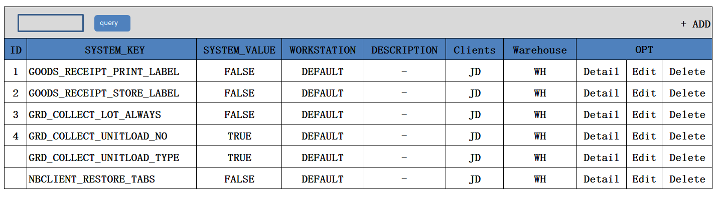

1. 功能：显示所有System Property记录
2. 方法

|  |
| --- |
| GET /System/System Property |

1. 示例

|  |
| --- |
| {  " SystemProperty_search response ": {  "systemProperty _List": [  {  "id": “d75b38d24bd847789ee936af8db2873f”，  “WareHouse”: {  “id”: “0123456789abcdef0123456789abcdef”,  “name”: “仓库1”  },  “Client”: {  “id”: “0123456789abcdef0123456789abcdef”,  “name”: “京东”  },  "systemkey": " STRATEGY_STORAGE_DEFAULT ",  "systemValue": " Default ",  "workstation": DEFAULT ,  "description": "-",  "additional_content": "aaaaaaa"  }  {  "id": “d75b38d24bd847789ee936af8db2873f”，  “WareHouse”: {  “id”: “0123456789abcdef0123456789abcdef”,  “name”: “仓库1”  },  “Client”: {  “id”: “0123456789abcdef0123456789abcdef”,  “name”: “京东”  },  "systemkey": " STRATEGY_STORAGE_DEFAULT ",  "systemValue": " Default2 ",  "workstation": DEFAULT2 ,  "description": "-",  "additional_content": "aaaaaaa"  }  ]，  "total": 2,  }  } |

## Create

1. Create页面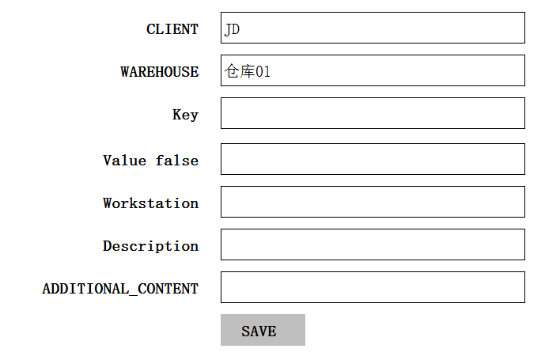

2、功能：新建一条System Property记录

3、方法

|  |
| --- |
| POST /System/systemProperty |

4、输入参数

|  |  |  |  |  |
| --- | --- | --- | --- | --- |
| **参数名称** | **类型** | **是否必须** | **示例值** | **描述** |
| WareHouse | String | 是 | W001 | 仓库编码 |
| Client | String | 是 | C0001 | 客户编码 |
| Key | String | 是 | STRATEGY_STORAGE_DEFAULT | 数据字典中的KEY值 |
| Value | String | 否 | Default | Value值 |
| WorkStation | String | 否 | Default | Default |
| Description | String | 否 | Default | Data Dictionary 的描述 |
| ADDITIONAL_CONTENT | String | 否 | Other | 其它附加的信息 |

1. 示例

|  |
| --- |
| {  "id": “d75b38d24bd847789ee936af8db2873f”，  “WareHouse”: {  “id”: “0123456789abcdef0123456789abcdef”,  “name”: “仓库1”  },  “Client”: {  “id”: “0123456789abcdef0123456789abcdef”,  “name”: “京东”  },  "systemkey": " STRATEGY_STORAGE_DEFAULT ",  "systemValue": " Default ",  "workstation": DEFAULT ,  "description": "-",  "additional_content": "aaaaaaa"  "entity_lock": "100",  "VERSION" : VERSION +1,  “CREATED_BY”: {  “id”: “0123456789abcdef0123456789abcdef”,  “username”: “admin”  },  “MODIFIED_BY”: {  “id”: “0123456789abcdef0123456789abcdef”,  “username”: “admin”  },  “MODIFIED_DATE”: “2012-01-01T12:00:00Z”,  “MODIFIED_ DATE”: “2012-01-01T12:00:00Z”  } |

## Detail

1. Detail页面

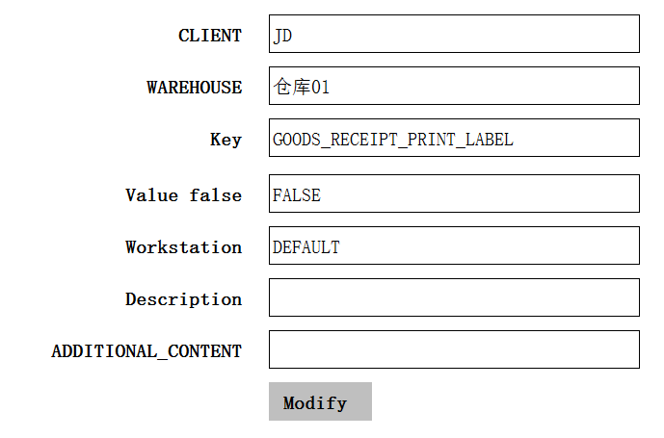

1. :获取一条WareHouse记录
2. 方法

|  |
| --- |
| GET /System/systemProperty/{ sp_id} |

1. 示例

|  |
| --- |
| {  "id": “d75b38d24bd847789ee936af8db2873f”，  “WareHouse”: {  “id”: “0123456789abcdef0123456789abcdef”,  “name”: “仓库1”  },  “Client”: {  “id”: “0123456789abcdef0123456789abcdef”,  “name”: “京东”  },  "systemkey": " STRATEGY_STORAGE_DEFAULT ",  "systemValue": " Default ",  "workstation": DEFAULT ,  "description": "-",  "additional_content": "aaaaaaa"  } |

## Edit

1. Edit页面

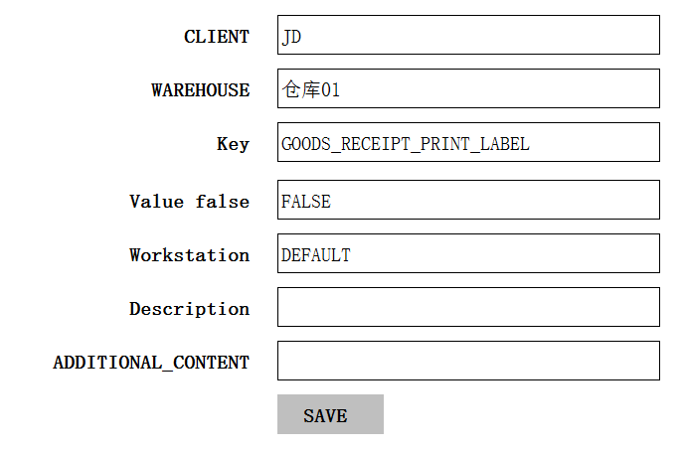

1. 功能：编辑一条System Property记录

3、方法

|  |
| --- |
| PUT /System/systemProperty/{ sp_id} |

4、输入参数

|  |  |  |  |  |
| --- | --- | --- | --- | --- |
| **参数名称** | **类型** | **是否必须** | **示例值** | **描述** |
| WareHouse | String | 是 | W001 | 仓库编码 |
| Client | String | 是 | C0001 | 客户编码 |
| Key | String | 是 | STRATEGY_STORAGE_DEFAULT | 数据字典中的KEY值 |
| Value | String | 否 | Default | Value值 |
| WorkStation | String | 否 | Default | Default |
| Description | String | 否 | Default | Data Dictionary 的描述 |
| ADDITIONAL_CONTENT | String | 否 | Other | 其它附加的信息 |

5、示例

|  |
| --- |
| {  "id": “d75b38d24bd847789ee936af8db2873f”，  “WareHouse”: {  “id”: “0123456789abcdef0123456789abcdef”,  “name”: “仓库1”  },  “Client”: {  “id”: “0123456789abcdef0123456789abcdef”,  “name”: “京东”  },  "systemkey": " STRATEGY_STORAGE_DEFAULT ",  "systemValue": " Default ",  "workstation": DEFAULT ,  "description": "-",  "additional_content": "aaaaaaa"  "entity_lock": "100",  "VERSION" : VERSION +1,  “CREATED_BY”: {  “id”: “0123456789abcdef0123456789abcdef”,  “username”: “admin”  },  “MODIFIED_BY”: {  “id”: “0123456789abcdef0123456789abcdef”,  “username”: “admin”  },  “MODIFIED_DATE”: “2012-01-01T12:00:00Z”,  “MODIFIED_ DATE”: “2012-01-01T12:00:00Z”  } |

## Delete

1. 功能:删除一条Data Dictionary记录

2、方法

|  |
| --- |
| DELETE /System/ systemProperty/{ sp_id} |

3、示例

|  |
| --- |
| {  "id": “d75b38d24bd847789ee936af8db2873f”，  "systemkey": " STRATEGY_STORAGE_DEFAULT ",  "systemValue": " Default ",  "workstation": DEFAULT ,  "description": "-",  "additional_content": "aaaaaaa"  "entity_lock": "101",  "VERSION" : VERSION +1,  “CREATED_BY”: {  “id”: “0123456789abcdef0123456789abcdef”,  “username”: “admin”  },  “MODIFIED_BY”: {  “id”: “0123456789abcdef0123456789abcdef”,  “username”: “admin”  },  “MODIFIED_DATE”: “2012-01-01T12:00:00Z”,  “MODIFIED_ DATE”: “2012-01-01T12:00:00Z”  } |

# Container Type

## List

1. List页面

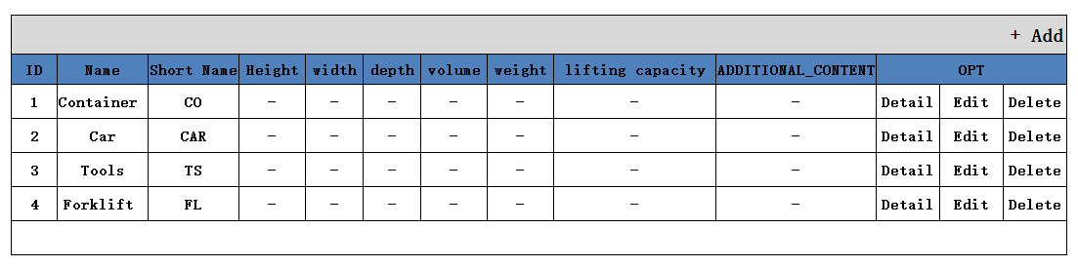2、功能：显示所有Container Type记录

3、方法

|  |
| --- |
| GET /System/ ContainerType |

1. 示例

|  |
| --- |
| {  "ContainerType _search response ": {  " ContainerType_List": [  {  "name": "Container",  "shortname": " CON ",  "height": 100 ,  "width": 100,  "depth": 100,  "volume": 100,  "weight": 100,  "liftingcapacity": "-",  "additional_content": "aaaaaaa"  }  {  "name": "Container",  "shortname": " CON ",  "height": 100 ,  "width": 100,  "depth": 100,  "volume": 100,  "weight": 100,  "liftingcapacity": "-",  "additional_content": "BBBBBBBB"  }  ]，  "total": 2,  }  } |

## Create

1. Create页面

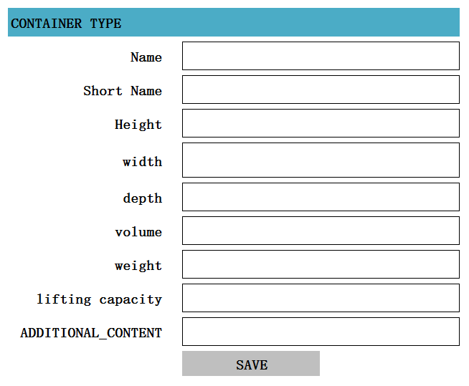

2、功能：编辑一条Container Type记录

3、方法

|  |
| --- |
| POST /System/containerType |

4、输入参数

|  |  |  |  |  |
| --- | --- | --- | --- | --- |
| **参数名称** | **类型** | **是否必须** | **示例值** | **描述** |
| Name | String | 是 | Container | 加载工具类型名称 |
| Short Name | String | 是 | CO | 简写，用于生成container编号使用 |
| Height | decimal | 否 | 100 | 高度 |
| Width | decimal | 否 | 100 | 宽度 |
| Depth | decimal | 否 | 100 | 深度 |
| Volume | decimal | 否 | 1000000 | 体积 |
| Weight | decimal | 否 | 1（吨） | 重量 |
| Lifting Capacity | decimal | 否 | 2（吨） | 起重重量 |
| Additional content | String | 否 | Other | 其它附加的信息 |

1. 示例

|  |
| --- |
| {  "id": “d75b38d24bd847789ee936af8db2873f”，  "name": "Container",  "shortname": " CON ",  "height": 100 ,  "width": 100,  "depth": 100,  "volume": 1000000,  "weight": 1,  "liftingcapacity": 2,  "additional_content": "aaaaaaa"  "entity_lock": "100",  "VERSION" : 1,  “CREATED_BY”: {  “id”: “0123456789abcdef0123456789abcdef”,  “username”: “admin”  },  “MODIFIED_BY”: {  “id”: “0123456789abcdef0123456789abcdef”,  “username”: “admin”  },  “MODIFIED_DATE”: “2012-01-01T12:00:00Z”,  “MODIFIED_ DATE”: “2012-01-01T12:00:00Z”  } |

## Detail

1. Detail页面

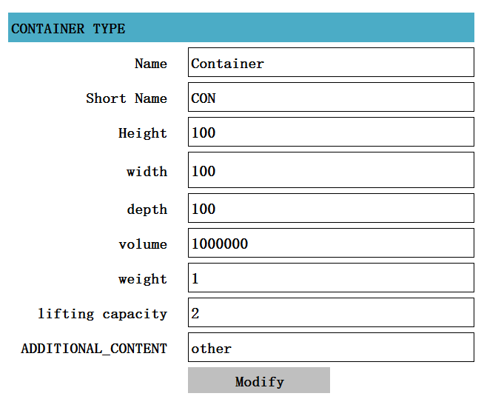

1. 功能：获取一条Container Type记录
2. 方法

|  |
| --- |
| GET /System/containerType/{id} |

1. 示例

|  |
| --- |
| {  "id": “d75b38d24bd847789ee936af8db2873f”，  "name": "Container",  "shortname": " CON ",  "height": 100 ,  "width": 100,  "depth": 100,  "volume": 1000000,  "weight": 1,  "liftingcapacity": 2,  "additional_content": "other"  "entity_lock": "100",  } |

## Edit

1. Edit页面

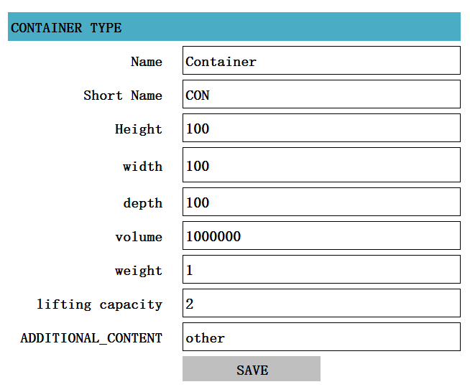

2、功能：编辑一条Container Type记录

3、方法

|  |
| --- |
| PUT /System/containerType/{ ct_id} |

4、输入参数

|  |  |  |  |  |
| --- | --- | --- | --- | --- |
| **参数名称** | **类型** | **是否必须** | **示例值** | **描述** |
| Name | String | 是 | Container | 加载工具类型名称 |
| Short Name | String | 是 | CO | 简写，用于生成container编号使用 |
| Height | decimal | 否 | 100 | 高度 |
| Width | decimal | 否 | 100 | 宽度 |
| Depth | decimal | 否 | 100 | 深度 |
| Volume | decimal | 否 | 1000000 | 体积 |
| Weight | decimal | 否 | 1（吨） | 重量 |
| Lifting Capacity | decimal | 否 | 2（吨） | 起重重量 |
| Additional content | String | 否 | Other | 其它附加的信息 |

5、示例

|  |
| --- |
| {  "id": “d75b38d24bd847789ee936af8db2873f”，  "name": "Container",  "shortname": " CON ",  "height": 100 ,  "width": 100,  "depth": 100,  "volume": 1000000,  "weight": 1,  "liftingcapacity": 2,  "additional_content": "aaaaaaa"  "entity_lock": "100",  "VERSION" : VERSION + 1,  “CREATED_BY”: {  “id”: “0123456789abcdef0123456789abcdef”,  “username”: “admin”  },  “MODIFIED_BY”: {  “id”: “0123456789abcdef0123456789abcdef”,  “username”: “admin”  },  “MODIFIED_DATE”: “2012-01-01T12:00:00Z”,  “MODIFIED_ DATE”: “2012-01-01T12:00:00Z”  } |

## Delete

1、功能:删除一条Container Type记录

2、方法

|  |
| --- |
| DELETE /System/ containerType/{ ct_id} |

3、示例

|  |
| --- |
| {  "id": “d75b38d24bd847789ee936af8db2873f”，  "name": "Container",  "shortname": " CON ",  "height": 100 ,  "width": 100,  "depth": 100,  "volume": 1000000,  "weight": 1,  "liftingcapacity": 2,  "additional_content": "aaaaaaa"  "entity_lock": "101",  "VERSION" : VERSION + 1,  “CREATED_BY”: {  “id”: “0123456789abcdef0123456789abcdef”,  “username”: “admin”  },  “MODIFIED_BY”: {  “id”: “0123456789abcdef0123456789abcdef”,  “username”: “admin”  },  “MODIFIED_DATE”: “2012-01-01T12:00:00Z”,  “MODIFIED_ DATE”: “2012-01-01T12:00:00Z”  } |

# Container

## List

1. list页面

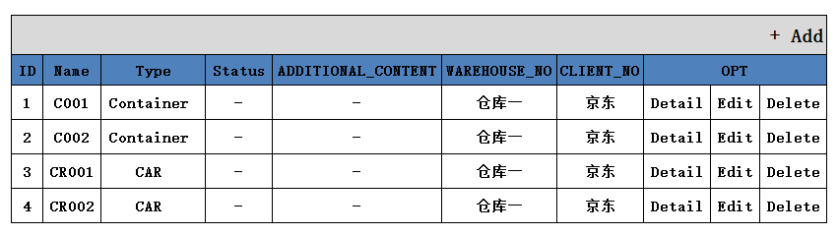

1. 功能：显示所有Container记录
2. 方法

|  |
| --- |
| GET /System/ container |

1. 示例

|  |
| --- |
| {  "Container_search_response ": {  " Container_List": [  {  "name": "CON000001",  "type": " Container ",  "status": "1",  "additional_content": "-"  “Warehouse”: {  “id”: “0123456789abcdef0123456789abcdef”,  “name”: “仓库1”  },  “Clients”: {  “id”: “0123456789abcdef0123456789abcdef”,  “name”: “京东”  },  }  {  "name": "CON000002",  "type": " Container ",  "status": "1",  "additional_content": "-"  “Warehouse”: {  “id”: “0123456789abcdef0123456789abcdef”,  “name”: “仓库1”  },  “Clients”: {  “id”: “0123456789abcdef0123456789abcdef”,  “name”: “京东”  },  }  {  "name": "CON000003",  "type": " Container ",  "status": "1",  "additional_content": "-"  “Warehouse”: {  “id”: “0123456789abcdef0123456789abcdef”,  “name”: “仓库1”  },  “Clients”: {  “id”: “0123456789abcdef0123456789abcdef”,  “name”: “京东”  },  }    ]，  "total": 3,  }  } |

## Create

1. Create页面

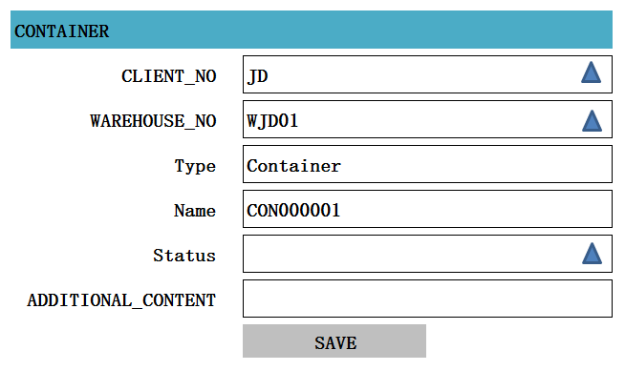

2、功能：新建一条Container记录

3、方法

|  |
| --- |
| POST /System/container |

4、输入参数

|  |  |  |  |  |
| --- | --- | --- | --- | --- |
| **参数名称** | **类型** | **是否必须** | **示例值** | **描述** |
| WareHouse_NO | String | 是 | W001 | 仓库编码 |
| Client_NO | String | 是 | C0001 | 客户编码 |
| Type | String | 是 | Container | Container type 中的所有记录绑定 |
| Name | String | 是 | CON0000001 | Container type的简称+6位流水码 |
| ~~Amount~~ | ~~Int32~~ | ~~否~~ | ~~1~~ | ~~生成的Container的记录条数，并且根据 Amount自动生成Container的数量，和Container的名称~~ |
| Status | String | 否 | 0 | 0:关闭；1:开启； |
| ADDITIONAL_CONTENT | String | 否 | Other | 其它附加的信息 |

5、示例

|  |
| --- |
| {  "id": “d75b38d24bd847789ee936af8db2873f”，  “WareHouse”: {  “id”: “0123456789abcdef0123456789abcdef”,  “name”: “仓库1”  },  “Client”: {  “id”: “0123456789abcdef0123456789abcdef”,  “name”: “京东”  },  "name": "CON000001",  "typeid": {  “id”: “0123456789abcdef0123456789abcdef”,  “name”: “container”  },  "status": "1",  "additional_content": "-"  "VERSION" : 1,  “CREATED_BY”: {  “id”: “0123456789abcdef0123456789abcdef”,  “username”: “admin”  },  “MODIFIED_BY”: {  “id”: “0123456789abcdef0123456789abcdef”,  “username”: “admin”  },  “MODIFIED_DATE”: “2012-01-01T12:00:00Z”,  “MODIFIED_ DATE”: “2012-01-01T12:00:00Z”  } |

## Detail

1. Detail页面

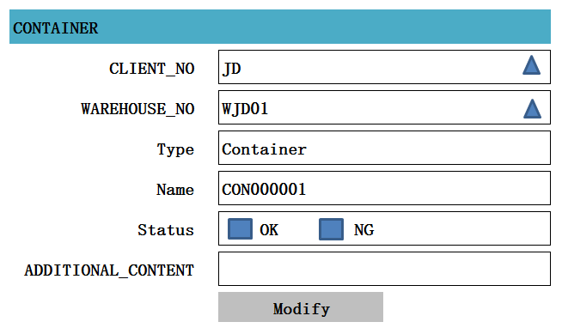

1. 功能：获取一条Containe记录

3、方法

|  |
| --- |
| GET /System/container/{c_id} |

1. 示例

|  |
| --- |
| {  "id": “d75b38d24bd847789ee936af8db2873f”，  “WareHouse”: {  “id”: “0123456789abcdef0123456789abcdef”,  “name”: “仓库1”  },  “Client”: {  “id”: “0123456789abcdef0123456789abcdef”,  “name”: “京东”  },  "name": "CON000001",  "typeid": {  “id”: “0123456789abcdef0123456789abcdef”,  “name”: “container”  },  "name": "CON0000001",  "status": 0 ,  "additional_content": "other"  } |

## Edit

1. Edit页面

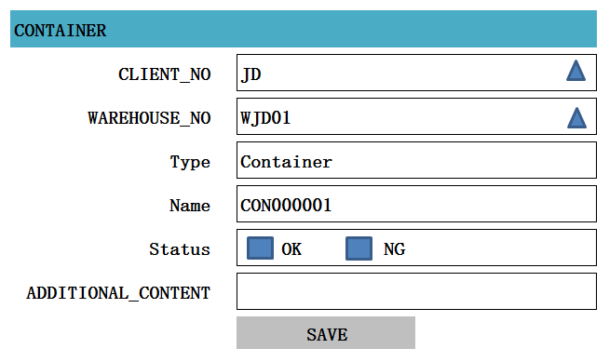

2、功能：编辑一条Container记录

3、方法

|  |
| --- |
| PUT /System/container/{c_id} |

4、输入参数

|  |  |  |  |  |
| --- | --- | --- | --- | --- |
| **参数名称** | **类型** | **是否可以编辑** | **示例值** | **描述** |
| WareHouse_NO | String | 是 | W001 | 仓库编码 |
| Client_NO | String | 是 | C0001 | 客户编码 |
| Type | String | 否 | Container | Container type 中的所有记录绑定 |
| Name | String | 否 | CON0000001 | Container type的简称+6位流水码 |
| Status | String | 是 | 0 | 0:关闭；1:开启； |
| ADDITIONAL_CONTENT | String | 是 | Other | 其它附加的信息 |

5、示例

|  |
| --- |
| {  "id": “d75b38d24bd847789ee936af8db2873f”，  “WareHouse”: {  “id”: “0123456789abcdef0123456789abcdef”,  “name”: “仓库1”  },  “Client”: {  “id”: “0123456789abcdef0123456789abcdef”,  “name”: “京东”  },  "name": "CON000001",  "typeid": {  “id”: “0123456789abcdef0123456789abcdef”,  “name”: “container”  },  "status": "1",  "additional_content": "-"  "VERSION" : VERSION + 1,  “CREATED_BY”: {  “id”: “0123456789abcdef0123456789abcdef”,  “username”: “admin”  },  “MODIFIED_BY”: {  “id”: “0123456789abcdef0123456789abcdef”,  “username”: “admin”  },  “MODIFIED_DATE”: “2012-01-01T12:00:00Z”,  “MODIFIED_ DATE”: “2012-01-01T12:00:00Z”  } |

## Delete

1、功能:删除一条Container记录

2、方法

|  |
| --- |
| DELETE /System/ container/{ c_id} |

3、示例

|  |
| --- |
| {  "id": “d75b38d24bd847789ee936af8db2873f”，  “WareHouse”: {  “id”: “0123456789abcdef0123456789abcdef”,  “name”: “仓库1”  },  “Client”: {  “id”: “0123456789abcdef0123456789abcdef”,  “name”: “京东”  },  "name": "CON000001",  "typeid": {  “id”: “0123456789abcdef0123456789abcdef”,  “name”: “container”  },  "status": "0",  "additional_content": "-"  "VERSION" : VERSION + 1,  “CREATED_BY”: {  “id”: “0123456789abcdef0123456789abcdef”,  “username”: “admin”  },  “MODIFIED_BY”: {  “id”: “0123456789abcdef0123456789abcdef”,  “username”: “admin”  },  “MODIFIED_DATE”: “2012-01-01T12:00:00Z”,  “MODIFIED_ DATE”: “2012-01-01T12:00:00Z”  } |

# ZONE

## List

1. 页面初始化

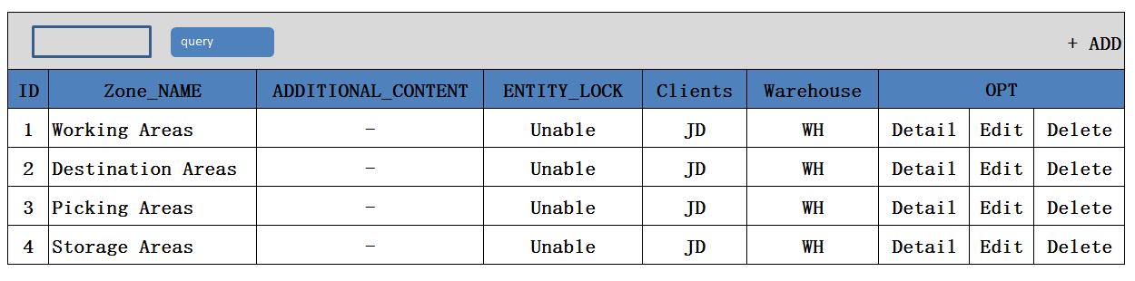

1. 功能：显示所有Zone记录
2. 方法

|  |
| --- |
| GET /System/Zones |

1. 示例

|  |
| --- |
| {  " zones_search response ": {  " zones_List": [  {  "id": " 903747BB-57CF-4272-8582-E30E61D67DBC",  "name": "BUFFER_ZONE",  "additional_content",  "entity_lock": "not locked",  "ClientId": {  "id": " 903747BB-57CF-4272-8582-E30E61D67DBC",  "name": "京东"  },  "WarehouseId": {  "id": " 903747BB-57CF-4272-8582-E30E61D67DBC",  "name": "苏州仓"  },  }  ],  "total": 1,  }  } |

## Create

1. Create页面

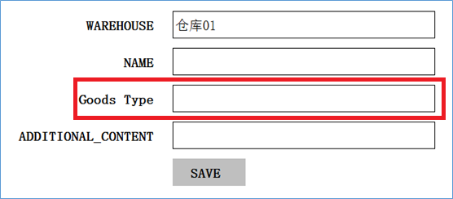

1. 功能：新增一条ZONE记录
2. 方法：

|  |
| --- |
| POST /System/Zone |

1. 输入参数

|  |  |  |  |  |
| --- | --- | --- | --- | --- |
| **参数名称** | **类型** | **是否必须** | **示例值** | **描述** |
| CLIENT_ID | String | 是 | 京东 | 客户名称 |
| WareHouse_ID | String | 是 | 仓库1 | 仓库名称 |
| Zone_Name | String | 是 | BUFFER_ZONE | ZONE名称 |
| ADDITIONAL_CONTENT | String | 否 | Other | 其它附加的信息 |

1. 示例

|  |
| --- |
| {  "id": “d75b38d24bd847789ee936af8db2873f”，  "client_id": {  “id”: “0123456789abcdef0123456789abcdef”,  “name”: “京东”  },  " WareHouse_id": {  “id”: “0123456789abcdef0123456789abcdef”,  “name”: “仓库1”  },  "Name":"BUFFER_ZONE" ,  "additional_content": "aaaaaaa"  "entity_lock": "100",  "VERSION" : 1,  “CREATED_BY”: {  “id”: “0123456789abcdef0123456789abcdef”,  “username”: “admin”  },  “MODIFIED_BY”: {  “id”: “0123456789abcdef0123456789abcdef”,  “username”: “admin”  },  “MODIFIED_DATE”: “2012-01-01T12:00:00Z”,  “MODIFIED_ DATE”: “2012-01-01T12:00:00Z”  } |

## Detail

1. Detail页面

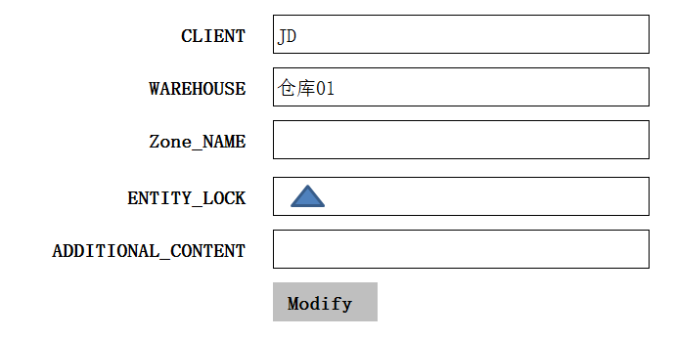

1. 功能: 获取一条Zone记录
2. 方法:

|  |
| --- |
| GET /System/Zone/{id} |

1. 示例

|  |
| --- |
| {  "id": “d75b38d24bd847789ee936af8db2873f”，  "client_id": {  “id”: “0123456789abcdef0123456789abcdef”,  “name”: “京东”  },  " wareHouse_id": {  “id”: “0123456789abcdef0123456789abcdef”,  “name”: “仓库1”  },  "Name":"BUFFER_ZONE" ,  "additional_content": "aaaaaaa"  "entity_lock": "100",  } |

## Edit

1. Edit页面

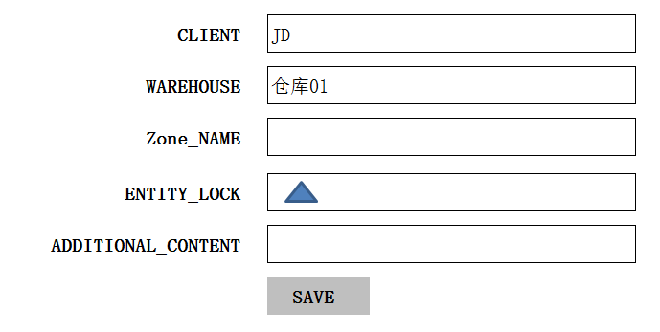

1. 功能：修改一条ZONE记录

3、方法：

|  |
| --- |
| PUT /System/ Zone/{id} |

4、输入参数

|  |  |  |  |  |
| --- | --- | --- | --- | --- |
| **参数名称** | **类型** | **是否可以**  **修改** | **示例值** | **描述** |
| CLIENT_ID | String | 是 | 京东 | 客户名称 |
| WareHouse_ID | String | 是 | 仓库1 | 仓库名称 |
| Zone_Name | String | 是 | BUFFER_ZONE | ZONE名称 |
| ENTITY_LOCK | String | 是 | No locked | 是否开启 |
| ADDITIONAL_CONTENT | String | 是 | Other | 其它附加的信息 |

1. 示例

|  |
| --- |
| {  "id": “d75b38d24bd847789ee936af8db2873f”，  "client_id": {  “id”: “0123456789abcdef0123456789abcdef”,  “name”: “京东”  },  " WareHouse_id": {  “id”: “0123456789abcdef0123456789abcdef”,  “name”: “仓库1”  },  "Name":"BUFFER_ZONE" ,  "additional_content": "aaaaaaa"  "entity_lock": "100",  "VERSION" : VERSION + 1,  “CREATED_BY”: {  “id”: “0123456789abcdef0123456789abcdef”,  “username”: “admin”  },  “MODIFIED_BY”: {  “id”: “0123456789abcdef0123456789abcdef”,  “username”: “admin”  },  “MODIFIED_DATE”: “2012-01-01T12:00:00Z”,  “MODIFIED_ DATE”: “2012-01-01T12:00:00Z”  } |

## Delete

1. 功能:删除一条Zone记录
2. 方法

|  |
| --- |
| DELETE /System/Zone/{id} |

3、示例

|  |
| --- |
| {  "id": “d75b38d24bd847789ee936af8db2873f”，  "client_id": {  “id”: “0123456789abcdef0123456789abcdef”,  “name”: “京东”  },  " WareHouse_id": {  “id”: “0123456789abcdef0123456789abcdef”,  “name”: “仓库1”  },  "Name":"BUFFER_ZONE" ,  "additional_content": "aaaaaaa"  "entity_lock": "101",  "VERSION" : VERSION + 1,  “CREATED_BY”: {  “id”: “0123456789abcdef0123456789abcdef”,  “username”: “admin”  },  “MODIFIED_BY”: {  “id”: “0123456789abcdef0123456789abcdef”,  “username”: “admin”  },  “MODIFIED_DATE”: “2012-01-01T12:00:00Z”,  “MODIFIED_ DATE”: “2012-01-01T12:00:00Z”  } |

# BIN TYPE【Storage location Type】

## List

1. Stroage location_Type页面初始化

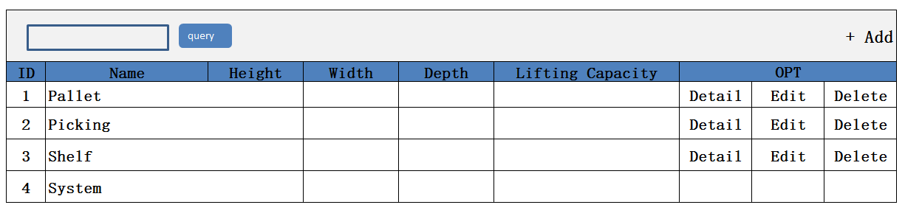

1. 功能：显示所有Stroage location_Type记录
2. 方法：

|  |
| --- |
| GET /System/locationTypes |

4、示例

|  |
| --- |
| {  "locationTypes _search response ": {  "locationTypes _List": [  {  "id": " 903747BB-57CF-4272-8582-E30E61D67DBC",  "name": " Pallet ",  "height": 100 ,  "width": 100,  "depth": 100,  "liftingcapacity": "-",  "additional_content",  "entity_lock": "not locked",  "ClientId": {  "id": " 903747BB-57CF-4272-8582-E30E61D67DBC",  "name": "京东"  },  "WarehouseId": {  "id": " 903747BB-57CF-4272-8582-E30E61D67DBC",  "name": "苏州仓"  },  }  ],  "total": 1,  }  } |

## Create

1. Create页面

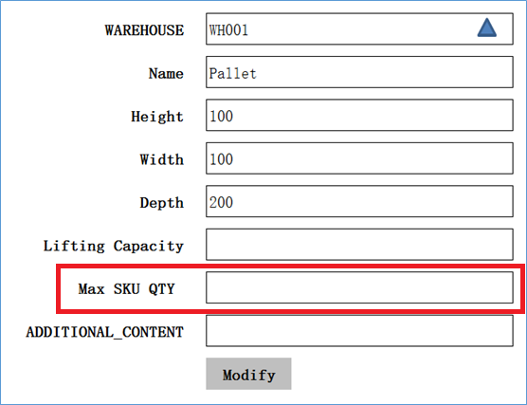

1. 功能：新增一条location Types记录
2. 方法：

|  |
| --- |
| POST /System/locationTypes |

1. 输入参数

|  |  |  |  |  |
| --- | --- | --- | --- | --- |
| **参数名称** | **类型** | **是否必须** | **示例值** | **描述** |
| CLIENT_ID | String | 是 | 京东 | 客户名称 |
| WareHouse_ID | String | 是 | 仓库1 | 仓库名称 |
| Name | String | 是 | Pallet | location Types名称 |
| Height | decimal | 否 | 100 | 高度 |
| Width | decimal | 否 | 100 | 宽度 |
| Depth | decimal | 否 | 100 | 深度 |
| Lifting Capacity | decimal | 否 | 2（吨） | 起重重量 |

1. 示例

|  |
| --- |
| {  "id": “d75b38d24bd847789ee936af8db2873f”，  "client_id": {  “id”: “0123456789abcdef0123456789abcdef”,  “name”: “京东”  },  " WareHouse_id": {  “id”: “0123456789abcdef0123456789abcdef”,  “name”: “仓库1”  },  "name": " Pallet ",  "height": 100 ,  "width": 100,  "depth": 100,  "liftingcapacity": "-",  "additional_content": "aaaaaaa"  "entity_lock": "100",  "VERSION" : 1,  “CREATED_BY”: {  “id”: “0123456789abcdef0123456789abcdef”,  “username”: “admin”  },  “MODIFIED_BY”: {  “id”: “0123456789abcdef0123456789abcdef”,  “username”: “admin”  },  “MODIFIED_DATE”: “2012-01-01T12:00:00Z”,  “MODIFIED_ DATE”: “2012-01-01T12:00:00Z”  } |

## Detail

1. Detail页面

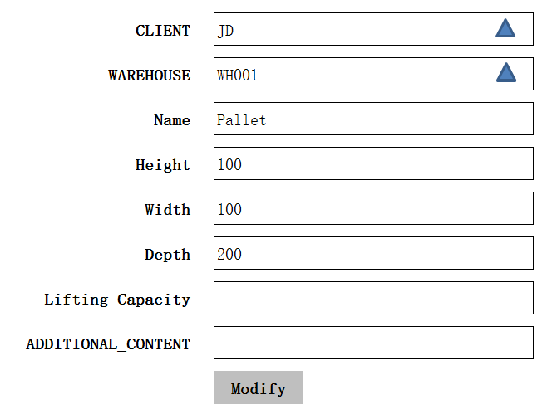

1. 功能：获取一条location Types记录
2. 方法：

|  |
| --- |
| GET /System/locationTypes/{id} |

4、示例：

|  |
| --- |
| {  "id": " 903747BB-57CF-4272-8582-E30E61D67DBC",  "name": " Pallet ",  "height": 100 ,  "width": 100,  "depth": 100,  "liftingcapacity": "-",  "additional_content",  "entity_lock": "not locked",  "ClientId": {  "id": " 903747BB-57CF-4272-8582-E30E61D67DBC",  "name": "京东"  }，  "WarehouseId": {  "id": " 903747BB-57CF-4272-8582-E30E61D67DBC",  "name": "苏州仓"  }  } |

## Edit

1. Edit页面

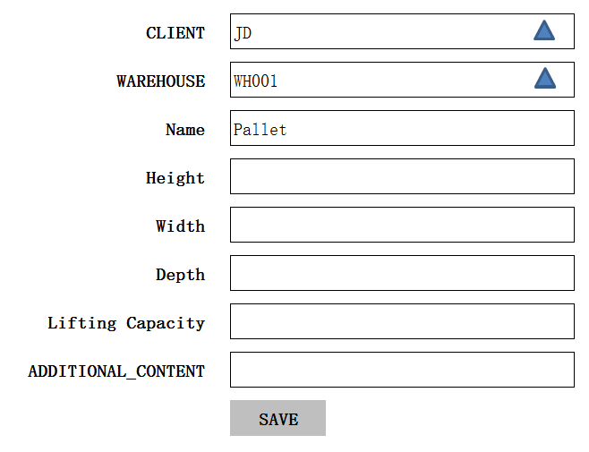

1. 功能：修改一条locationTypes记录
2. 方法：

|  |
| --- |
| PUT /System/locationTypes/{id} |

1. 输入参数

|  |  |  |  |  |
| --- | --- | --- | --- | --- |
| **参数名称** | **类型** | **是否必须** | **示例值** | **描述** |
| CLIENT_ID | String | 是 | 京东 | 客户名称 |
| WareHouse_ID | String | 是 | 仓库1 | 仓库名称 |
| Name | String | 是 | Pallet | location Types名称 |
| Height | decimal | 否 | 100 | 高度 |
| Width | decimal | 否 | 100 | 宽度 |
| Depth | decimal | 否 | 100 | 深度 |
| Lifting Capacity | decimal | 否 | 2（吨） | 起重重量 |

1. 示例

|  |
| --- |
| {  "id": “d75b38d24bd847789ee936af8db2873f”，  "client_id": {  “id”: “0123456789abcdef0123456789abcdef”,  “name”: “京东”  },  " WareHouse_id": {  “id”: “0123456789abcdef0123456789abcdef”,  “name”: “仓库1”  },  "name": " Pallet ",  "height": 100 ,  "width": 100,  "depth": 100,  "liftingcapacity": "-",  "additional_content": "aaaaaaa"  "entity_lock": "100",  "VERSION" : VERSION + 1,  “CREATED_BY”: {  “id”: “0123456789abcdef0123456789abcdef”,  “username”: “admin”  },  “MODIFIED_BY”: {  “id”: “0123456789abcdef0123456789abcdef”,  “username”: “admin”  },  “MODIFIED_DATE”: “2012-01-01T12:00:00Z”,  “MODIFIED_ DATE”: “2012-01-01T12:00:00Z”  } |

## Delete

1. 功能：删除一条locationTypes记录

2、方法

|  |
| --- |
| DELETE /System/locationTypes/{id} |

3、示例

|  |
| --- |
| {  "id": “d75b38d24bd847789ee936af8db2873f”，  "client_id": {  “id”: “0123456789abcdef0123456789abcdef”,  “name”: “京东”  },  " WareHouse_id": {  “id”: “0123456789abcdef0123456789abcdef”,  “name”: “仓库1”  },  "name": " Pallet ",  "height": 100 ,  "width": 100,  "depth": 100,  "liftingcapacity": "-",  "additional_content": "aaaaaaa"  "entity_lock": "101",  "VERSION" : VERSION + 1,  “CREATED_BY”: {  “id”: “0123456789abcdef0123456789abcdef”,  “username”: “admin”  },  “MODIFIED_BY”: {  “id”: “0123456789abcdef0123456789abcdef”,  “username”: “admin”  },  “MODIFIED_DATE”: “2012-01-01T12:00:00Z”,  “MODIFIED_ DATE”: “2012-01-01T12:00:00Z”  } |

# Locations Clusters

## List

1. List页面

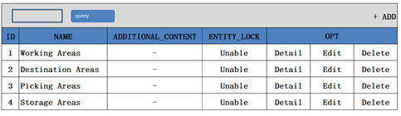

1. 功能: 显示所有locationClusters记录
2. 方法：

|  |
| --- |
| GET /System/locationClusters |

1. 示例：

|  |
| --- |
| {  " locationClusters_search response ": {  " locationClusters_List": [  {  "id": " 903747BB-57CF-4272-8582-E30E61D67DBC",  "name": "BIG_Location",  "additional_content",  "entity_lock": "not locked",  "ClientId": {  "id": " 903747BB-57CF-4272-8582-E30E61D67DBC",  "name": "京东"  },  "WarehouseId": {  "id": " 903747BB-57CF-4272-8582-E30E61D67DBC",  "name": "苏州仓"  },  }  ],  "total": 1,  }  } |

## Create

1. Create页面

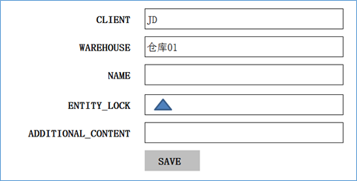

1. 功能：新增一条locationClusters记录

3、方法：

|  |
| --- |
| POST /System/locationClusters |

4、输入参数

|  |  |  |  |  |
| --- | --- | --- | --- | --- |
| **参数名称** | **类型** | **是否必须** | **示例值** | **描述** |
| CLIENT_ID | String | 是 | 京东 | 客户名称 |
| WareHouse_ID | String | 是 | 仓库1 | 仓库名称 |
| Name | String | 是 | BIG_Location | Location Clusters名称 |
| ADDITIONAL_CONTENT | String | 否 | Other | 其它附加的信息 |

1. 示例

|  |
| --- |
| {  "id": “d75b38d24bd847789ee936af8db2873f”，  "client_id": {  “id”: “0123456789abcdef0123456789abcdef”,  “name”: “京东”  },  " WareHouse_id": {  “id”: “0123456789abcdef0123456789abcdef”,  “name”: “仓库1”  },  "Name":"BIG_Location" ,  "additional_content": "aaaaaaa"  "entity_lock": "100",  "VERSION" : 1,  “CREATED_BY”: {  “id”: “0123456789abcdef0123456789abcdef”,  “username”: “admin”  },  “MODIFIED_BY”: {  “id”: “0123456789abcdef0123456789abcdef”,  “username”: “admin”  },  “MODIFIED_DATE”: “2012-01-01T12:00:00Z”,  “MODIFIED_ DATE”: “2012-01-01T12:00:00Z”  } |

## Detail

1. Detail页面

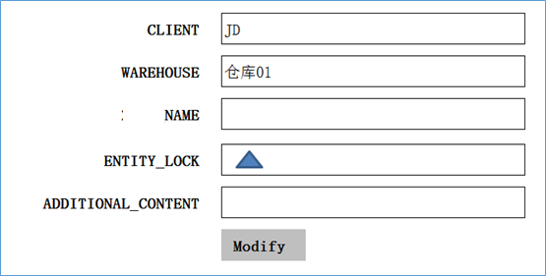

1. 功能: 获取一条locationClusters记录
2. 方法:

|  |
| --- |
| GET /System/locationClusters/{id} |

1. 示例

|  |
| --- |
| {  "id": “d75b38d24bd847789ee936af8db2873f”，  "client_id": {  “id”: “0123456789abcdef0123456789abcdef”,  “name”: “京东”  },  " wareHouse_id": {  “id”: “0123456789abcdef0123456789abcdef”,  “name”: “仓库1”  },  "Name":"BIG_LOCATION" ,  "additional_content": "aaaaaaa"  "entity_lock": "100",  } |

## Edit

1. Edit页面

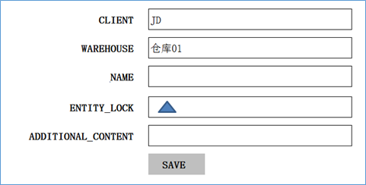

1. 功能：修改一条locationClusters记录

3、方法：

|  |
| --- |
| PUT /System/ locationClusters/{id} |

4、输入参数

|  |  |  |  |  |
| --- | --- | --- | --- | --- |
| **参数名称** | **类型** | **是否可以**  **修改** | **示例值** | **描述** |
| CLIENT_ID | String | 是 | 京东 | 客户名称 |
| WareHouse_ID | String | 是 | 仓库1 | 仓库名称 |
| Name | String | 是 | BIG_LOCATION | Location Clusters名称 |
| ENTITY_LOCK | String | 是 | No locked | 是否开启 |
| ADDITIONAL_CONTENT | String | 是 | Other | 其它附加的信息 |

1. 示例

|  |
| --- |
| {  "id": “d75b38d24bd847789ee936af8db2873f”，  "client_id": {  “id”: “0123456789abcdef0123456789abcdef”,  “name”: “京东”  },  " WareHouse_id": {  “id”: “0123456789abcdef0123456789abcdef”,  “name”: “仓库1”  },  "Name":" BIG_LOCATION" ,  "additional_content": "aaaaaaa"  "entity_lock": "100",  "VERSION" : VERSION + 1,  “CREATED_BY”: {  “id”: “0123456789abcdef0123456789abcdef”,  “username”: “admin”  },  “MODIFIED_BY”: {  “id”: “0123456789abcdef0123456789abcdef”,  “username”: “admin”  },  “MODIFIED_DATE”: “2012-01-01T12:00:00Z”,  “MODIFIED_ DATE”: “2012-01-01T12:00:00Z”  } |

## Delete

1. 功能:删除一条locationClusters记录
2. 方法

|  |
| --- |
| DELETE /System/ locationClusters /{id} |

3、示例

|  |
| --- |
| {  "id": “d75b38d24bd847789ee936af8db2873f”，  "client_id": {  “id”: “0123456789abcdef0123456789abcdef”,  “name”: “京东”  },  " WareHouse_id": {  “id”: “0123456789abcdef0123456789abcdef”,  “name”: “仓库1”  },  "Name":"BIG LOCATION " ,  "additional_content": "aaaaaaa"  "entity_lock": "101",  "VERSION" : VERSION + 1,  “CREATED_BY”: {  “id”: “0123456789abcdef0123456789abcdef”,  “username”: “admin”  },  “MODIFIED_BY”: {  “id”: “0123456789abcdef0123456789abcdef”,  “username”: “admin”  },  “MODIFIED_DATE”: “2012-01-01T12:00:00Z”,  “MODIFIED_ DATE”: “2012-01-01T12:00:00Z”  } |

# Working Areas【暂缓】

## List

1. List页面初始化

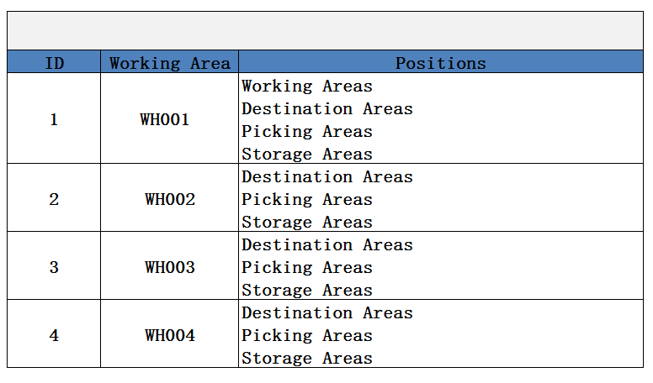

1. 功能：显示所有Working Areas记录
2. 方法：

|  |
| --- |
| GET /System/ Working Areas |

1. 示例

|  |
| --- |
| {  " Areas_search response ": {  " Areas_List": [  {  "id": " 903747BB-57CF-4272-8582-E30E61D67DBC",  "name": "Working Area 001 ",  "Positions":　{  "id": " 903747BB-57CF-4272-8582-E30E61D67DBC",  "name": "Destination Areas"  },  "ClientId": {  "id": " 903747BB-57CF-4272-8582-E30E61D67DBC",  "name": "京东"  },  "WarehouseId": {  "id": " 903747BB-57CF-4272-8582-E30E61D67DBC",  "name": "苏州仓"  },  }  ],  "total": 1,  }  } |

## Create

1. Create页面

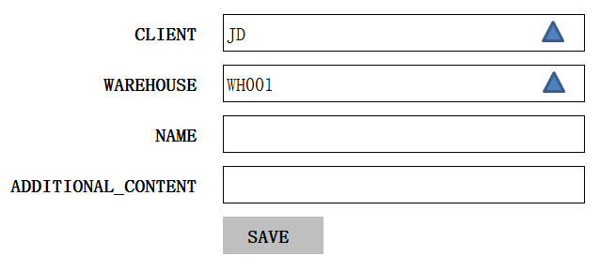

1. 功能：创建一条Working Areas记录
2. 方法：

|  |
| --- |
| POST /System/workingAreas |

4、输入参数

|  |  |  |  |  |
| --- | --- | --- | --- | --- |
| **参数名称** | **类型** | **是否必须** | **示例值** | **描述** |
| CLIENT_ID | String | 是 | 京东 | 客户名称 |
| WareHouse_ID | String | 是 | 仓库1 | 仓库名称 |
| Name | String | 是 | WA001 | working Areas 名称 |
| additional_content | String | 否 | other | 额外的内容 |

5、示例

|  |
| --- |
| {  "id": “d75b38d24bd847789ee936af8db2873f”，  "client_id": {  “id”: “0123456789abcdef0123456789abcdef”,  “name”: “京东”  },  " WareHouse_id": {  “id”: “0123456789abcdef0123456789abcdef”,  “name”: “仓库1”  },  "name": " WA01 ",  "additional_content": "aaaaaaa"  "entity_lock": "100",  "VERSION" : 1,  “CREATED_BY”: {  “id”: “0123456789abcdef0123456789abcdef”,  “username”: “admin”  },  “MODIFIED_BY”: {  “id”: “0123456789abcdef0123456789abcdef”,  “username”: “admin”  },  “MODIFIED_DATE”: “2012-01-01T12:00:00Z”,  “MODIFIED_ DATE”: “2012-01-01T12:00:00Z”  } |

## Detail

1. Detail页面

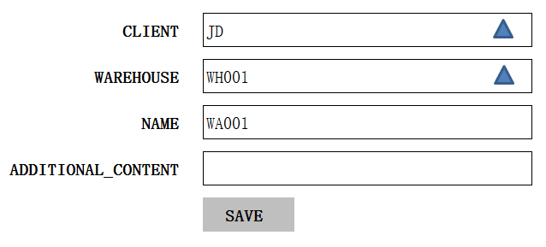

1. 功能：获取一条working Areas记录
2. 方法：

|  |
| --- |
| GET /System/ workingAreas/{id} |

1. 示例：

|  |
| --- |
| {  "id": “d75b38d24bd847789ee936af8db2873f”，  "client_id": {  “id”: “0123456789abcdef0123456789abcdef”,  “name”: “京东”  },  " WareHouse_id": {  “id”: “0123456789abcdef0123456789abcdef”,  “name”: “仓库1”  },  "name": " WA01 ",  "additional_content": "memo"  } |

## Edit

1. Edit页面



2、功能：修改一条working Areas记录

3、方法：

|  |
| --- |
| PUT /System/working Areas/{id} |

4、输入参数

|  |  |  |  |  |
| --- | --- | --- | --- | --- |
| **参数名称** | **类型** | **是否必须** | **示例值** | **描述** |
| CLIENT_ID | String | 是 | 京东 | 客户名称 |
| WareHouse_ID | String | 是 | 仓库1 | 仓库名称 |
| Name | String | 是 | WA001 | working Areas 名称 |
| additional_content | String | 否 | other | 额外的内容 |

1. 示例

|  |
| --- |
| {  "id": “d75b38d24bd847789ee936af8db2873f”，  "client_id": {  “id”: “0123456789abcdef0123456789abcdef”,  “name”: “京东”  },  " WareHouse_id": {  “id”: “0123456789abcdef0123456789abcdef”,  “name”: “仓库1”  },  "name": " WA01 ",  "additional_content": "aaaaaaa"  "entity_lock": "100",  "VERSION" : VERSION + 1,  “CREATED_BY”: {  “id”: “0123456789abcdef0123456789abcdef”,  “username”: “admin”  },  “MODIFIED_BY”: {  “id”: “0123456789abcdef0123456789abcdef”,  “username”: “admin”  },  “MODIFIED_DATE”: “2012-01-01T12:00:00Z”,  “MODIFIED_ DATE”: “2012-01-01T12:00:00Z”  } |

## Delete

1. 功能：删除一条Working Areas记录，及其与location Clusters的关系

2、方法

|  |
| --- |
| DELETE /System/Working Areas/{id} |

3、示例

|  |
| --- |
| {  "id": “d75b38d24bd847789ee936af8db2873f”，  "client_id": {  “id”: “0123456789abcdef0123456789abcdef”,  “name”: “京东”  },  " WareHouse_id": {  “id”: “0123456789abcdef0123456789abcdef”,  “name”: “仓库1”  },  "name": " WA001",  "additional_content": "aaaaaaa"  "entity_lock": "101",  "VERSION" : VERSION + 1,  “CREATED_BY”: {  “id”: “0123456789abcdef0123456789abcdef”,  “username”: “admin”  },  “MODIFIED_BY”: {  “id”: “0123456789abcdef0123456789abcdef”,  “username”: “admin”  },  “MODIFIED_DATE”: “2012-01-01T12:00:00Z”,  “MODIFIED_ DATE”: “2012-01-01T12:00:00Z”  } |

## Working Areas Positions

1. Setting 页面

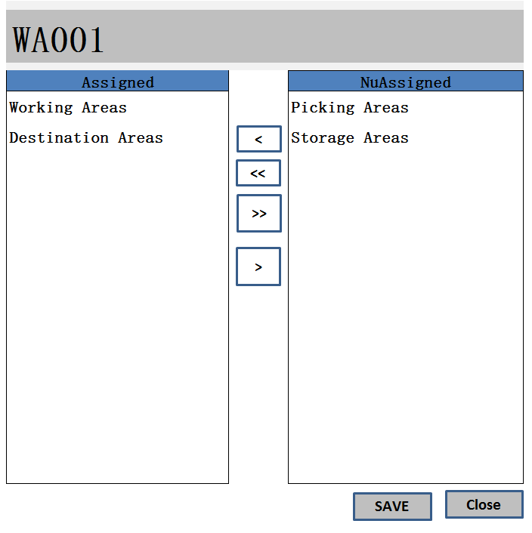

1. 功能点1: Unassigned列表中显示未加载的Zone

方法：

|  |
| --- |
| GET /Zone/{Cluster_ID} |

示例

|  |
| --- |
| {  cluster_List": [  “ cluster_id”: {  “id”: “0123456789abcdef0123456789abcdef”,  “name”: “ BIG ZONE01”  },  “ cluster_id”: {  “id”: “0123456789abcdef0123456789abcdef”,  “name”: “ BIG ZONE02”  }  ],  "total": 2,  } |

1. 功能点2: Assigned列表中显示已加载的Location Cluster

方法：

|  |
| --- |
| GET / Location Cluster /{ Cluster_ID } |

示例

|  |
| --- |
| {  cluster_List": [  “ cluster_id”: {  “id”: “0123456789abcdef0123456789abcdef”,  “name”: “ BIG ZONE01”  },  “ cluster_id”: {  “id”: “0123456789abcdef0123456789abcdef”,  “name”: “ BIG ZONE02”  }  ],  "total": 2,  } |

1. 功能点3: 添加一条Working Areas Positions记录

方法

|  |
| --- |
| POST /WorkingAreasPositions |

示例

|  |
| --- |
| {  cluster _List": [  “ cluster_id”: {  “id”: “0123456789abcdef0123456789abcdef”,  “name”: “ BIG ZONE02”  },  “WorkingAreas_id”: {  “id”: “0123456789abcdef0123456789abcdef”,  “username”: “WA01”  } |

1. 功能点4: 删除一条Assigned记录

方法

|  |
| --- |
| DELETE / WorkingAreasPositions /{cluster_id} |

示例

|  |
| --- |
| {  cluster _List": [  “ cluster_id”: {  r“id”: “0123456789abcdef0123456789abcdef”,  “name”: “ BIG ZONE01”  },  “WorkingAreas_id”: {  “id”: “0123456789abcdef0123456789abcdef”,  “username”: “WA01”  } |

# Bay Type

## List

1、页面

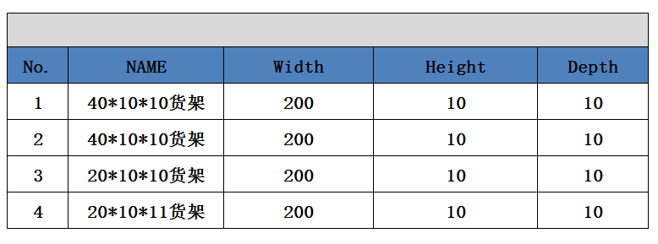

2、功能：显示所有BayType记录

3、方法：

|  |
| --- |
| GET /System/BayType |

## Create

1、页面

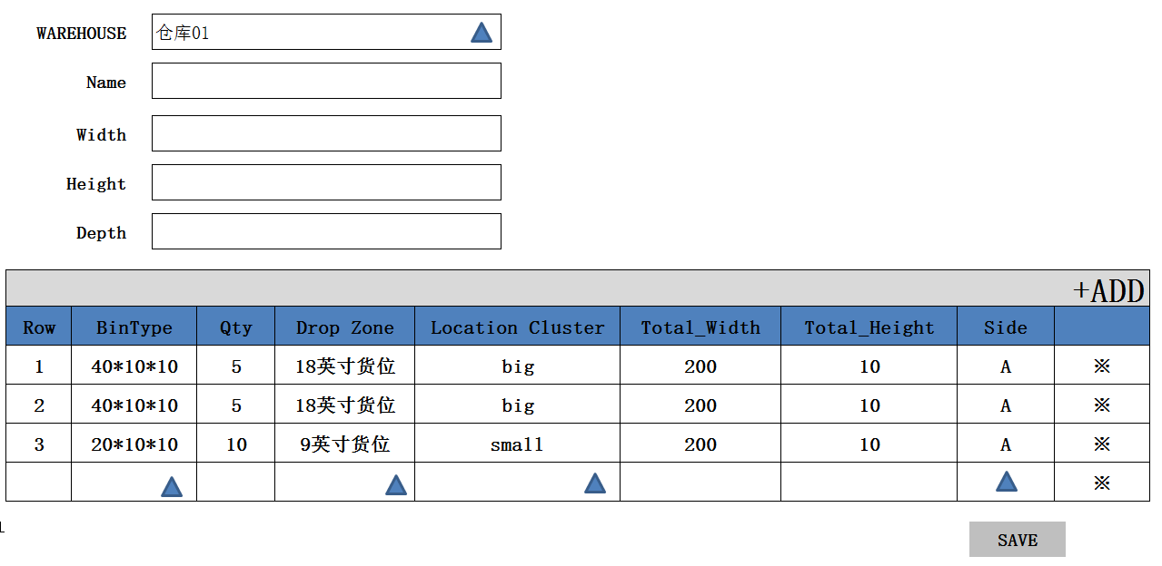

2、新增BayType信息

|  |
| --- |
| POST /System/BayType |

3、创建与RackType的RackTypePosition信息

|  |
| --- |
| POST /System/RackTypePosition |

## Detail

1、功能：

2、方法

|  |
| --- |
| GET /System/ RackType /{id} |

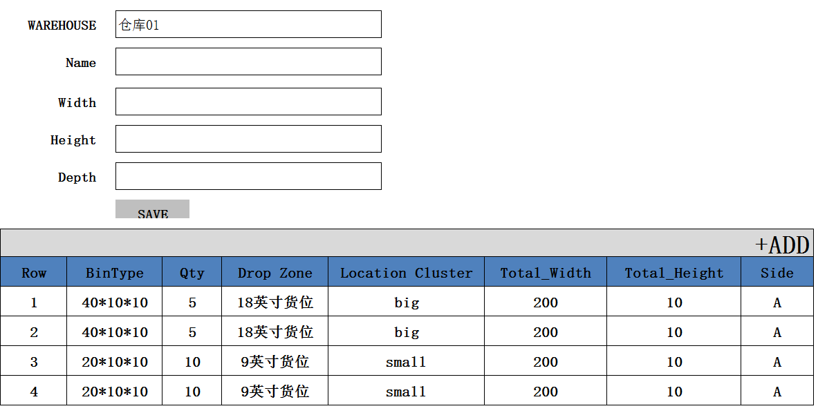

## Edit

1、功能：编辑一条BayType记录

2、方法

|  |
| --- |
| PUT /System/ BayType/{id} |



## Delete

1、功能：删除一条BayType记录

2、方法：

|  |
| --- |
| DELETE /System/ BayType/{id} |

# Bay

## List

1. list页面

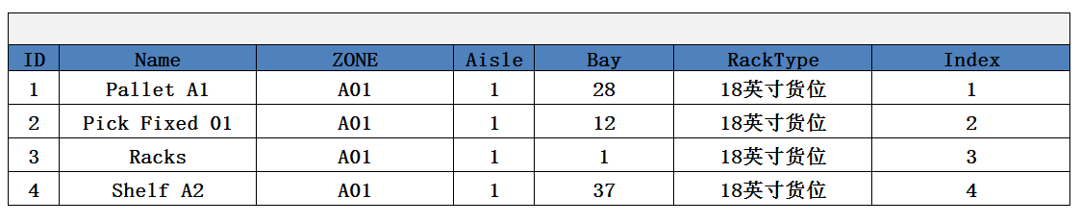

1. 功能：获取所有Bay记录
2. 方法：

|  |
| --- |
| GET /System/ Bay |

1. 示例：

|  |
| --- |
| {  " Racks_search_response ": {  "Racks_List": [  {  "id": " 903747BB-57CF-4272-8582-E30E61D67DBC",  "name": "Pallet A1",  "Aisle": "200",  "ClientId": {  "id": " 903747BB-57CF-4272-8582-E30E61D67DBC",  "name": "京东"  },  "WarehouseId": {  "id": " 903747BB-57CF-4272-8582-E30E61D67DBC",  "name": "苏州仓"  },  }  ],  "total": 1,  }  } |

## Create

1. 批量Create页面

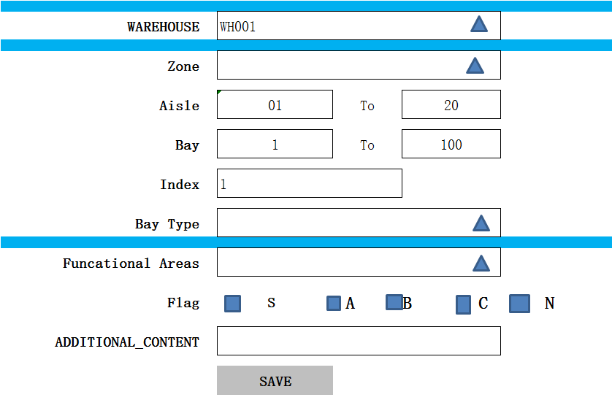

1. 功能：创建一条bay记录
2. 方法：

|  |
| --- |
| POST /System/bay |

1. 输入参数

|  |  |  |  |  |
| --- | --- | --- | --- | --- |
| **参数名称** | **类型** | **是否必须** | **示例值** | **描述** |
| WareHouse_ID | String | 是 | 仓库1 | 仓库名称 |
| Name | String | 是 | Pallet A1 | racks 名称 |
| Aisle | Int32 | 否 | 200 | 位置 |
| additional_content | String | 否 | other | 额外的内容 |

5、示例：

|  |
| --- |
| {  "id": " 903747BB-57CF-4272-8582-E30E61D67DBC",  "name": Zome + Aisle + Bay  "Aisle": "01",  "WarehouseId": {  "id": " 903747BB-57CF-4272-8582-E30E61D67DBC",  "name": "苏州仓"  },  "entity_lock": "100",  "VERSION" : 1,  “CREATED_BY”: {  “id”: “0123456789abcdef0123456789abcdef”,  “username”: “admin”  },  “MODIFIED_BY”: {  “id”: “0123456789abcdef0123456789abcdef”,  “username”: “admin”  },  “MODIFIED_DATE”: “2012-01-01T12:00:00Z”,  “MODIFIED_ DATE”: “2012-01-01T12:00:00Z”  } |

## Detail

1. Detail页面

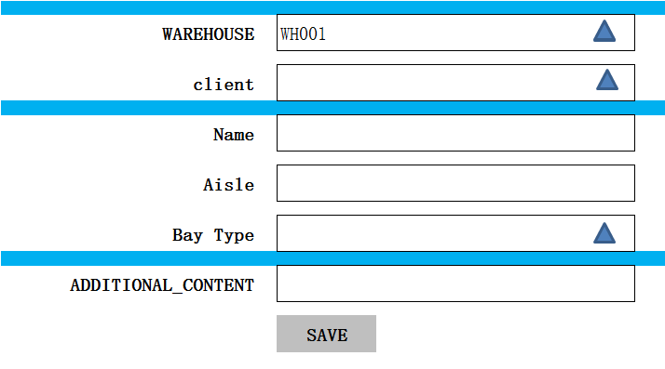

1. 功能：获取一条Racks记录

3、方法：

|  |
| --- |
| GET /System/ racks/{id} |

4、示例：

|  |
| --- |
| {  "id": " 903747BB-57CF-4272-8582-E30E61D67DBC",  "name": "Pallet A1",  "Aisle": "200",  "ClientId": {  "id": " 903747BB-57CF-4272-8582-E30E61D67DBC",  "name": "京东"  },  "WarehouseId": {  "id": " 903747BB-57CF-4272-8582-E30E61D67DBC",  "name": "苏州仓"  }  } |

## Edit

1. Edit页面



2、功能：修改一条rack记录

3、方法：

|  |
| --- |
| PUT /System/rack/{id} |

4、输入参数

|  |  |  |  |  |
| --- | --- | --- | --- | --- |
| **参数名称** | **类型** | **是否必须** | **示例值** | **描述** |
| CLIENT_ID | String | 是 | 京东 | 客户名称 |
| WareHouse_ID | String | 是 | 仓库1 | 仓库名称 |
| Name | String | 是 | Pallet A1 | racks 名称 |
| Aisle | Int32 | 否 | 200 | 位置 |
| additional_content | String | 否 | other | 额外的内容 |

5、示例：

|  |
| --- |
| {  "id": " 903747BB-57CF-4272-8582-E30E61D67DBC",  "name": "Pallet A1",  "Aisle": "200",  "ClientId": {  "id": " 903747BB-57CF-4272-8582-E30E61D67DBC",  "name": "京东"  },  "WarehouseId": {  "id": " 903747BB-57CF-4272-8582-E30E61D67DBC",  "name": "苏州仓"  },  "entity_lock": "100",  "VERSION" : VERSION + 1,  “CREATED_BY”: {  “id”: “0123456789abcdef0123456789abcdef”,  “username”: “admin”  },  “MODIFIED_BY”: {  “id”: “0123456789abcdef0123456789abcdef”,  “username”: “admin”  },  “MODIFIED_DATE”: “2012-01-01T12:00:00Z”,  “MODIFIED_ DATE”: “2012-01-01T12:00:00Z”  } |

## Delete

1. 功能：删除一条rack记录

2、方法

|  |
| --- |
| DELETE /System/rack/{id} |

3、示例

|  |
| --- |
| {  "id": " 903747BB-57CF-4272-8582-E30E61D67DBC",  "name": "Pallet A1",  "Aisle": "200",  "ClientId": {  "id": " 903747BB-57CF-4272-8582-E30E61D67DBC",  "name": "京东"  },  "WarehouseId": {  "id": " 903747BB-57CF-4272-8582-E30E61D67DBC",  "name": "苏州仓"  },  "entity_lock": "101",  "VERSION" : VERSION + 1,  “CREATED_BY”: {  “id”: “0123456789abcdef0123456789abcdef”,  “username”: “admin”  },  “MODIFIED_BY”: {  “id”: “0123456789abcdef0123456789abcdef”,  “username”: “admin”  },  “MODIFIED_DATE”: “2012-01-01T12:00:00Z”,  “MODIFIED_ DATE”: “2012-01-01T12:00:00Z”  } |

# BIN 【Loctation】

## List

1. List页面

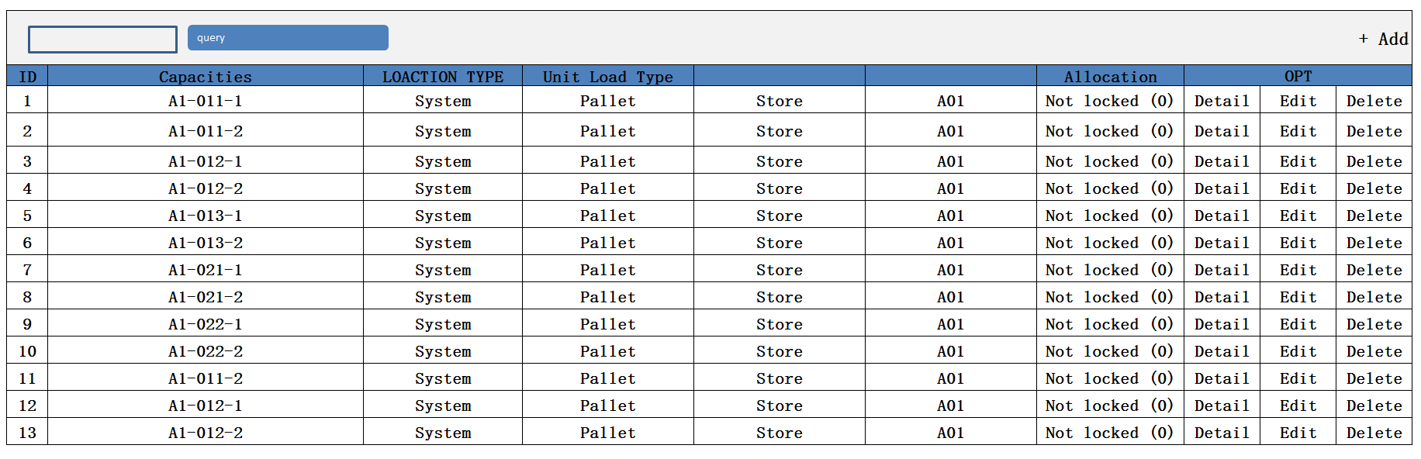

1. 功能：显示所有StorageLocations记录
2. 方法：

|  |
| --- |
| GET /System/ Locations |

1. 示例：

|  |
| --- |
| " Locations_search_response ": {  " Locations _List": [  {  "id": " 903747BB-57CF-4272-8582-E30E61D67DBC",  "ClientId": {  "id": " 903747BB-57CF-4272-8582-E30E61D67DBC",  "name": "京东"  },  "WarehouseId": {  "id": " 903747BB-57CF-4272-8582-E30E61D67DBC",  "name": "苏州仓"  },  "Lock": {  "id": " 903747BB-57CF-4272-8582-E30E61D67DBC",  "name": "NO Locked"  },  "Lock": {  "id": "100",  "name": "NO Locked"  },  "name": "Pallet A1",  "Type": {  "id": " 903747BB-57CF-4272-8582-E30E61D67DBC",  "name": "Pallet"  },  "Ares": {  "id": " 903747BB-57CF-4272-8582-E30E61D67DBC",  "name": "Store"  },  "Location Cluster": {  "id": " 903747BB-57CF-4272-8582-E30E61D67DBC",  "name": "Big Pallet"  },  "Zone": {  "id": " 903747BB-57CF-4272-8582-E30E61D67DBC",  "name": "Pallet_Zone01"  },  "X": "0",  "Y": "0",  "Z": "0",  "Field": "0",  "Field-Index": "0",  "Order-Index": "0",  "Allocation (%)": "-",  "Capacity": {  "id": " 903747BB-57CF-4272-8582-E30E61D67DBC",  "name": "EURO"  },  "Unit Loads": {  "id": " 903747BB-57CF-4272-8582-E30E61D67DBC",  "name": "000000001"  },  "Last Stocktaking": "-",  "additional content": "-",  "VERSION" : 1,  “CREATED_BY”: {  “id”: “0123456789abcdef0123456789abcdef”,  “username”: “admin”  },  “MODIFIED_BY”: {  “id”: “0123456789abcdef0123456789abcdef”,  “username”: “admin”  },  “MODIFIED_DATE”: “2012-01-01T12:00:00Z”,  “MODIFIED_ DATE”: “2012-01-01T12:00:00Z”  }  ],  "total": 1,  }  } |

## Create

1. Create页面

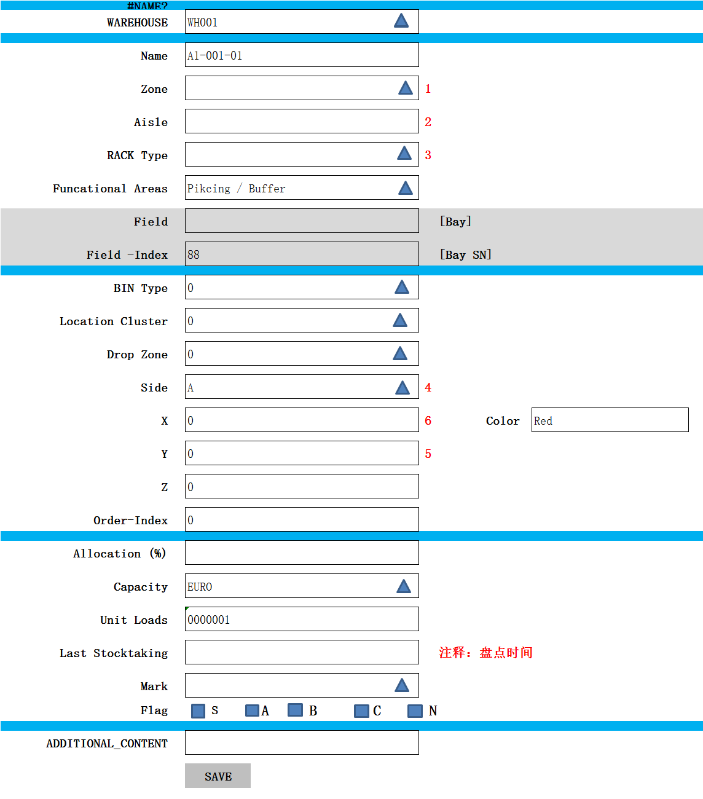

~~Plc-code~~

~~Scan-code~~

~~Tcc-id 数据库有这三个字段 去除Unit Load 字段~~

~~注释2016/10/08：~~

~~1、页面+数据库中增加一个Color字段~~

1. 功能：新建一条Location记录
2. 方法：

|  |
| --- |
| POST /System/ Location |

1. 输入参数:

|  |  |  |  |  |
| --- | --- | --- | --- | --- |
| **参数名称** | **类型** | **是否必须** | **示例值** | **描述** |
| CLIENT_ID | String | 是 | 京东 | 客户名称 |
| WareHouse_ID | String | 是 | 仓库1 | 仓库名称 |
| Lock | **Int32** | 是 | 100 | 是否锁定 |
| name | String | 是 | A1-021-2 | Location编号 |
| Type | String | 是 | Pallet | Bin Type |
| Area | String | 是 | Store | Working areas |
| Loacation Cluster | String | 是 | pallet | Drop Zone |
| Zone | String | 是 | Zone | 区域 |
| Pack | String | 是 | pack | 货架 |
| X | Int32 | 否 | 0 | X |
| Y | Int32 | 否 | 0 | Y |
| Z | Int32 | 否 | 0 | Z |
| Field | Int32 | 否 | - | Bay |
| Field-Index | Int32 | 是 | 0 | Bay-index |
| Order-index | Int32 | 是 | 0 | 默认为0 |
| Allocation(%) | Int32 | 否 | 100 | 默认为0 |
| SCAN_CODE |  |  |  | 默认为 Location编号 |
| Capacity/allocation_type | String | 是 | EURO | 默认为 Bin Type |
| ~~Unit Laods~~ | String | 是 | 00000001 | Unit Laods |
| Last Stocktaking | time | 是 | -/- | 最后的盘点 |
| Additional Content | String | 是 | MEMO | 描述 |
| Color | String | 是 | Red | 颜色 |

1. 示例

|  |
| --- |
| {  "id": " 903747BB-57CF-4272-8582-E30E61D67DBC",  "ClientId": {  "id": " 903747BB-57CF-4272-8582-E30E61D67DBC",  "name": "京东"  },  "WarehouseId": {  "id": " 903747BB-57CF-4272-8582-E30E61D67DBC",  "name": "苏州仓"  },  "Lock": {  "id": " 903747BB-57CF-4272-8582-E30E61D67DBC",  "name": "NO Locked"  },  "Lock": {  "id": "100",  "name": "NO Locked"  },  "name": "Pallet A1",  "Type": {  "id": " 903747BB-57CF-4272-8582-E30E61D67DBC",  "name": "Pallet"  },  "Ares": {  "id": " 903747BB-57CF-4272-8582-E30E61D67DBC",  "name": "Store"  },  "Location Cluster": {  "id": " 903747BB-57CF-4272-8582-E30E61D67DBC",  "name": "Big Pallet"  },  "Zone": {  "id": " 903747BB-57CF-4272-8582-E30E61D67DBC",  "name": "Pallet_Zone01"  },  "X": "0",  "Y": "0",  "Z": "0",  "Field": "0",  "Field-Index": "0",  "Order-Index": "0",  "Allocation (%)": "-",  "Capacity": {  "id": " 903747BB-57CF-4272-8582-E30E61D67DBC",  "name": "EURO"  },  "Unit Loads": {  "id": " 903747BB-57CF-4272-8582-E30E61D67DBC",  "name": "000000001"  },  "Last Stocktaking": "-",  "additional content": "-",  "VERSION" : 1,  “CREATED_BY”: {  “id”: “0123456789abcdef0123456789abcdef”,  “username”: “admin”  },  “MODIFIED_BY”: {  “id”: “0123456789abcdef0123456789abcdef”,  “username”: “admin”  },  “MODIFIED_DATE”: “2012-01-01T12:00:00Z”,  “MODIFIED_ DATE”: “2012-01-01T12:00:00Z”  } |

## Detail

1、Detail页面

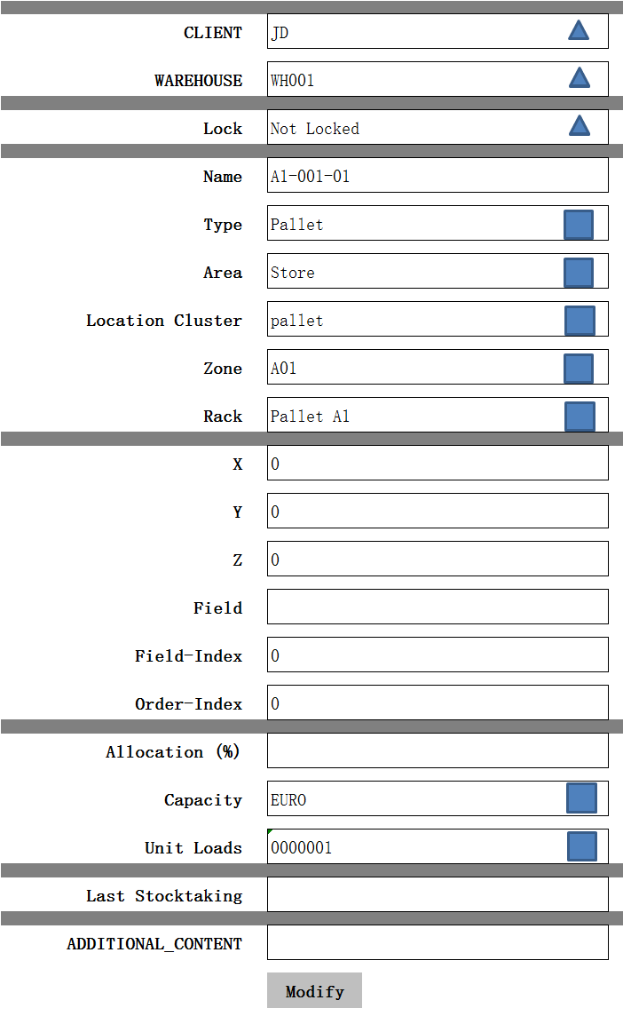

1. 功能：获取一条Location记录
2. 方法：

|  |
| --- |
| GET /System/ Location/{id} |

1. 示例：

|  |
| --- |
| {  "id": " 903747BB-57CF-4272-8582-E30E61D67DBC",  "ClientId": {  "id": " 903747BB-57CF-4272-8582-E30E61D67DBC",  "name": "京东"  },  "WarehouseId": {  "id": " 903747BB-57CF-4272-8582-E30E61D67DBC",  "name": "苏州仓"  },  "Lock": {  "id": " 903747BB-57CF-4272-8582-E30E61D67DBC",  "name": "NO Locked"  },  "Lock": {  "id": "100",  "name": "NO Locked"  },  "name": "Pallet A1",  "Type": {  "id": " 903747BB-57CF-4272-8582-E30E61D67DBC",  "name": "Pallet"  },  "Ares": {  "id": " 903747BB-57CF-4272-8582-E30E61D67DBC",  "name": "Store"  },  "Location Cluster": {  "id": " 903747BB-57CF-4272-8582-E30E61D67DBC",  "name": "Big Pallet"  },  "Zone": {  "id": " 903747BB-57CF-4272-8582-E30E61D67DBC",  "name": "Pallet_Zone01"  },  "X": "0",  "Y": "0",  "Z": "0",  "Field": "0",  "Field-Index": "0",  "Order-Index": "0",  "Allocation (%)": "-",  "Capacity": {  "id": " 903747BB-57CF-4272-8582-E30E61D67DBC",  "name": "EURO"  },  "Unit Loads": {  "id": " 903747BB-57CF-4272-8582-E30E61D67DBC",  "name": "000000001"  },  "Last Stocktaking": "-",  "additional content": "-",  "VERSION" : VERSION + 1  } |

## Edit

1、Edit页面

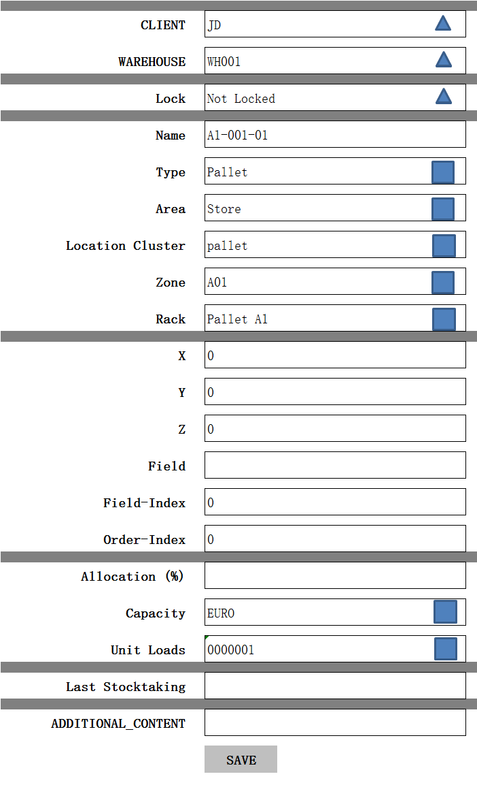

2、功能：修改一条Location记录

3、方法：

|  |
| --- |
| PUT /System/ Location/{id} |

4、输入参数

|  |  |  |  |  |
| --- | --- | --- | --- | --- |
| **参数名称** | **类型** | **是否必须** | **示例值** | **描述** |
| CLIENT_ID | String | 是 | 京东 | 客户名称 |
| WareHouse_ID | String | 是 | 仓库1 | 仓库名称 |
| Lock | **Int32** | 是 | 100 | 是否锁定 |
| name | String | 是 | A1-021-2 | Location编号 |
| Type | String | 是 | Pallet | Type |
| Area | String | 是 | Store | Working areas |
| Loacation Cluster | String | 是 | pallet | Drop Zone |
| Zone | String | 是 | Zone | 区域 |
| Pack | String | 是 | pack | 货架 |
| X | Int32 | 否 | 0 | X |
| Y | Int32 | 否 | 0 | Y |
| Z | Int32 | 否 | 0 | Z |
| Field | Int32 | 否 | - | 场 |
| Field-Index | Int32 | 是 | 0 | 场指数 |
| Order-index | Int32 | 是 | 0 | 订单指数 |
| Allocation(%) | Int32 | 否 | 100 | 比例 |
| Capacity | String | 是 | EURO | Capacity |
| Unit Laods | String | 是 | 00000001 | Unit Laods |
| Last Stocktaking | String | 是 | -/- | 最后的盘点 |
| Additional Content | String | 是 | MEMO | 描述 |

5、示例

|  |
| --- |
| {  "id": " 903747BB-57CF-4272-8582-E30E61D67DBC",  "ClientId": {  "id": " 903747BB-57CF-4272-8582-E30E61D67DBC",  "name": "京东"  },  "WarehouseId": {  "id": " 903747BB-57CF-4272-8582-E30E61D67DBC",  "name": "苏州仓"  },  "Lock": {  "id": " 903747BB-57CF-4272-8582-E30E61D67DBC",  "name": "NO Locked"  },  "Lock": {  "id": "100",  "name": "NO Locked"  },  "name": "Pallet A1",  "Type": {  "id": " 903747BB-57CF-4272-8582-E30E61D67DBC",  "name": "Pallet"  },  "Ares": {  "id": " 903747BB-57CF-4272-8582-E30E61D67DBC",  "name": "Store"  },  "Location Cluster": {  "id": " 903747BB-57CF-4272-8582-E30E61D67DBC",  "name": "Big Pallet"  },  "Zone": {  "id": " 903747BB-57CF-4272-8582-E30E61D67DBC",  "name": "Pallet_Zone01"  },  "X": "0",  "Y": "0",  "Z": "0",  "Field": "0",  "Field-Index": "0",  "Order-Index": "0",  "Allocation (%)": "-",  "Capacity": {  "id": " 903747BB-57CF-4272-8582-E30E61D67DBC",  "name": "EURO"  },  "Unit Loads": {  "id": " 903747BB-57CF-4272-8582-E30E61D67DBC",  "name": "000000001"  },  "Last Stocktaking": "-",  "additional content": "-",  "VERSION" : VERSION + 1,  “CREATED_BY”: {  “id”: “0123456789abcdef0123456789abcdef”,  “username”: “admin”  },  “MODIFIED_BY”: {  “id”: “0123456789abcdef0123456789abcdef”,  “username”: “admin”  },  “MODIFIED_DATE”: “2012-01-01T12:00:00Z”,  “MODIFIED_ DATE”: “2012-01-01T12:00:00Z”  } |

## Delete

1. 功能：删除一条location记录

2、方法

|  |
| --- |
| DELETE /System/location/{id} |

3、示例

|  |
| --- |
| {  "id": " 903747BB-57CF-4272-8582-E30E61D67DBC",  "ClientId": {  "id": " 903747BB-57CF-4272-8582-E30E61D67DBC",  "name": "京东"  },  "WarehouseId": {  "id": " 903747BB-57CF-4272-8582-E30E61D67DBC",  "name": "苏州仓"  },  "Lock": {  "id": " 903747BB-57CF-4272-8582-E30E61D67DBC",  "name": "NO Locked"  },  "Lock": {  "id": "101",  "name": "Locked"  },  "name": "Pallet A1",  "Type": {  "id": " 903747BB-57CF-4272-8582-E30E61D67DBC",  "name": "Pallet"  },  "Ares": {  "id": " 903747BB-57CF-4272-8582-E30E61D67DBC",  "name": "Store"  },  "Location Cluster": {  "id": " 903747BB-57CF-4272-8582-E30E61D67DBC",  "name": "Big Pallet"  },  "Zone": {  "id": " 903747BB-57CF-4272-8582-E30E61D67DBC",  "name": "Pallet_Zone01"  },  "X": "0",  "Y": "0",  "Z": "0",  "Field": "0",  "Field-Index": "0",  "Order-Index": "0",  "Allocation (%)": "-",  "Capacity": {  "id": " 903747BB-57CF-4272-8582-E30E61D67DBC",  "name": "EURO"  },  "Unit Loads": {  "id": " 903747BB-57CF-4272-8582-E30E61D67DBC",  "name": "000000001"  },  "Last Stocktaking": "-",  "additional content": "-",  "VERSION" : VERSION + 1,  “CREATED_BY”: {  “id”: “0123456789abcdef0123456789abcdef”,  “username”: “admin”  },  “MODIFIED_BY”: {  “id”: “0123456789abcdef0123456789abcdef”,  “username”: “admin”  },  “MODIFIED_DATE”: “2012-01-01T12:00:00Z”,  “MODIFIED_ DATE”: “2012-01-01T12:00:00Z”  } |

# Functional Areas

## List

1. Functional Areas页面

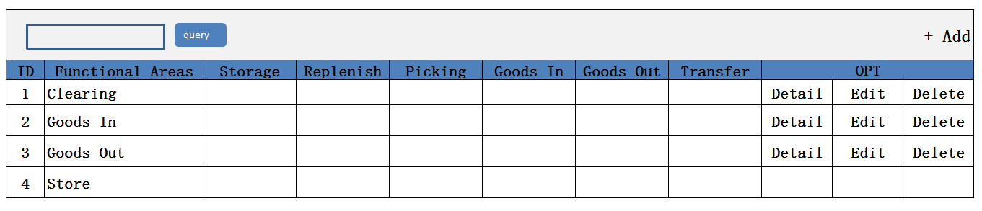

1. 功能：显示所有Areas记录
2. 方法

|  |
| --- |
| GET /System/Areas |

1. 示例

|  |
| --- |
| {  " Areas_search response ": {  " Areas_List": [  {  "id": " 903747BB-57CF-4272-8582-E30E61D67DBC",  "name": "Goods IN",  "USE_FOR_GOODSIN": True  "USE_FOR_GOODSOUT":False  "USE_FOR_PICKING": False  "USE_FOR_REPLENISH": False  "USE_FOR_STORAGE": False  "USE_FOR_TRANSFER": False  "ClientId": {  "id": " 903747BB-57CF-4272-8582-E30E61D67DBC",  "name": "京东"  },  "WarehouseId": {  "id": " 903747BB-57CF-4272-8582-E30E61D67DBC",  "name": "苏州仓"  },  }  ],  "total": 1,  }  } |

## Create

1. Create页面

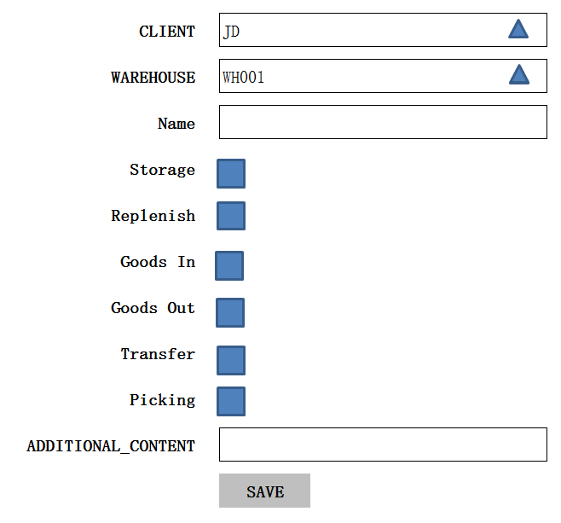

1. 功能：新增一条Areas记录
2. 方法

|  |
| --- |
| POST /System/Areas |

4、输入参数

|  |  |  |  |  |
| --- | --- | --- | --- | --- |
| **参数名称** | **类型** | **是否必须** | **示例值** | **描述** |
| CLIENT_ID | String | 是 | 京东 | 客户名称 |
| WareHouse_ID | String | 是 | 仓库1 | 仓库名称 |
| Name | String | 是 | Goods IN | Areas名称 |
| GOODSIN | Bit | 否 | True | 商品 |
| GOODSOUT | Bit | 否 | False | 货物 |
| PICKING | Bit | 否 | False | 采摘 |
| REPLENISH | Bit | 否 | False | 补充 |
| STORAGE | Bit | 否 | False | 存储 |
| TRANSFER | Bit | 否 |  | 转移 |
| ADDITIONAL_CONTENT | String | 否 | Other | 其它附加的信息 |

5、示例

|  |
| --- |
| {  "id": “d75b38d24bd847789ee936af8db2873f”，  "client_id": {  “id”: “0123456789abcdef0123456789abcdef”,  “name”: “京东”  },  " WareHouse_id": {  “id”: “0123456789abcdef0123456789abcdef”,  “name”: “仓库1”  },  "name": "Goods IN",  "USE_FOR_GOODSIN": True  "USE_FOR_GOODSOUT":False  "USE_FOR_PICKING": False  "USE_FOR_REPLENISH": False  "USE_FOR_STORAGE": False  "USE_FOR_TRANSFER": False  "additional_content": "aaaaaaa"  "entity_lock": "100",  "VERSION" : 1,  “CREATED_BY”: {  “id”: “0123456789abcdef0123456789abcdef”,  “username”: “admin”  },  “MODIFIED_BY”: {  “id”: “0123456789abcdef0123456789abcdef”,  “username”: “admin”  },  “MODIFIED_DATE”: “2012-01-01T12:00:00Z”,  “MODIFIED_ DATE”: “2012-01-01T12:00:00Z”  } |

## Detail

1. Detail页面

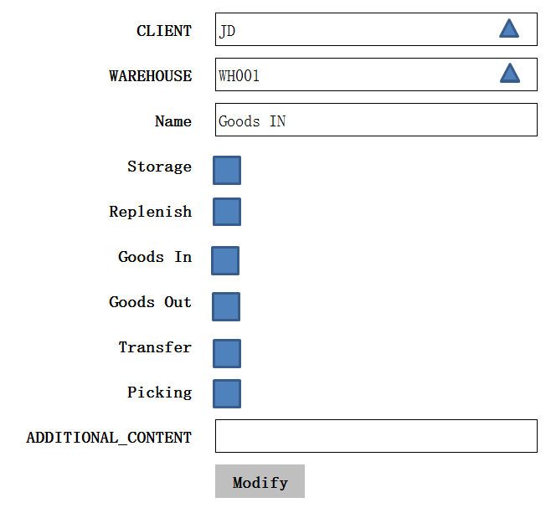

1. 功能：获取一条Areas记录
2. 方法：

|  |
| --- |
| GET /System/Areas/{id} |

1. 示例

|  |
| --- |
| {  "id": " 903747BB-57CF-4272-8582-E30E61D67DBC",  "name": "Goods IN",  "USE_FOR_GOODSIN": True  "USE_FOR_GOODSOUT":False  "USE_FOR_PICKING": False  "USE_FOR_REPLENISH": False  "USE_FOR_STORAGE": False  "USE_FOR_TRANSFER": False  "ClientId": {  "id": " 903747BB-57CF-4272-8582-E30E61D67DBC",  "name": "京东"  },  "WarehouseId": {  "id": " 903747BB-57CF-4272-8582-E30E61D67DBC",  "name": "苏州仓"  },  } |

## Edit

1. Edit页面



1. 功能：修改一条Areas记录
2. 方法

|  |
| --- |
| PUT /System/ Areas /{id} |

4、输入参数

|  |  |  |  |  |
| --- | --- | --- | --- | --- |
| **参数名称** | **类型** | **是否必须** | **示例值** | **描述** |
| CLIENT_ID | String | 是 | 京东 | 客户名称 |
| WareHouse_ID | String | 是 | 仓库1 | 仓库名称 |
| Name | String | 是 | Goods IN | Areas名称 |
| GOODSIN | Bit | 否 | True | 商品 |
| GOODSOUT | Bit | 否 | False | 货物 |
| PICKING | Bit | 否 | False | 采摘 |
| REPLENISH | Bit | 否 | False | 补充 |
| STORAGE | Bit | 否 | False | 存储 |
| TRANSFER | Bit | 否 |  | 转移 |
| ADDITIONAL_CONTENT | String | 否 | Other | 其它附加的信息 |

5、示例

|  |
| --- |
| {  "id": “d75b38d24bd847789ee936af8db2873f”，  "client_id": {  “id”: “0123456789abcdef0123456789abcdef”,  “name”: “京东”  },  " WareHouse_id": {  “id”: “0123456789abcdef0123456789abcdef”,  “name”: “仓库1”  },  "name": "Goods IN",  "USE_FOR_GOODSIN": True  "USE_FOR_GOODSOUT":False  "USE_FOR_PICKING": False  "USE_FOR_REPLENISH": False  "USE_FOR_STORAGE": False  "USE_FOR_TRANSFER": False  "additional_content": "aaaaaaa"  "entity_lock": "100",  "VERSION" : 1,  “CREATED_BY”: {  “id”: “0123456789abcdef0123456789abcdef”,  “username”: “admin”  },  “MODIFIED_BY”: {  “id”: “0123456789abcdef0123456789abcdef”,  “username”: “admin”  },  “MODIFIED_DATE”: “2012-01-01T12:00:00Z”,  “MODIFIED_ DATE”: “2012-01-01T12:00:00Z”  } |

## Delete

1. 功能:删除一条Areas记录
2. 方法

|  |
| --- |
| DELETE /System/ Areas/{id} |

3、示例

|  |
| --- |
| {  "id": “d75b38d24bd847789ee936af8db2873f”，  "client_id": {  “id”: “0123456789abcdef0123456789abcdef”,  “name”: “京东”  },  " WareHouse_id": {  “id”: “0123456789abcdef0123456789abcdef”,  “name”: “仓库1”  },  "name": "Goods IN",  "USE_FOR_GOODSIN": True  "USE_FOR_GOODSOUT":False  "USE_FOR_PICKING": False  "USE_FOR_REPLENISH": False  "USE_FOR_STORAGE": False  "USE_FOR_TRANSFER": False  "additional_content": "aaaaaaa"  "entity_lock": "100",  "VERSION" : 1,  “CREATED_BY”: {  “id”: “0123456789abcdef0123456789abcdef”,  “username”: “admin”  },  “MODIFIED_BY”: {  “id”: “0123456789abcdef0123456789abcdef”,  “username”: “admin”  },  “MODIFIED_DATE”: “2012-01-01T12:00:00Z”,  “MODIFIED_ DATE”: “2012-01-01T12:00:00Z”  } |

# Fixed location Assignment

## List

1. List页面初始化

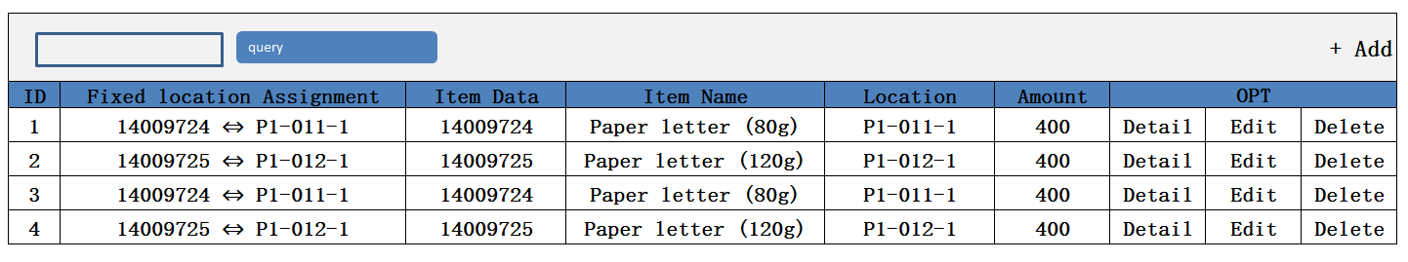

1. 功能：显示所有FIXLOCATIONASSIGNMENT记录
2. 方法：

|  |
| --- |
| GET /System/FIXLOCATIONASSIGNMENT |

1. 示例

|  |
| --- |
| {  " FIXLOCATIONASSIGNMENT_search response ": {  " FIXLOCATIONASSIGNMENT_List": [  {  "id": " 903747BB-57CF-4272-8582-E30E61D67DBC",  "Assigned Location":  {  "id": " 903747BB-57CF-4272-8582-E30E61D67DBC",  "name": " P1-011-1"  } ,  " Item Data":  {  "id": " 903747BB-57CF-4272-8582-E30E61D67DBC",  "name": "14009724"  } ,  " Desired Amount ": 400,  "additional_content",  "entity_lock": "not locked",  "ClientId": {  "id": " 903747BB-57CF-4272-8582-E30E61D67DBC",  "name": "京东"  },  "WarehouseId": {  "id": " 903747BB-57CF-4272-8582-E30E61D67DBC",  "name": "苏州仓"  },  }  ],  "total": 1,  }  } |

## Create

1. Create页面

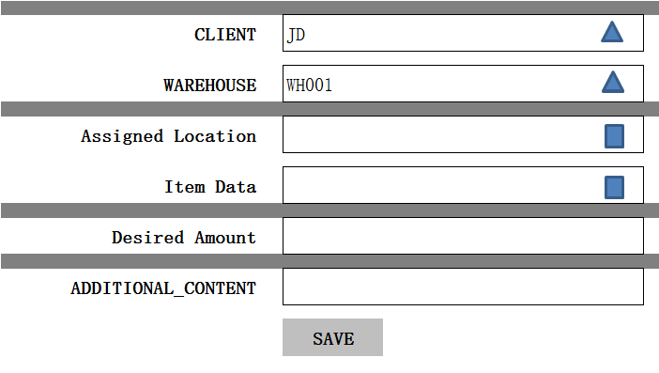

1. 功能：新建一条FIXLOCATIONASSIGNMENT记录
2. 方法：

|  |
| --- |
| POST /System/FIXLOCATIONASSIGNMENT |

1. 输入参数

|  |  |  |  |  |
| --- | --- | --- | --- | --- |
| **参数名称** | **类型** | **是否必须** | **示例值** | **描述** |
| CLIENT_ID | String | 是 | 京东 | 客户名称 |
| WareHouse_ID | String | 是 | 仓库1 | 仓库名称 |
| additional_content | String | 是 | other | 额外的内容 |
| Item Data | String | 否 | 14009724 | Item Data |
| Location | String | 否 | P1-011-1 | Location |
| Desired Amount | decimal | 否 | 1000 | 需量 |

1. 示例

|  |
| --- |
| {  "id": " 903747BB-57CF-4272-8582-E30E61D67DBC",  "Assigned Location":  {  "id": " 903747BB-57CF-4272-8582-E30E61D67DBC",  "name": " P1-011-1"  } ,  " Item Data":  {  "id": " 903747BB-57CF-4272-8582-E30E61D67DBC",  "name": "14009724"  } ,  " Desired Amount ": 400,  "additional_content",  "entity_lock": "not locked",  "ClientId": {  "id": " 903747BB-57CF-4272-8582-E30E61D67DBC",  "name": "京东"  },  "WarehouseId": {  "id": " 903747BB-57CF-4272-8582-E30E61D67DBC",  "name": "苏州仓"  }  } |

## Detail

1. Detail页面

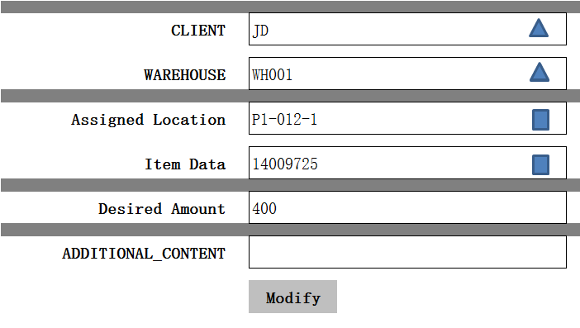

1. 功能：查询一条FIXLOCATIONASSIGNMENT记录
2. 方法：

|  |
| --- |
| GET /System/ FIXLOCATIONASSIGNMENT /{id} |

1. 示例

|  |
| --- |
| {  "id": " 903747BB-57CF-4272-8582-E30E61D67DBC",  "Assigned Location":  {  "id": " 903747BB-57CF-4272-8582-E30E61D67DBC",  "name": " P1-011-1"  } ,  " Item Data":  {  "id": " 903747BB-57CF-4272-8582-E30E61D67DBC",  "name": "14009724"  } ,  " Desired Amount ": 400,  "additional_content",  "entity_lock": "not locked",  "ClientId": {  "id": " 903747BB-57CF-4272-8582-E30E61D67DBC",  "name": "京东"  },  "WarehouseId": {  "id": " 903747BB-57CF-4272-8582-E30E61D67DBC",  "name": "苏州仓"  }  } |

## Edit

1. Edit页面

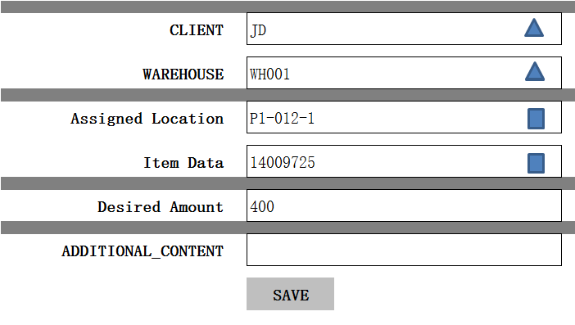

2、功能：修改一条FIXLOCATIONASSIGNMENT记录

3、方法：

|  |
| --- |
| PUT /System/ FIXLOCATIONASSIGNMENT/{id} |

4、输入参数

|  |  |  |  |  |
| --- | --- | --- | --- | --- |
| **参数名称** | **类型** | **是否必须** | **示例值** | **描述** |
| CLIENT_ID | String | 是 | 京东 | 客户名称 |
| WareHouse_ID | String | 是 | 仓库1 | 仓库名称 |
| additional_content | String | 是 | other | 额外的内容 |
| Item Data | String | 否 | 14009724 | Item Data |
| Location | String | 否 | P1-011-1 | Location |
| Desired Amount | decimal | 否 | 1000 | 需量 |

5、示例

|  |
| --- |
| {  "id": " 903747BB-57CF-4272-8582-E30E61D67DBC",  "Assigned Location":  {  "id": " 903747BB-57CF-4272-8582-E30E61D67DBC",  "name": " P1-011-1"  } ,  " Item Data":  {  "id": " 903747BB-57CF-4272-8582-E30E61D67DBC",  "name": "14009724"  } ,  " Desired Amount ": 400,  "additional_content",  "entity_lock": "not locked",  "ClientId": {  "id": " 903747BB-57CF-4272-8582-E30E61D67DBC",  "name": "京东"  },  "WarehouseId": {  "id": " 903747BB-57CF-4272-8582-E30E61D67DBC",  "name": "苏州仓"  }  } |

## Delete

1. 功能：删除一条FIXLOCATIONASSIGNMENT记录
2. 方法：

|  |
| --- |
| DELETE /System/ FIXLOCATIONASSIGNMENT /{id} |

1. 示例

|  |
| --- |
| {  "id": " 903747BB-57CF-4272-8582-E30E61D67DBC",  "Assigned Location":  {  "id": " 903747BB-57CF-4272-8582-E30E61D67DBC",  "name": " P1-011-1"  } ,  " Item Data":  {  "id": " 903747BB-57CF-4272-8582-E30E61D67DBC",  "name": "14009724"  } ,  " Desired Amount ": 400,  "additional_content",  "entity_lock": "not locked",  "ClientId": {  "id": " 903747BB-57CF-4272-8582-E30E61D67DBC",  "name": "京东"  },  "WarehouseId": {  "id": " 903747BB-57CF-4272-8582-E30E61D67DBC",  "name": "苏州仓"  }  } |

# Unit Load Type

## List

1. List页面初始化

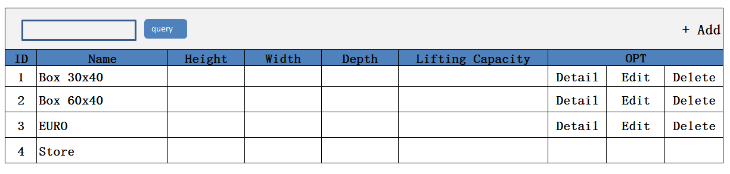

1. 功能：显示所有UNITLOADTYPE记录
2. 方法

4、示例：

|  |
| --- |
| GET /System/UnitLoadType |

4、示例

|  |
| --- |
| {  " UnitLoadType_search response ": {  " UnitLoadType_List": [  {  "id": " 903747BB-57CF-4272-8582-E30E61D67DBC",  "name": " EURO",  "height": 100 ,  "width": 100,  "depth": 100,  " Weight ": "1",  "additional_content",  "entity_lock": "not locked",  "ClientId": {  "id": " 903747BB-57CF-4272-8582-E30E61D67DBC",  "name": "京东"  },  "WarehouseId": {  "id": " 903747BB-57CF-4272-8582-E30E61D67DBC",  "name": "苏州仓"  },  }  ],  "total": 1,  }  } |

## Create

1. Create页面



1. 功能：新增一条UnitLoadType记录
2. 方法：

|  |
| --- |
| POST /System/UnitLoadType |

1. 输入参数

|  |  |  |  |  |
| --- | --- | --- | --- | --- |
| **参数名称** | **类型** | **是否必须** | **示例值** | **描述** |
| CLIENT_ID | String | 是 | 京东 | 客户名称 |
| WareHouse_ID | String | 是 | 仓库1 | 仓库名称 |
| Name | String | 是 | EURO | UnitLoadType 名称 |
| Height | decimal | 否 | 100 | 高度 |
| Width | decimal | 否 | 100 | 宽度 |
| Depth | decimal | 否 | 100 | 深度 |
| Weight | decimal | 否 | 2（吨） | 起重重量 |

1. 示例

|  |
| --- |
| {  "id": “d75b38d24bd847789ee936af8db2873f”，  "client_id": {  “id”: “0123456789abcdef0123456789abcdef”,  “name”: “京东”  },  " WareHouse_id": {  “id”: “0123456789abcdef0123456789abcdef”,  “name”: “仓库1”  },  "name": " EURO ",  "height": 100 ,  "width": 100,  "depth": 100,  " Weight": "1",  "additional_content": "aaaaaaa"  "entity_lock": "100",  "VERSION" : 1,  “CREATED_BY”: {  “id”: “0123456789abcdef0123456789abcdef”,  “username”: “admin”  },  “MODIFIED_BY”: {  “id”: “0123456789abcdef0123456789abcdef”,  “username”: “admin”  },  “MODIFIED_DATE”: “2012-01-01T12:00:00Z”,  “MODIFIED_ DATE”: “2012-01-01T12:00:00Z”  } |

## Detail

1. Detail页面



1. 功能：查询一条UnitLoadType记录
2. 方法

|  |
| --- |
| GET /System/UnitLoadType/{id} |

1. 示例

|  |
| --- |
| {  "id": " 903747BB-57CF-4272-8582-E30E61D67DBC",  "name": " EURO ",  "height": 100 ,  "width": 100,  "depth": 100,  "weight": "1",  "additional_content",  "entity_lock": "not locked",  "ClientId": {  "id": " 903747BB-57CF-4272-8582-E30E61D67DBC",  "name": "京东"  }，  "WarehouseId": {  "id": " 903747BB-57CF-4272-8582-E30E61D67DBC",  "name": "苏州仓"  }  } |

## Edit

1. Edit页面



2、功能：修改一条locationTypes记录

3、方法：

|  |
| --- |
| PUT /System/ UnitLoadType /{id} |

4、输入参数

|  |  |  |  |  |
| --- | --- | --- | --- | --- |
| **参数名称** | **类型** | **是否必须** | **示例值** | **描述** |
| CLIENT_ID | String | 是 | 京东 | 客户名称 |
| WareHouse_ID | String | 是 | 仓库1 | 仓库名称 |
| Name | String | 是 | EURO | UnitLoadType 名称 |
| Height | decimal | 否 | 100 | 高度 |
| Width | decimal | 否 | 100 | 宽度 |
| Depth | decimal | 否 | 100 | 深度 |
| Weight | decimal | 否 | 2（吨） | 起重重量 |

5、示例

|  |
| --- |
| {  "id": “d75b38d24bd847789ee936af8db2873f”，  "client_id": {  “id”: “0123456789abcdef0123456789abcdef”,  “name”: “京东”  },  " WareHouse_id": {  “id”: “0123456789abcdef0123456789abcdef”,  “name”: “仓库1”  },  "name": " EURO ",  "height": 100 ,  "width": 100,  "depth": 100,  " Weight ": "1",  "additional_content": "aaaaaaa"  "entity_lock": "100",  "VERSION" : VERSION + 1,  “CREATED_BY”: {  “id”: “0123456789abcdef0123456789abcdef”,  “username”: “admin”  },  “MODIFIED_BY”: {  “id”: “0123456789abcdef0123456789abcdef”,  “username”: “admin”  },  “MODIFIED_DATE”: “2012-01-01T12:00:00Z”,  “MODIFIED_ DATE”: “2012-01-01T12:00:00Z”  } |

## Delete

1. 功能：删除一条UnitLoadType记录

2、方法

|  |
| --- |
| DELETE /System/ UnitLoadType /{id} |

3、示例

|  |
| --- |
| {  "id": “d75b38d24bd847789ee936af8db2873f”，  "client_id": {  “id”: “0123456789abcdef0123456789abcdef”,  “name”: “京东”  },  " WareHouse_id": {  “id”: “0123456789abcdef0123456789abcdef”,  “name”: “仓库1”  },  "name": " EURO ",  "height": 100 ,  "width": 100,  "depth": 100,  "weight": "1",  "additional_content": "aaaaaaa"  "entity_lock": "101",  "VERSION" : VERSION + 1,  “CREATED_BY”: {  “id”: “0123456789abcdef0123456789abcdef”,  “username”: “admin”  },  “MODIFIED_BY”: {  “id”: “0123456789abcdef0123456789abcdef”,  “username”: “admin”  },  “MODIFIED_DATE”: “2012-01-01T12:00:00Z”,  “MODIFIED_ DATE”: “2012-01-01T12:00:00Z”  } |

# Capacity

## List

1. List页面

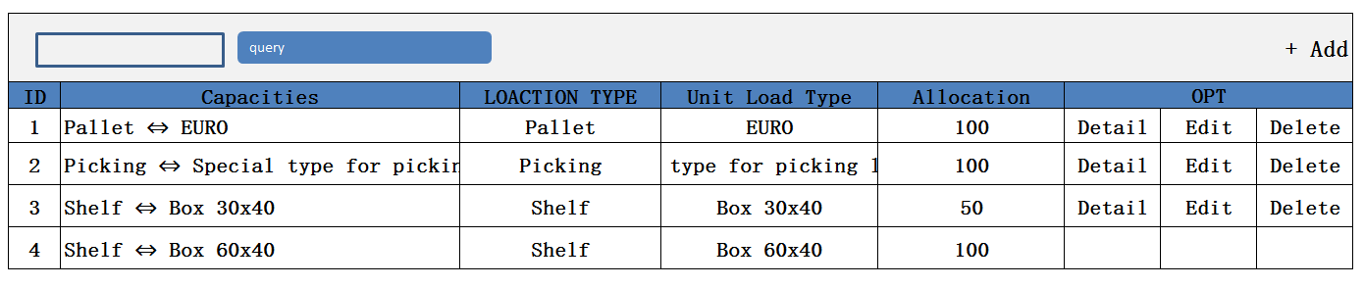

1. 功能：显示所有TypeCapacityConstraint记录
2. 方法：

|  |
| --- |
| GET /System/ Capacities |

1. 示例：

|  |
| --- |
| {  "Capacities_search_response ": {  " Capacities_List": [  {  "id": " 903747BB-57CF-4272-8582-E30E61D67DBC",  "name": " Pallet ⇔ EURO",  "location type ": {  "id": " 903747BB-57CF-4272-8582-E30E61D67DBC",  "name": "Pallet"  },  "Unit Load Type": {  "id": " 903747BB-57CF-4272-8582-E30E61D67DBC",  "name": "EURO"  },  "Allocation": "100 ",  "ClientId": {  "id": " 903747BB-57CF-4272-8582-E30E61D67DBC",  "name": "京东"  },  "WarehouseId": {  "id": " 903747BB-57CF-4272-8582-E30E61D67DBC",  "name": "苏州仓"  },  }  ],  "total": 1,  }  } |

## Create

1. Create页面

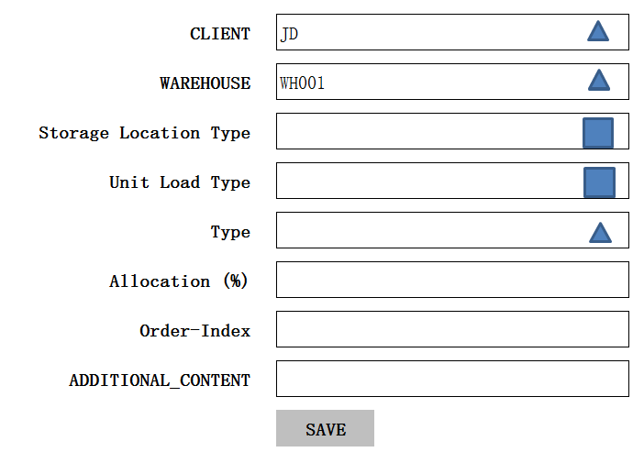

1. 功能：新增一条TypeCapacityConstraint记录
2. 方法：

|  |
| --- |
| POST /System/ Capacities |



1. 输入参数

|  |  |  |  |  |
| --- | --- | --- | --- | --- |
| **参数名称** | **类型** | **是否必须** | **示例值** | **描述** |
| CLIENT_ID | String | 是 | 京东 | 客户名称 |
| WareHouse_ID | String | 是 | 仓库1 | 仓库名称 |
| Storage location type | String | 是 | Pallet | Storage location type 名称 |
| Unit Load Type | String | 是 | EURO | Unit Load Type名称 |
| Type | String | 是 | One Unit Load Type (Percentage of one unit load on location) | Capacities类型 |
| Allocation | Int32 | 是 | 100 | 百分比 |
| Order-index | Int32 | 是 | 0 | 订单指数 |
| additional_content | String | 否 | - | 额外的内容 |

1. 示例：

|  |
| --- |
| {  "id": " 903747BB-57CF-4272-8582-E30E61D67DBC",  "name": "Pallet A1",  "Storage location type":{  "id": " 903747BB-57CF-4272-8582-E30E61D67DBC",  "name": " Pallet "  }  "Unit Load Type":{  "id": " 903747BB-57CF-4272-8582-E30E61D67DBC",  "name": " EURO "  }  "Type":{  "id": " 903747BB-57CF-4272-8582-E30E61D67DBC",  "name": " One Unit Load Type "  }  "Allocation": 100,  "Order-index": 0,  "ClientId": {  "id": " 903747BB-57CF-4272-8582-E30E61D67DBC",  "name": "京东"  },  "WarehouseId": {  "id": " 903747BB-57CF-4272-8582-E30E61D67DBC",  "name": "苏州仓"  },  "entity_lock": "100",  "VERSION" : 1,  “CREATED_BY”: {  “id”: “0123456789abcdef0123456789abcdef”,  “username”: “admin”  },  “MODIFIED_BY”: {  “id”: “0123456789abcdef0123456789abcdef”,  “username”: “admin”  },  “MODIFIED_DATE”: “2012-01-01T12:00:00Z”,  “MODIFIED_ DATE”: “2012-01-01T12:00:00Z”  } |

## Detail

1. Detail页面

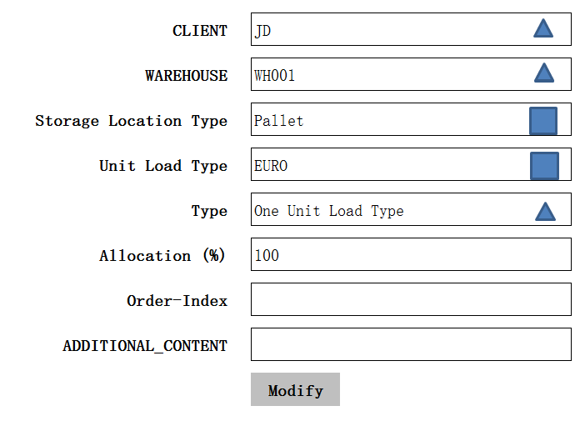

1. 功能：获取一条Capacities记录
2. 方法：

|  |
| --- |
| GET /System/ Capacities/{id} |

1. 示例：

|  |
| --- |
| {  "id": " 903747BB-57CF-4272-8582-E30E61D67DBC",  "name": "Pallet A1",  "Storage location type":{  "id": " 903747BB-57CF-4272-8582-E30E61D67DBC",  "name": " Pallet "  }  "Unit Load Type":{  "id": " 903747BB-57CF-4272-8582-E30E61D67DBC",  "name": " EURO "  }  "Type":{  "id": " 903747BB-57CF-4272-8582-E30E61D67DBC",  "name": " One Unit Load Type "  }  "Allocation": 100,  "Order-index": 0,  "ClientId": {  "id": " 903747BB-57CF-4272-8582-E30E61D67DBC",  "name": "京东"  },  "WarehouseId": {  "id": " 903747BB-57CF-4272-8582-E30E61D67DBC",  "name": "苏州仓"  }  } |

## Edit

1、Edit页面

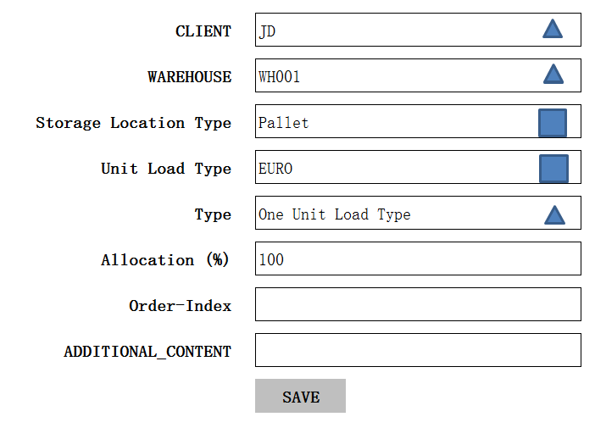

2、功能：修改一条Capacities记录

3、方法：

|  |
| --- |
| PUT /System/ Capacities /{id} |

4、输入参数

|  |  |  |  |  |
| --- | --- | --- | --- | --- |
| **参数名称** | **类型** | **是否必须** | **示例值** | **描述** |
| CLIENT_ID | String | 是 | 京东 | 客户名称 |
| WareHouse_ID | String | 是 | 仓库1 | 仓库名称 |
| Storage location type | String | 是 | Pallet | Storage location type 名称 |
| Unit Load Type | String | 是 | EURO | Unit Load Type名称 |
| Type | String | 是 | One Unit Load Type (Percentage of one unit load on location) | Capacities类型 |
| Allocation | Int32 | 是 | 100 | 百分比 |
| Order-index | Int32 | 是 | 0 | 订单指数 |
| additional_content | String | 否 | - | 额外的内容 |

5、示例

|  |
| --- |
| {  "id": " 903747BB-57CF-4272-8582-E30E61D67DBC",  "name": "Pallet A1",  "Storage location type":{  "id": " 903747BB-57CF-4272-8582-E30E61D67DBC",  "name": " Pallet "  }  "Unit Load Type":{  "id": " 903747BB-57CF-4272-8582-E30E61D67DBC",  "name": " EURO "  }  "Type":{  "id": " 903747BB-57CF-4272-8582-E30E61D67DBC",  "name": " One Unit Load Type "  }  "Allocation": 100,  "Order-index": 0,  "ClientId": {  "id": " 903747BB-57CF-4272-8582-E30E61D67DBC",  "name": "京东"  },  "WarehouseId": {  "id": " 903747BB-57CF-4272-8582-E30E61D67DBC",  "name": "苏州仓"  },  "entity_lock": "100",  "VERSION" : VERSION + 1,  “CREATED_BY”: {  “id”: “0123456789abcdef0123456789abcdef”,  “username”: “admin”  },  “MODIFIED_BY”: {  “id”: “0123456789abcdef0123456789abcdef”,  “username”: “admin”  },  “MODIFIED_DATE”: “2012-01-01T12:00:00Z”,  “MODIFIED_ DATE”: “2012-01-01T12:00:00Z”  } |

## Delete

1、功能：删除一条Capacities记录

2、方法

|  |
| --- |
| DELETE /System/Capacities/{id} |

3、示例

|  |
| --- |
| {  "id": " 903747BB-57CF-4272-8582-E30E61D67DBC",  "name": "Pallet A1",  "Storage location type":{  "id": " 903747BB-57CF-4272-8582-E30E61D67DBC",  "name": " Pallet "  }  "Unit Load Type":{  "id": " 903747BB-57CF-4272-8582-E30E61D67DBC",  "name": " EURO "  }  "Type":{  "id": " 903747BB-57CF-4272-8582-E30E61D67DBC",  "name": " One Unit Load Type "  }  "Allocation": 100,  "Order-index": 0,  "ClientId": {  "id": " 903747BB-57CF-4272-8582-E30E61D67DBC",  "name": "京东"  },  "WarehouseId": {  "id": " 903747BB-57CF-4272-8582-E30E61D67DBC",  "name": "苏州仓"  },  "entity_lock": "101",  "VERSION" : VERSION + 1,  “CREATED_BY”: {  “id”: “0123456789abcdef0123456789abcdef”,  “username”: “admin”  },  “MODIFIED_BY”: {  “id”: “0123456789abcdef0123456789abcdef”,  “username”: “admin”  },  “MODIFIED_DATE”: “2012-01-01T12:00:00Z”,  “MODIFIED_ DATE”: “2012-01-01T12:00:00Z”  } |

# Destination Location

## List

1. List页面

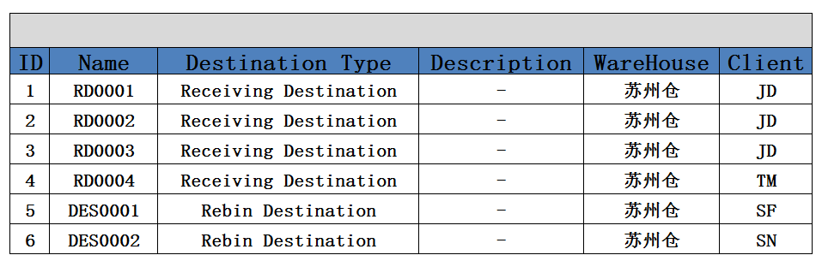

1. 功能： 显示所有Destination location记录
2. 方法：

|  |
| --- |
| GET /System/ destinationlocation |

1. 示例：

|  |
| --- |
| {  " destinationlocation_search response ": {  " destinationlocation_List": [  {  "id": " 903747BB-57CF-4272-8582-E30E61D67DBC",  "ClientId": {  "id": " 903747BB-57CF-4272-8582-E30E61D67DBC",  "name": "京东"  },  "WarehouseId": {  "id": " 903747BB-57CF-4272-8582-E30E61D67DBC",  "name": "苏州仓"  },  "destinationType": {  "id": " 903747BB-57CF-4272-8582-E30E61D67DBC",  "name": "Receiving Destination"  },  "name": " JD_WS0001",  "Description": " - ",  "  "VERSION" : 1,  "ENTITY_LOCK":"100",  “CREATED_BY”: {  “id”: “0123456789abcdef0123456789abcdef”,  “username”: “admin”  },  “MODIFIED_BY”: {  “id”: “0123456789abcdef0123456789abcdef”,  “username”: “admin”  },  “MODIFIED_DATE”: “2012-01-01T12:00:00Z”,  “MODIFIED_ DATE”: “2012-01-01T12:00:00Z”  }  ],  "total": 1,  }  } |

## Create

1. Create页面

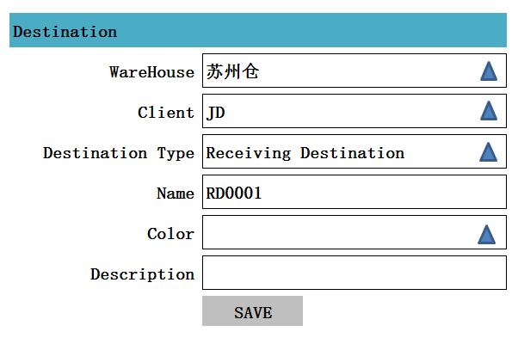

注释：追加一个类型

1. 功能： 创建一条Destination记录
2. 方法：

|  |
| --- |
| POST /System/destinationlocation |

1. 输入参数

|  |  |  |  |  |
| --- | --- | --- | --- | --- |
| **参数名称** | **类型** | **是否必须** | **示例值** | **描述** |
| WareHouse_NO | String | 是 | 苏州仓 | 仓库编码 |
| Client_NO | String | 是 | JD | 客户编码 |
| Name | String | 是 | RD0001 | Destination location 名称 |
| Destination Type | String | 是 | Receiving Destination | Destination 类型 |
| Color | String | 否 | Red | 颜色 |
| Description | String | 否 | 描述信息 |  |

1. 示例：

|  |
| --- |
| {  "id": " 903747BB-57CF-4272-8582-E30E61D67DBC",  "ClientId": {  "id": " 903747BB-57CF-4272-8582-E30E61D67DBC",  "name": "京东"  },  "WarehouseId": {  "id": " 903747BB-57CF-4272-8582-E30E61D67DBC",  "name": "苏州仓"  },  "destinationType": {  "id": " 903747BB-57CF-4272-8582-E30E61D67DBC",  "name": "Receiving Destination"  },  "name": " RD0001",  "Description": " - ",  "  "VERSION" : 1,  "ENTITY_LOCK":"100",  “CREATED_BY”: {  “id”: “0123456789abcdef0123456789abcdef”,  “username”: “admin”  },  “MODIFIED_BY”: {  “id”: “0123456789abcdef0123456789abcdef”,  “username”: “admin”  },  “MODIFIED_DATE”: “2012-01-01T12:00:00Z”,  “MODIFIED_ DATE”: “2012-01-01T12:00:00Z”  } |

## Detail

1. Detail页面

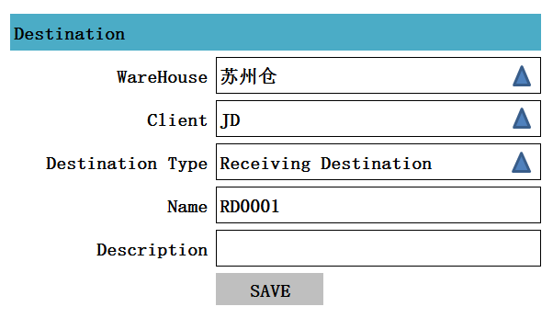

1. 功能：获得一条Destination location记录
2. 方法：

|  |
| --- |
| GET /System/ receiving destination /{id} |

4、示例：

|  |
| --- |
| {  "id": " 903747BB-57CF-4272-8582-E30E61D67DBC",  "ClientId": {  "id": " 903747BB-57CF-4272-8582-E30E61D67DBC",  "name": "京东"  },  "WarehouseId": {  "id": " 903747BB-57CF-4272-8582-E30E61D67DBC",  "name": "苏州仓"  },  "destinationType": {  "id": " 903747BB-57CF-4272-8582-E30E61D67DBC",  "name": "Receiving Destination"  },  "name": " RD0001",  "Description": " - ",  "  } |

## Edit

1. Edit页面



1. 功能：编辑一条Destination location记录
2. 方法：

|  |
| --- |
| PUT /System/Destinationlocation/{id} |

1. 输入参数

|  |  |  |  |  |
| --- | --- | --- | --- | --- |
| **参数名称** | **类型** | **是否必须** | **示例值** | **描述** |
| WareHouse_NO | String | 是 | 苏州仓 | 仓库编码 |
| Client_NO | String | 是 | JD | 客户编码 |
| Name | String | 是 | RD0001 | Destination location 名称 |
| Destination Type | String | 是 | Receiving Destination | Destination 类型 |
| Description | String | 否 | 描述信息 |  |

1. 示例：

|  |
| --- |
| {  "id": " 903747BB-57CF-4272-8582-E30E61D67DBC",  "ClientId": {  "id": " 903747BB-57CF-4272-8582-E30E61D67DBC",  "name": "京东"  },  "WarehouseId": {  "id": " 903747BB-57CF-4272-8582-E30E61D67DBC",  "name": "苏州仓"  },  "destinationType": {  "id": " 903747BB-57CF-4272-8582-E30E61D67DBC",  "name": "Receiving Destination"  },  "name": " RD0001",  "Description": " - ",  "  "VERSION" : VERSION + 1,  "ENTITY_LOCK":"100",  “CREATED_BY”: {  “id”: “0123456789abcdef0123456789abcdef”,  “username”: “admin”  },  “MODIFIED_BY”: {  “id”: “0123456789abcdef0123456789abcdef”,  “username”: “admin”  },  “MODIFIED_DATE”: “2012-01-01T12:00:00Z”,  “MODIFIED_ DATE”: “2012-01-01T12:00:00Z”  } |

## Delete

1. 功能： 删除一条Destination Location记录

2、方法：

|  |
| --- |
| DELETE /System/ Destination Location /{id} |

1. 示例

|  |
| --- |
| {  "id": " 903747BB-57CF-4272-8582-E30E61D67DBC",  "ClientId": {  "id": " 903747BB-57CF-4272-8582-E30E61D67DBC",  "name": "京东"  },  "WarehouseId": {  "id": " 903747BB-57CF-4272-8582-E30E61D67DBC",  "name": "苏州仓"  },  "destinationType": {  "id": " 903747BB-57CF-4272-8582-E30E61D67DBC",  "name": "Receiving Destination"  },  "name": " RD0001",  "Description": " - ",  "  "VERSION" : VERSION + 1,  "ENTITY_LOCK":"101",  “CREATED_BY”: {  “id”: “0123456789abcdef0123456789abcdef”,  “username”: “admin”  },  “MODIFIED_BY”: {  “id”: “0123456789abcdef0123456789abcdef”,  “username”: “admin”  },  “MODIFIED_DATE”: “2012-01-01T12:00:00Z”,  “MODIFIED_ DATE”: “2012-01-01T12:00:00Z”  } |

# SKU Type Grade

## List

1、页面

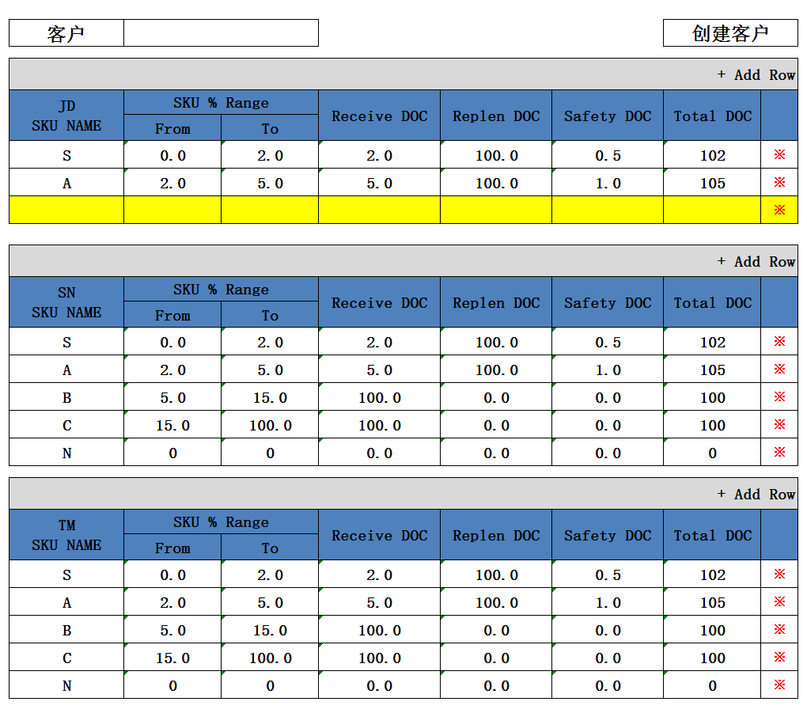

2、功能：获得所有的Items Selling Degree记录

3、方法

|  |
| --- |
| GET /System/ Items Selling Degree |

## Create客户

注释： 字段Receive DOC，Replen DOC，Safety DOC页面先保留，稍后确定是否需要

数据追加字段：RECEIVE_DOC\REPLEN_DOC\SAFETY_DOC\TOTAL_DOC

1、页面

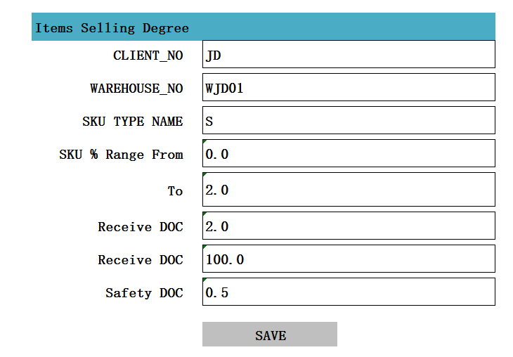

2、功能：创建一条Items Selling Degree记录

3、方法：

|  |
| --- |
| POST /System/ItemsSellingDegree |

4、输入参数

|  |  |  |  |  |
| --- | --- | --- | --- | --- |
| **参数名称** | **类型** | **是否必须** | **示例值** | **描述** |
| WareHouse_NO | String | 是 | 苏州仓 | 仓库编码 |
| Client_NO | String | 是 | JD | 客户编码 |
| SKU TYPE NAME | String | 是 | S | 名称 |
| SKU % Range From | decimal | 是 | 0.0 | 开始 |
| To | decimal | 是 | 2.0 | 结束 |
| Receive DOC | Int32 | 是 | 2.0 | 在库 |
| Replen DOC | Int32 | 是 | 100.0 | 缓冲区 |
| Safety DOC | Int32 | 是 | 0.0 | 安全天数 |

5、示例

|  |
| --- |
| {  "id": " 903747BB-57CF-4272-8582-E30E61D67DBC",  "ClientId": {  "id": " 903747BB-57CF-4272-8582-E30E61D67DBC",  "name": "京东"  },  "WarehouseId": {  "id": " 903747BB-57CF-4272-8582-E30E61D67DBC",  "name": "苏州仓"  },  SKU TYPE NAME": " S",  SKU % Range From ": " 0",  To": " 2",  Receive DOC: " 2",  Replen DOC: " 100",  Safety DOC: " 2",  "VERSION" : 1,  "ENTITY_LOCK":"100",  “CREATED_BY”: {  “id”: “0123456789abcdef0123456789abcdef”,  “username”: “admin”  },  “MODIFIED_BY”: {  “id”: “0123456789abcdef0123456789abcdef”,  “username”: “admin”  },  “MODIFIED_DATE”: “2012-01-01T12:00:00Z”,  “MODIFIED_ DATE”: “2012-01-01T12:00:00Z”  } |

## Edit

1、页面



2、功能：编辑一条Items Selling Degree记录

3、方法：

|  |
| --- |
| PUT /System/ItemsSellingDegree/{id} |

4、输入参数

|  |  |  |  |  |
| --- | --- | --- | --- | --- |
| **参数名称** | **类型** | **是否必须** | **示例值** | **描述** |
| WareHouse_NO | String | 是 | 苏州仓 | 仓库编码 |
| Client_NO | String | 是 | JD | 客户编码 |
| SKU TYPE NAME | String | 是 | S | 名称 |
| SKU % Range From | decimal | 是 | 0.0 | 开始 |
| To | decimal | 是 | 2.0 | 结束 |
| Receive DOC | Int32 | 是 | 2.0 | 在库 |
| Replen DOC | Int32 | 是 | 100.0 | 缓冲区 |
| Safety DOC | Int32 | 是 | 0.0 | 安全天数 |

5、示例

|  |
| --- |
| {  "id": " 903747BB-57CF-4272-8582-E30E61D67DBC",  "ClientId": {  "id": " 903747BB-57CF-4272-8582-E30E61D67DBC",  "name": "京东"  },  "WarehouseId": {  "id": " 903747BB-57CF-4272-8582-E30E61D67DBC",  "name": "苏州仓"  },  SKU TYPE NAME": " S",  SKU % Range From ": " 0",  To": " 2",  Receive DOC: " 2",  Replen DOC: " 100",  Safety DOC: " 2",  "VERSION" : 1,  "ENTITY_LOCK":"100",  “CREATED_BY”: {  “id”: “0123456789abcdef0123456789abcdef”,  “username”: “admin”  },  “MODIFIED_BY”: {  “id”: “0123456789abcdef0123456789abcdef”,  “username”: “admin”  },  “MODIFIED_DATE”: “2012-01-01T12:00:00Z”,  “MODIFIED_ DATE”: “2012-01-01T12:00:00Z”  } |

## Delete

1、功能：删除一条所有的Items Selling Degree记录

2、方法

|  |
| --- |
| DELETE /System/ Items Selling Degree/{id} |

# Item Units

## List

1. List页面

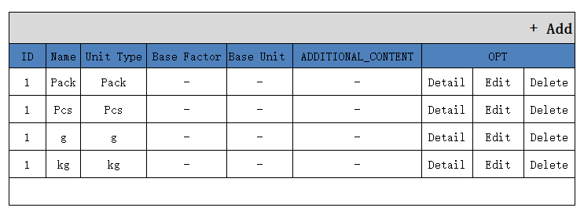

1. 功能： 显示所有Item Units记录

3、方法：

|  |
| --- |
| GET /System/ItemUnits |

1. 示例：

|  |
| --- |
| {  " ItemUnits_search response ": {  " ItemUnits_List": [  {  "id": " 903747BB-57CF-4272-8582-E30E61D67DBC",  "ClientId": {  "id": " 903747BB-57CF-4272-8582-E30E61D67DBC",  "name": "京东"  },  "WarehouseId": {  "id": " 903747BB-57CF-4272-8582-E30E61D67DBC",  "name": "苏州仓"  },  " name ": "G",  " Unit Type ": " Piece ",  "Description": " - ",  "Base Factor": " 1 ",  " Base Unit ": {  "id": " 903747BB-57CF-4272-8582-E30E61D67DBC",  "name": "g"  }  "VERSION" : 1,  "ENTITY_LOCK":"100",  “CREATED_BY”: {  “id”: “0123456789abcdef0123456789abcdef”,  “username”: “admin”  },  “MODIFIED_BY”: {  “id”: “0123456789abcdef0123456789abcdef”,  “username”: “admin”  },  “MODIFIED_DATE”: “2012-01-01T12:00:00Z”,  “MODIFIED_ DATE”: “2012-01-01T12:00:00Z”  }  ],  "total": 1,  }  } |

## Create

1、Create页面

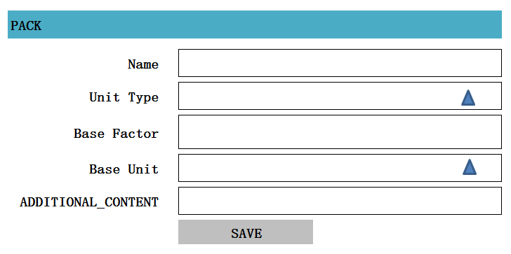

2、功能： 插入一条记ItemUnits录

3、方法：

|  |
| --- |
| POST /System/ItemUnits |

1. 输入参数

|  |  |  |  |  |
| --- | --- | --- | --- | --- |
| **参数名称** | **类型** | **是否必须** | **示例值** | **描述** |
| Name | String | 是 | Kg | 名称 |
| Unit Type | String | 是 | Piece | Unit Type |
| Base Factor | String | 否 | 1000 | 基础计量 |
| Base Unit | String | 否 | g | Unit |
| Description | String | 否 | - | 描述信息 |

5、示例：

|  |
| --- |
| {  "id": " 903747BB-57CF-4272-8582-E30E61D67DBC",  "ClientId": {  "id": " 903747BB-57CF-4272-8582-E30E61D67DBC",  "name": "京东"  },  "WarehouseId": {  "id": " 903747BB-57CF-4272-8582-E30E61D67DBC",  "name": "苏州仓"  },  " name ": "G",  " Unit Type ": " Piece ",  "Description": " - ",  "Base Factor": " 1 ",  " Base Unit ": {  “id”: “0123456789abcdef0123456789abcdef”,  “username”: “g”  },  "VERSION" : 1,  "ENTITY_LOCK":"100",  “CREATED_BY”: {  “id”: “0123456789abcdef0123456789abcdef”,  “username”: “admin”  },  “MODIFIED_BY”: {  “id”: “0123456789abcdef0123456789abcdef”,  “username”: “admin”  },  “MODIFIED_DATE”: “2012-01-01T12:00:00Z”,  “MODIFIED_ DATE”: “2012-01-01T12:00:00Z”  } |

## Detail

1. Detail页面

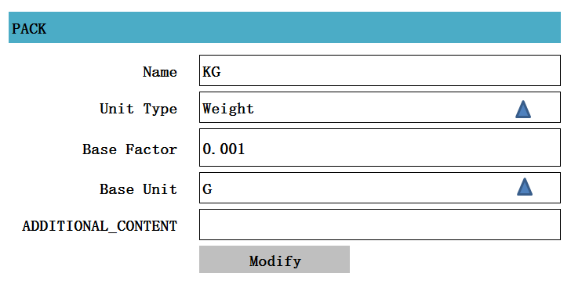

1. 功能：获得一条 ItemUnits记录
2. 方法：

|  |
| --- |
| GET /System/ ItemUnits /{id} |

4、示例：

|  |
| --- |
| {  "id": " 903747BB-57CF-4272-8582-E30E61D67DBC",  "ClientId": {  "id": " 903747BB-57CF-4272-8582-E30E61D67DBC",  "name": "京东"  },  "WarehouseId": {  "id": " 903747BB-57CF-4272-8582-E30E61D67DBC",  "name": "苏州仓"  },  " name ": "G",  " Unit Type ": " Piece ",  "Description": " - ",  "Base Factor": " 1 ",  " Base Unit ": {  “id”: “0123456789abcdef0123456789abcdef”,  “username”: “g”  },  "VERSION" : 1,  "ENTITY_LOCK":"100",  “CREATED_BY”: {  “id”: “0123456789abcdef0123456789abcdef”,  “username”: “admin”  },  “MODIFIED_BY”: {  “id”: “0123456789abcdef0123456789abcdef”,  “username”: “admin”  },  “MODIFIED_DATE”: “2012-01-01T12:00:00Z”,  “MODIFIED_ DATE”: “2012-01-01T12:00:00Z”  } |

## Edit

1. Edit页面



2、功能：修改一条Item Units记录

3、方法：

|  |
| --- |
| PUT /System/workingstation/{id} |

1. 输入参数：

|  |  |  |  |  |
| --- | --- | --- | --- | --- |
| **参数名称** | **类型** | **是否必须** | **示例值** | **描述** |
| Name | String | 是 | Kg | 名称 |
| Unit Type | String | 是 | Piece | Unit Type |
| Base Factor | String | 否 | 1000 | 基础计量 |
| Base Unit | String | 否 | g | Unit |
| Description | String | 否 | - | 描述信息 |

5、示例：

|  |
| --- |
| {  "id": " 903747BB-57CF-4272-8582-E30E61D67DBC",  "ClientId": {  "id": " 903747BB-57CF-4272-8582-E30E61D67DBC",  "name": "京东"  },  "WarehouseId": {  "id": " 903747BB-57CF-4272-8582-E30E61D67DBC",  "name": "苏州仓"  },  " name ": "G",  " Unit Type ": " Piece ",  "Description": " - ",  "Base Factor": " 1 ",  " Base Unit ": {  “id”: “0123456789abcdef0123456789abcdef”,  “username”: “g”  },  "VERSION" : VERSION + 1,  "ENTITY_LOCK":"100",  “CREATED_BY”: {  “id”: “0123456789abcdef0123456789abcdef”,  “username”: “admin”  },  “MODIFIED_BY”: {  “id”: “0123456789abcdef0123456789abcdef”,  “username”: “admin”  },  “MODIFIED_DATE”: “2012-01-01T12:00:00Z”,  “MODIFIED_ DATE”: “2012-01-01T12:00:00Z”  } |

## Delete

1. 功能： 删除一条Item Units记录

2、方法：

|  |
| --- |
| DELETE /System/ItemUnits/{id} |

1. 示例

|  |
| --- |
| {  "id": " 903747BB-57CF-4272-8582-E30E61D67DBC",  "ClientId": {  "id": " 903747BB-57CF-4272-8582-E30E61D67DBC",  "name": "京东"  },  "WarehouseId": {  "id": " 903747BB-57CF-4272-8582-E30E61D67DBC",  "name": "苏州仓"  },  " name ": "G",  " Unit Type ": " Piece ",  "Description": " - ",  "Base Factor": " 1 ",  " Base Unit ": {  “id”: “0123456789abcdef0123456789abcdef”,  “username”: “g”  },  "VERSION" : VERSION + 1,  "ENTITY_LOCK":"101",  “CREATED_BY”: {  “id”: “0123456789abcdef0123456789abcdef”,  “username”: “admin”  },  “MODIFIED_BY”: {  “id”: “0123456789abcdef0123456789abcdef”,  “username”: “admin”  },  “MODIFIED_DATE”: “2012-01-01T12:00:00Z”,  “MODIFIED_ DATE”: “2012-01-01T12:00:00Z”  } |

# BOM【Bills of Material】

## List

1. List页面初始化

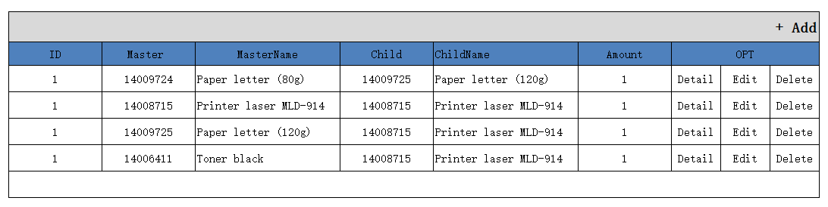

1. 功能：显示所有BOMS记录
2. 方法：

|  |
| --- |
| GET /System/BOMS |

1. 示例：

|  |
| --- |
| {  "boms_search response ": {  "boms_List": [  {  "id": " 903747BB-57CF-4272-8582-E30E61D67DBC",  "PARENT_ID": {  "id": " 903747BB-57CF-4272-8582-E30E61D67DBC",  "name": "KG"  },  "Child": {  "id": " 903747BB-57CF-4272-8582-E30E61D67DBC",  "name": "Pallet"  },  "Amount ": "0",  "Order-Index": "0",  "Additional content": "-",  }],  "total": 1,  }  } |

## Create

1. Create页面

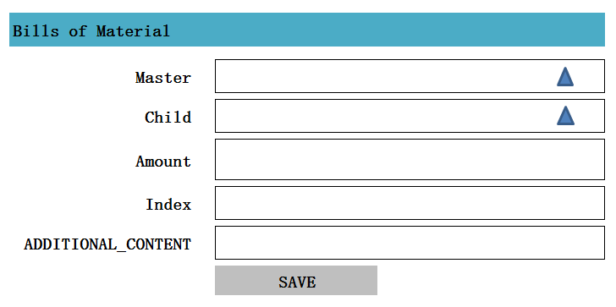

1. 功能： 创建一个BOM记录
2. 方法：

|  |
| --- |
| POST /System/BOM |

1. 输入参数：

|  |  |  |  |  |
| --- | --- | --- | --- | --- |
| **参数名称** | **类型** | **是否必须** | **示例值** | **描述** |
| ~~CLIENT_ID~~ | ~~String~~ | ~~是~~ | ~~京东~~ | ~~客户名称~~ |
| ~~WareHouse_ID~~ | ~~String~~ | ~~是~~ | ~~仓库1~~ | ~~仓库名称~~ |
| parent | String | 是 | 10002830 | 主Item Data |
| Child | String | 是 | 10002830 | 子Item Data |
| Amount | String | 是 | 0 | 数量 |
| Index | String | 是 | 100 | 百分百 |
| additional content | String | 否 | MEMO | 备注 |

1. 示例：

|  |
| --- |
| {  "id": " 903747BB-57CF-4272-8582-E30E61D67DBC",  " PARENT_ID": {  "id": " 903747BB-57CF-4272-8582-E30E61D67DBC",  "name": "KG"  },  "Child_ID ": {  "id": " 903747BB-57CF-4272-8582-E30E61D67DBC",  "name": "Pallet"  },  "Amount ": "0",  "Index": "0",  "Additional content": "-",  "VERSION" : 1,  “CREATED_BY”: {  “id”: “0123456789abcdef0123456789abcdef”,  “username”: “admin”  },  “MODIFIED_BY”: {  “id”: “0123456789abcdef0123456789abcdef”,  “username”: “admin”  },  “MODIFIED_DATE”: “2012-01-01T12:00:00Z”,  “MODIFIED_ DATE”: “2012-01-01T12:00:00Z”  } |

## Detail

1. Detail页面

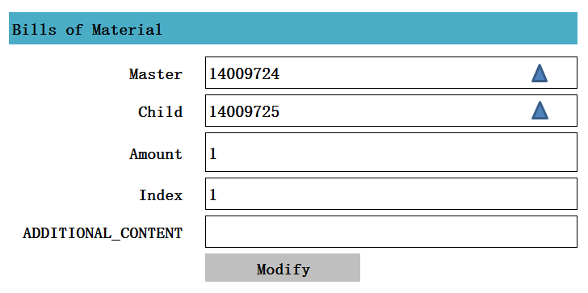

1. 功能：
2. 方法

|  |
| --- |
| GET /System/ Bom/{id} |

1. 示例

|  |
| --- |
| {  "id": " 903747BB-57CF-4272-8582-E30E61D67DBC",  " PARENT_ID ": {  "id": " 903747BB-57CF-4272-8582-E30E61D67DBC",  "name": "KG"  },  "Child": {  "id": " 903747BB-57CF-4272-8582-E30E61D67DBC",  "name": "Pallet"  },  "Amount ": "0",  "Index": "0",  "Additional content": "-",  } |

## Edit

1. Edit页面
2. 功能：编辑一条BOM记录
3. 方法

|  |
| --- |
| PUT /System/BOM/{id} |

1. 输入参数

|  |  |  |  |  |
| --- | --- | --- | --- | --- |
| **参数名称** | **类型** | **是否必须** | **示例值** | **描述** |
| PARENT_ID | String | 是 | 10002830 | 主Item Data |
| Child_ID | String | 是 | 10002830 | 子Item Data |
| Amount | String | 是 | 0 | 数量 |
| Index | String | 是 | 100 | 百分百 |
| additional content | String | 否 | MEMO | 备注 |

1. 示例

|  |
| --- |
| {  "id": " 903747BB-57CF-4272-8582-E30E61D67DBC",  " PARENT_ID ": {  "id": " 903747BB-57CF-4272-8582-E30E61D67DBC",  "name": "KG"  },  "Child_ID": {  "id": " 903747BB-57CF-4272-8582-E30E61D67DBC",  "name": "Pallet"  },  "Amount ": "0",  "Index": "0",  "Additional content": "-",  "VERSION" : VERSION + 1,  “CREATED_BY”: {  “id”: “0123456789abcdef0123456789abcdef”,  “username”: “admin”  },  “MODIFIED_BY”: {  “id”: “0123456789abcdef0123456789abcdef”,  “username”: “admin”  },  “MODIFIED_DATE”: “2012-01-01T12:00:00Z”,  “MODIFIED_ DATE”: “2012-01-01T12:00:00Z”  } |

## Delete

1. 功能：删除一条BOM记录

2、方法：

|  |
| --- |
| DELETE /System/BOM/{id} |

3、示例：

|  |
| --- |
| {  "id": " 903747BB-57CF-4272-8582-E30E61D67DBC",  " PARENT_ID ": {  "id": " 903747BB-57CF-4272-8582-E30E61D67DBC",  "name": "KG"  },  "Child_ID": {  "id": " 903747BB-57CF-4272-8582-E30E61D67DBC",  "name": "Pallet"  },  "Amount ": "0",  "Index": "0",  "Additional content": "-",  "VERSION" : VERSION + 1,  “CREATED_BY”: {  “id”: “0123456789abcdef0123456789abcdef”,  “username”: “admin”  },  “MODIFIED_BY”: {  “id”: “0123456789abcdef0123456789abcdef”,  “username”: “admin”  },  “MODIFIED_DATE”: “2012-01-01T12:00:00Z”,  “MODIFIED_ DATE”: “2012-01-01T12:00:00Z”  } |

# Item Group

## List

1、页面

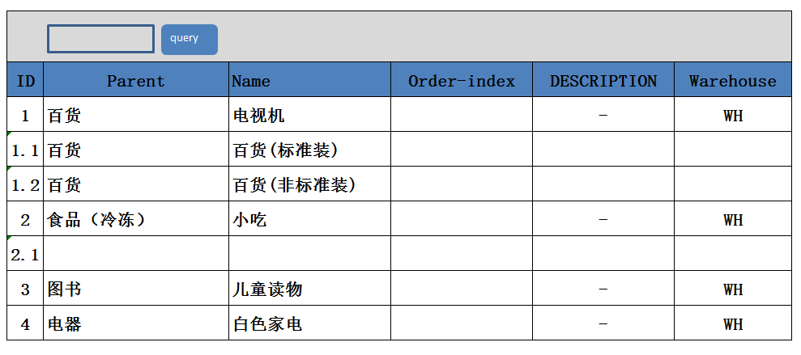

2、功能：获得所有Item Group列表

3、方法：

|  |
| --- |
| GET /System/Item Group |

## Create

1、页面

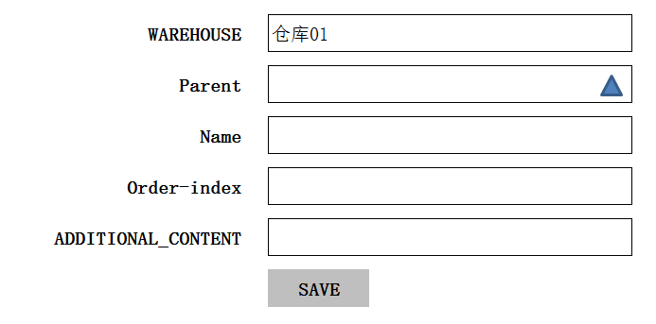

2、功能：新建一条Item Group记录

3、方法：

|  |
| --- |
| POST /System/Item Group |

## Edit

## Detail

## Delete

# Drop Zone

## List

1、页面

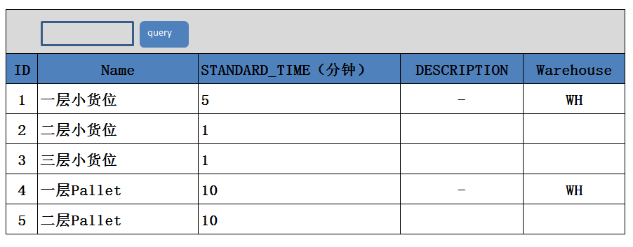

2、功能：获得所有DropZone列表

3、方法：

|  |
| --- |
| GET /System/DropZone |

## Create

1、页面

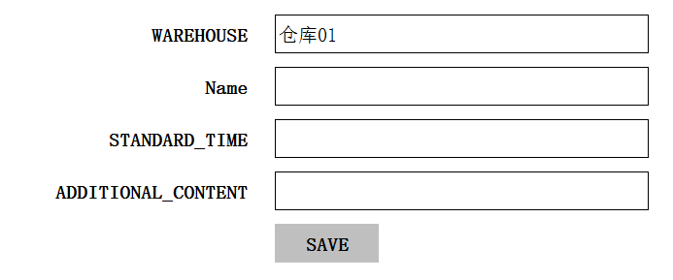

2、功能：新建一条DropZone记录

3、方法：

|  |
| --- |
| POST /System/DropZone |

## Edit

## Detail

## Delete

# Zone-ItemGroup

## List

1、页面

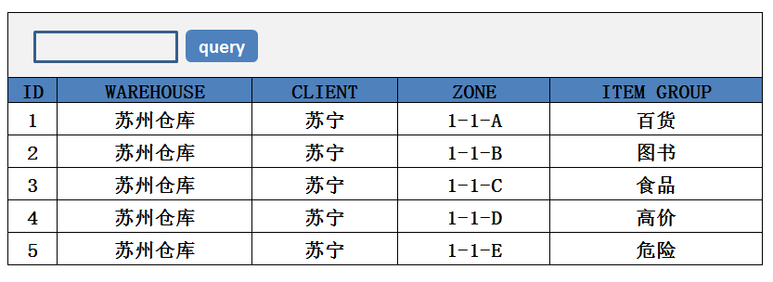

2、功能：获得所有Zone-ItemGroup列表

3、方法：

|  |
| --- |
| GET /System/ ZoneItemGroup |

## Create

1、页面

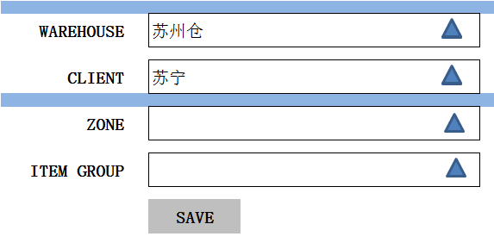

2、功能：新建一条Zone-ItemGroup记录

3、方法：

|  |
| --- |
| POST /System/ Zone-ItemGroup |

## Edit

## Detail

## Delete

# STORAGELOCATION_ITEMSELLINGDEGREE

## List

1、页面

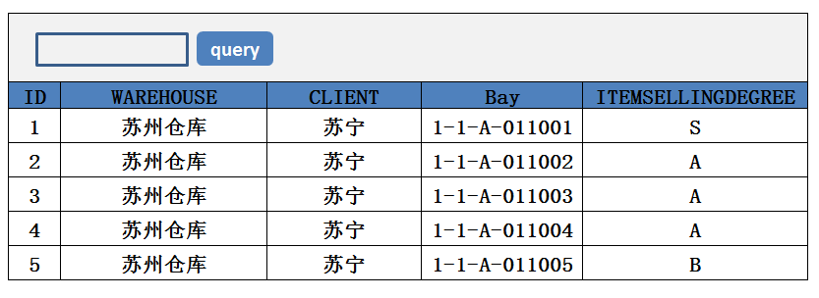

2、功能：获得所有STORAGELOCATION_ITEMSELLINGDEGREE列表

3、方法：

|  |
| --- |
| GET /System/STORAGELOCATION_ITEMSELLINGDEGREE |

## Create

1、页面

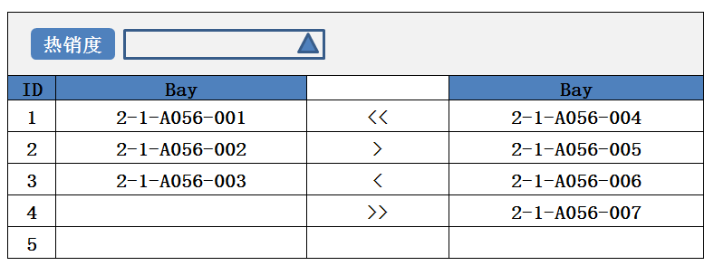

2、功能：新建一条STORAGELOCATION_ITEMSELLINGDEGREE记录

3、方法：

|  |
| --- |
| POST /System/ STORAGELOCATION_ITEMSELLINGDEGREE |

## Edit

## Detail

## Delete

# Item Data Group

## List

1. 页面初始化

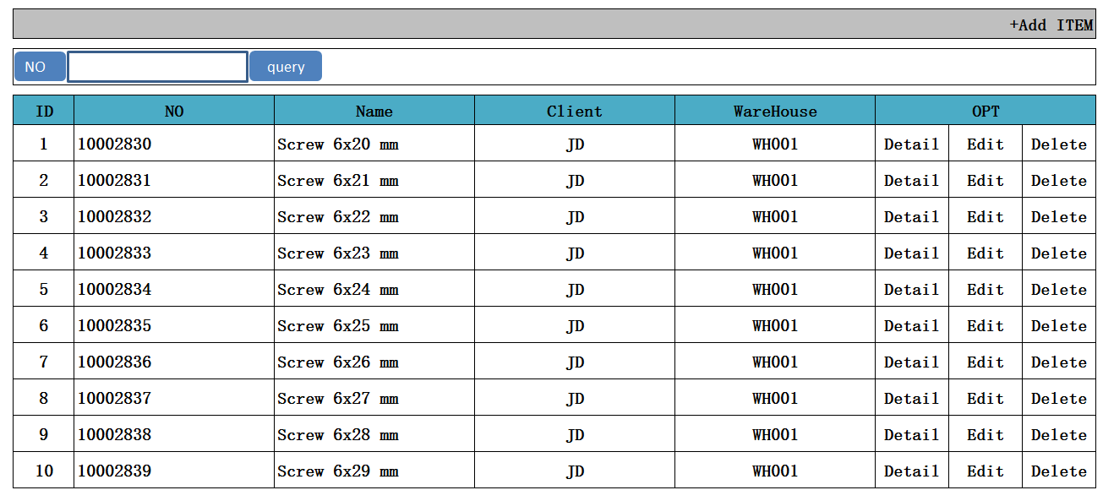

1. 功能：显示所有Item Data Group记录
2. 方法：

|  |
| --- |
| GET /System/ ItemDatas Group |

1. 示例

|  |
| --- |
| {  " ItemDatas_search response ": {  " ItemDatas_List": [  {  "id": " 903747BB-57CF-4272-8582-E30E61D67DBC",  "ClientId": {  "id": " 903747BB-57CF-4272-8582-E30E61D67DBC",  "name": "京东"  },  "WarehouseId": {  "id": " 903747BB-57CF-4272-8582-E30E61D67DBC",  "name": "苏州仓"  },  "number": " 10002830",  "name": " Screw 6x20 mm ",  "Description": " Screw 6x20 mm ",  "Safety Stock": " 0",  "Default Unit Load Type": {  "id": " 903747BB-57CF-4272-8582-E30E61D67DBC",  "name": " Box 60x40"  },  " Trade Group ": " Examplematerial ",  " EAN-Codes ": {  "id": " 903747BB-57CF-4272-8582-E30E61D67DBC",  "name": "EN"  },  " Zone ": {  "id": " 903747BB-57CF-4272-8582-E30E61D67DBC",  "name": "Pallet A01 "  },  "Advice Mandatory": False,  "Lot Mandatory ":False,  " Lot Substitution": {  "id": " 903747BB-57CF-4272-8582-E30E61D67DBC",  "name": " NOT ALLOWED "  },  " Residual term of usage (GI)":0,  " Serial Record ": {  "id": " 903747BB-57CF-4272-8582-E30E61D67DBC",  "name": " NO RECORD "  },  "Number of Decimals": 0,  " Handling Unit ": {  "id": " 903747BB-57CF-4272-8582-E30E61D67DBC",  "name": " g "  },  "Height": " 0 "  "Width": " 0 "  "Depth": " 0 "  "Weight": " 0 "  "additional content": "-",  "VERSION" : 1,  “CREATED_BY”: {  “id”: “0123456789abcdef0123456789abcdef”,  “username”: “admin”  },  “MODIFIED_BY”: {  “id”: “0123456789abcdef0123456789abcdef”,  “username”: “admin”  },  “MODIFIED_DATE”: “2012-01-01T12:00:00Z”,  “MODIFIED_ DATE”: “2012-01-01T12:00:00Z”  }  ],  "total": 1,  }  } |

## Create

1. Create页面

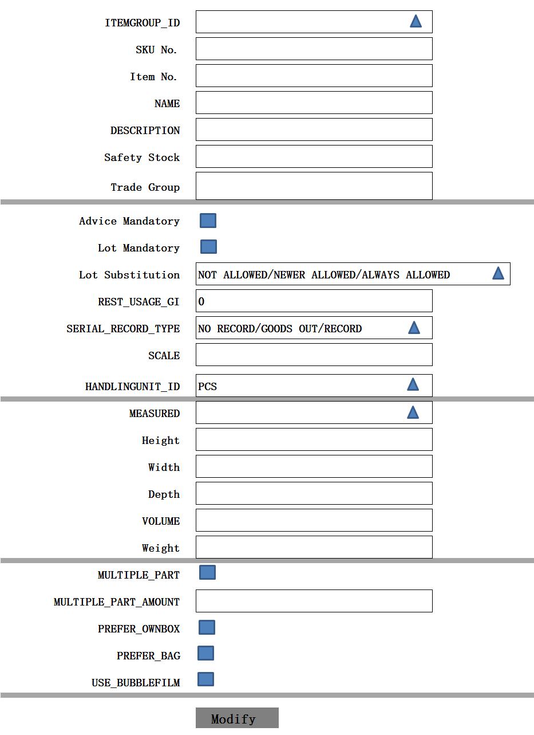

1. 功能： 新增一条Item Data记录
2. 方法：

|  |
| --- |
| POST /System/ItemData |

1. 输入参数

|  |  |  |  |  |
| --- | --- | --- | --- | --- |
| **参数名称** | **类型** | **是否必须** | **示例值** | **描述** |
| CLIENT_ID | String | 是 | 京东 | 客户名称 |
| WareHouse_ID | String | 是 | 仓库1 | 仓库名称 |
| Name | String | 是 | Screw 6x20 mm | 名称 |
| No | String | 是 | 10002830 | 编号 |
| New No | String | 是 | 10002830 | 牧星编号：  【ITEMDATA_NUMBER】【ITEMDATA_NO】 |
| Description | String | 是 | Screw 6x20 mm | 描述 |
| Default Unit Load Type | String | 是 | Box 60x40 | Unit Load Type |
| Trade Group | String | 否 | -- | 贸易Group |
| ~~EAN-Codes~~ | String | 否 | -- | 英文名称 |
| ~~Zone~~ | ~~String~~ | ~~是~~ | ~~Pallet A01~~ | ~~Zone~~ |
| ~~Advice Mandatory~~ | ~~bit~~ | ~~否~~ |  | ~~建议强制~~ |
| Lot Mandatory | bit | 否 |  | LOT强制性的【改为有效期检查】 |
| Lot Substitution | String | 否 | NOT ALLOWED | 很多替代 |
| S~~erial Record~~ | String | 否 | NO RECORD | 串行记录 |
| Residual term of usage (GI) | decimal | 否 | 0 | 剩余使用期限（地理标志） |
| Number of Decimals | decimal | 否 | 0 | 小数 |
| Handling Unit | String | 否 | KG | Handling Unit |
| Measurement Mandatory | String | 是 | 1 | 0：未测量状态  1：测量完成  2：测量中  3：异常状态 |
| Height | decimal | 否 | 100 | 高度 |
| Width | decimal | 否 | 100 | 宽度 |
| Depth | decimal | 否 | 100 | 深度 |
| Weight | decimal | 否 | 2（吨） | 起重重量 |
| additional content | String | 否 | MEMO | 备注 |
| Flag | String | 是 | S/N | 热销程度 |
| Mark | String | 是 | 0 | 危险程度 |
| Scale | Int |  |  | 规模 |

备注：

Item Data 中的New No，存放到数据表ITEMDATA_NUMBER中的ITEMDATA_NO值

1. 示例：

|  |
| --- |
| {  "id": " 903747BB-57CF-4272-8582-E30E61D67DBC",  "ClientId": {  "id": " 903747BB-57CF-4272-8582-E30E61D67DBC",  "name": "京东"  },  "WarehouseId": {  "id": " 903747BB-57CF-4272-8582-E30E61D67DBC",  "name": "苏州仓"  },  "number": " 10002830",  "name": " Screw 6x20 mm ",  "Description": " Screw 6x20 mm ",  "Safety Stock": " 0",  "Default Unit Load Type": {  "id": " 903747BB-57CF-4272-8582-E30E61D67DBC",  "name": " Box 60x40"  },  " Trade Group ": " Examplematerial ",  " EAN-Codes ": {  "id": " 903747BB-57CF-4272-8582-E30E61D67DBC",  "name": "EN"  },  " Zone ": {  "id": " 903747BB-57CF-4272-8582-E30E61D67DBC",  "name": "Pallet A01 "  },  "Advice Mandatory": False,  "Lot Mandatory ":False,  " Lot Substitution": {  "id": " 903747BB-57CF-4272-8582-E30E61D67DBC",  "name": " NOT ALLOWED "  },  " Residual term of usage (GI)":0,  " Serial Record ": {  "id": " 903747BB-57CF-4272-8582-E30E61D67DBC",  "name": " NO RECORD "  },  "Number of Decimals": 0,  " Handling Unit ": {  "id": " 903747BB-57CF-4272-8582-E30E61D67DBC",  "name": " g "  },  "Height": " 0 "  "Width": " 0 "  "Depth": " 0 "  "Weight": " 0 "  "additional content": "-",  "VERSION" : 1,  “CREATED_BY”: {  “id”: “0123456789abcdef0123456789abcdef”,  “username”: “admin”  },  “MODIFIED_BY”: {  “id”: “0123456789abcdef0123456789abcdef”,  “username”: “admin”  },  “MODIFIED_DATE”: “2012-01-01T12:00:00Z”,  “MODIFIED_ DATE”: “2012-01-01T12:00:00Z”  } |

## Detail

1. Detail页面

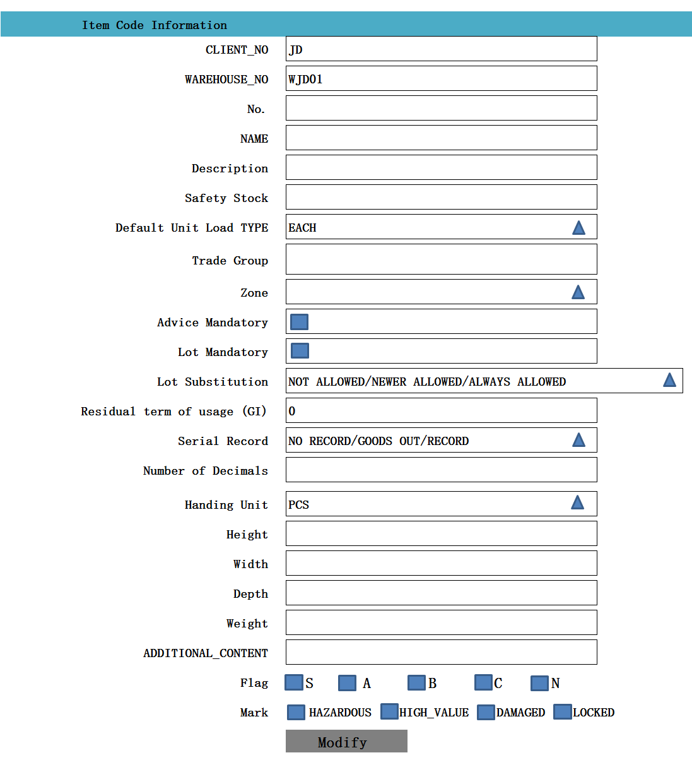

1. 功能：获取一条Item Data记录
2. 方法：

|  |
| --- |
| GET /System/ Item Data /{id} |

1. 示例：

|  |
| --- |
| {  "id": " 903747BB-57CF-4272-8582-E30E61D67DBC",  "ClientId": {  "id": " 903747BB-57CF-4272-8582-E30E61D67DBC",  "name": "京东"  },  "WarehouseId": {  "id": " 903747BB-57CF-4272-8582-E30E61D67DBC",  "name": "苏州仓"  },  "number": " 10002830",  "name": " Screw 6x20 mm ",  "Description": " Screw 6x20 mm ",  "Safety Stock": " 0",  "Default Unit Load Type": {  "id": " 903747BB-57CF-4272-8582-E30E61D67DBC",  "name": " Box 60x40"  },  " Trade Group ": " Examplematerial ",  " EAN-Codes ": {  "id": " 903747BB-57CF-4272-8582-E30E61D67DBC",  "name": "EN"  },  " Zone ": {  "id": " 903747BB-57CF-4272-8582-E30E61D67DBC",  "name": "Pallet A01 "  },  "Advice Mandatory": False,  "Lot Mandatory ":False,  " Lot Substitution": {  "id": " 903747BB-57CF-4272-8582-E30E61D67DBC",  "name": " NOT ALLOWED "  },  " Residual term of usage (GI)":0,  " Serial Record ": {  "id": " 903747BB-57CF-4272-8582-E30E61D67DBC",  "name": " NO RECORD "  },  "Number of Decimals": 0,  " Handling Unit ": {  "id": " 903747BB-57CF-4272-8582-E30E61D67DBC",  "name": " g "  },  "Height": " 0 "  "Width": " 0 "  "Depth": " 0 "  "Weight": " 0 "  "additional content": "-",  "VERSION" : 1,  “CREATED_BY”: {  “id”: “0123456789abcdef0123456789abcdef”,  “username”: “admin”  },  “MODIFIED_BY”: {  “id”: “0123456789abcdef0123456789abcdef”,  “username”: “admin”  },  “MODIFIED_DATE”: “2012-01-01T12:00:00Z”,  “MODIFIED_ DATE”: “2012-01-01T12:00:00Z”  } |

## Edit

1. Edit页面

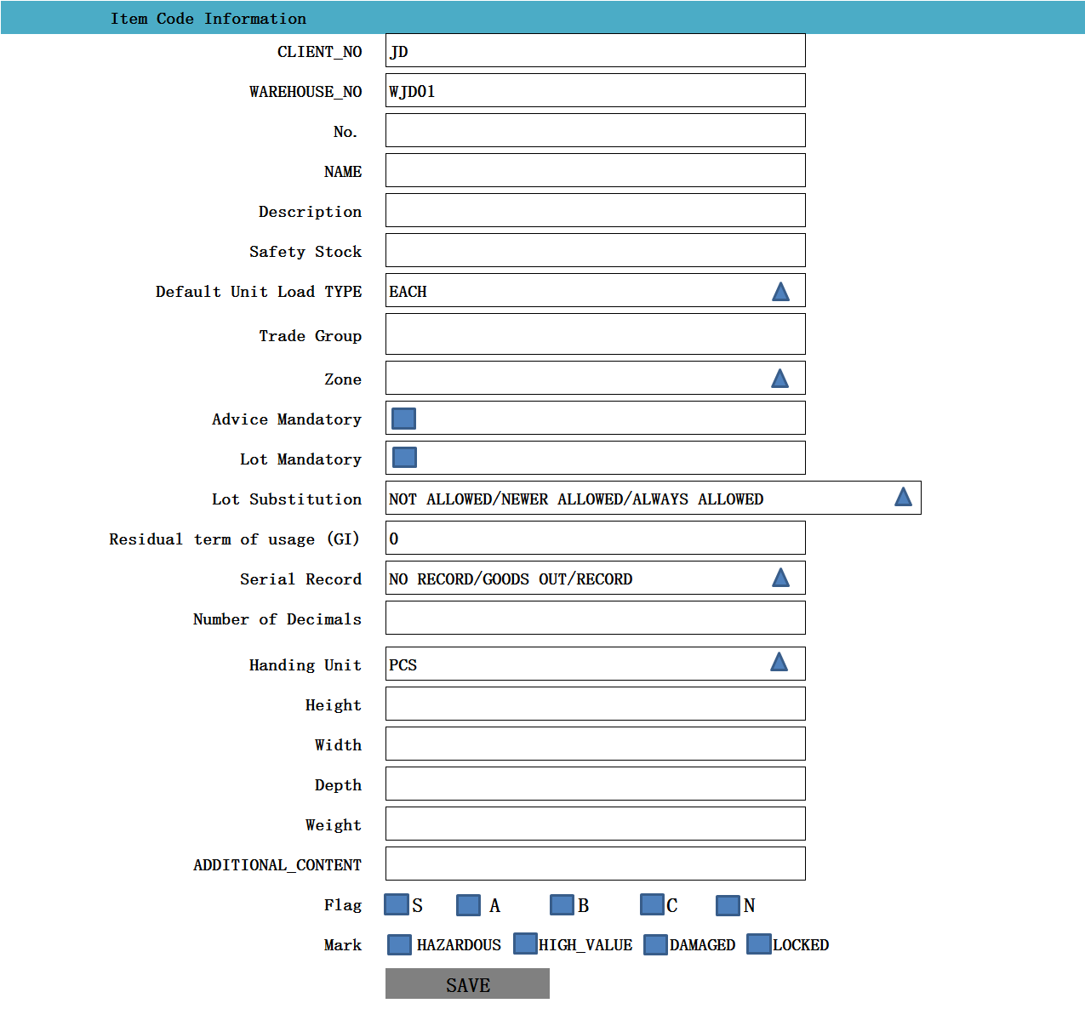

1. 功能：修改一条Item Data记录
2. 方法：

|  |
| --- |
| PUT /System/Item Data/{id} |

1. 输入参数

|  |  |  |  |  |
| --- | --- | --- | --- | --- |
| **参数名称** | **类型** | **是否必须** | **示例值** | **描述** |
| CLIENT_ID | String | 是 | 京东 | 客户名称 |
| WareHouse_ID | String | 是 | 仓库1 | 仓库名称 |
| Name | String | 是 | Screw 6x20 mm | 名称 |
| number | String | 是 | 10002830 | 编号 |
| Description | String | 是 | Screw 6x20 mm | 描述 |
| Default Unit Load Type | String | 是 | Box 60x40 | Unit Load Type |
| Trade Group | String | 否 | -- | Trade Group |
| EAN-Codes | String | 否 | -- | 英文名称 |
| Zone | String | 是 | Pallet A01 | Zone |
| Advice Mandatory | bit | 否 |  | 建议强制 |
| Lot Mandatory | bit | 否 |  | 很多强制性的 |
| Lot Substitution | String | 否 | NOT ALLOWED | 很多替代 |
| Serial Record | String | 否 | NO RECORD | 串行记录 |
| Residual term of usage (GI) | decimal | 否 | 0 | 剩余使用期限（地理标志） |
| Number of Decimals | decimal | 否 | 0 | 小数 |
| Handling Unit | String | 否 | KG | Handling Unit |
| Measurement Mandatory | String | 是 | 1 | 0：未测量状态  1：测量完成  2：测量中  3：异常状态 |
| Height | decimal | 否 | 100 | 高度 |
| Width | decimal | 否 | 100 | 宽度 |
| Depth | decimal | 否 | 100 | 深度 |
| Weight | decimal | 否 | 2（吨） | 起重重量 |
| additional content | String | 否 | MEMO | 备注 |
| Flag | String | 是 | S/N | 热销程度 |
| Mark | String | 是 | 0 | 危险程度 |

1. 示例

|  |
| --- |
| {  "id": " 903747BB-57CF-4272-8582-E30E61D67DBC",  "ClientId": {  "id": " 903747BB-57CF-4272-8582-E30E61D67DBC",  "name": "京东"  },  "WarehouseId": {  "id": " 903747BB-57CF-4272-8582-E30E61D67DBC",  "name": "苏州仓"  },  "number": " 10002830",  "name": " Screw 6x20 mm ",  "Description": " Screw 6x20 mm ",  "Safety Stock": " 0",  "Default Unit Load Type": {  "id": " 903747BB-57CF-4272-8582-E30E61D67DBC",  "name": " Box 60x40"  },  " Trade Group ": " Examplematerial ",  " EAN-Codes ": {  "id": " 903747BB-57CF-4272-8582-E30E61D67DBC",  "name": "EN"  },  " Zone ": {  "id": " 903747BB-57CF-4272-8582-E30E61D67DBC",  "name": "Pallet A01 "  },  "Advice Mandatory": False,  "Lot Mandatory ":False,  " Lot Substitution": {  "id": " 903747BB-57CF-4272-8582-E30E61D67DBC",  "name": " NOT ALLOWED "  },  " Residual term of usage (GI)":0,  " Serial Record ": {  "id": " 903747BB-57CF-4272-8582-E30E61D67DBC",  "name": " NO RECORD "  },  "Number of Decimals": 0,  " Handling Unit ": {  "id": " 903747BB-57CF-4272-8582-E30E61D67DBC",  "name": " g "  },  "Height": " 0 "  "Width": " 0 "  "Depth": " 0 "  "Weight": " 0 "  "additional content": "-",  "VERSION" : VERSION + 1,  “CREATED_BY”: {  “id”: “0123456789abcdef0123456789abcdef”,  “username”: “admin”  },  “MODIFIED_BY”: {  “id”: “0123456789abcdef0123456789abcdef”,  “username”: “admin”  },  “MODIFIED_DATE”: “2012-01-01T12:00:00Z”,  “MODIFIED_ DATE”: “2012-01-01T12:00:00Z”  } |

## Delete

1. 功能：删除一条ItemDate记录
2. 方法：

|  |
| --- |
| DELETE /System/ItemUnits/{id} |

1. 示例：

|  |
| --- |
| {  "id": " 903747BB-57CF-4272-8582-E30E61D67DBC",  "ClientId": {  "id": " 903747BB-57CF-4272-8582-E30E61D67DBC",  "name": "京东"  },  "WarehouseId": {  "id": " 903747BB-57CF-4272-8582-E30E61D67DBC",  "name": "苏州仓"  },  "name": " KG",  "UnitType": {  "id": " 903747BB-57CF-4272-8582-E30E61D67DBC",  "name": "KG"  },  "Type": {  "id": " 903747BB-57CF-4272-8582-E30E61D67DBC",  "name": "Pallet"  },  "Ares": {  "id": " 903747BB-57CF-4272-8582-E30E61D67DBC",  "name": "Store"  },  "Location Cluster": {  "id": " 903747BB-57CF-4272-8582-E30E61D67DBC",  "name": "Big Pallet"  },  "Zone": {  "id": " 903747BB-57CF-4272-8582-E30E61D67DBC",  "name": "Pallet_Zone01"  },  "X": "0",  "Y": "0",  "Z": "0",  "Field": "0",  "Field-Index": "0",  "Order-Index": "0",  "Allocation (%)": "-",  "Capacity": {  "id": " 903747BB-57CF-4272-8582-E30E61D67DBC",  "name": "EURO"  },  "Unit Loads": {  "id": " 903747BB-57CF-4272-8582-E30E61D67DBC",  "name": "000000001"  },  "Last Stocktaking": "-",  "additional content": "-",  "VERSION" : VERSION + 1,  “CREATED_BY”: {  “id”: “0123456789abcdef0123456789abcdef”,  “username”: “admin”  },  “MODIFIED_BY”: {  “id”: “0123456789abcdef0123456789abcdef”,  “username”: “admin”  },  “MODIFIED_DATE”: “2012-01-01T12:00:00Z”,  “MODIFIED_ DATE”: “2012-01-01T12:00:00Z”  } |

# Item Data

## List

1. 页面初始化



1. 功能：显示所有Item Data记录
2. 方法：

|  |
| --- |
| GET /System/ ItemDatas |

1. 示例

|  |
| --- |
| {  " ItemDatas_search response ": {  " ItemDatas_List": [  {  "id": " 903747BB-57CF-4272-8582-E30E61D67DBC",  "ClientId": {  "id": " 903747BB-57CF-4272-8582-E30E61D67DBC",  "name": "京东"  },  "WarehouseId": {  "id": " 903747BB-57CF-4272-8582-E30E61D67DBC",  "name": "苏州仓"  },  "number": " 10002830",  "name": " Screw 6x20 mm ",  "Description": " Screw 6x20 mm ",  "Safety Stock": " 0",  "Default Unit Load Type": {  "id": " 903747BB-57CF-4272-8582-E30E61D67DBC",  "name": " Box 60x40"  },  " Trade Group ": " Examplematerial ",  " EAN-Codes ": {  "id": " 903747BB-57CF-4272-8582-E30E61D67DBC",  "name": "EN"  },  " Zone ": {  "id": " 903747BB-57CF-4272-8582-E30E61D67DBC",  "name": "Pallet A01 "  },  "Advice Mandatory": False,  "Lot Mandatory ":False,  " Lot Substitution": {  "id": " 903747BB-57CF-4272-8582-E30E61D67DBC",  "name": " NOT ALLOWED "  },  " Residual term of usage (GI)":0,  " Serial Record ": {  "id": " 903747BB-57CF-4272-8582-E30E61D67DBC",  "name": " NO RECORD "  },  "Number of Decimals": 0,  " Handling Unit ": {  "id": " 903747BB-57CF-4272-8582-E30E61D67DBC",  "name": " g "  },  "Height": " 0 "  "Width": " 0 "  "Depth": " 0 "  "Weight": " 0 "  "additional content": "-",  "VERSION" : 1,  “CREATED_BY”: {  “id”: “0123456789abcdef0123456789abcdef”,  “username”: “admin”  },  “MODIFIED_BY”: {  “id”: “0123456789abcdef0123456789abcdef”,  “username”: “admin”  },  “MODIFIED_DATE”: “2012-01-01T12:00:00Z”,  “MODIFIED_ DATE”: “2012-01-01T12:00:00Z”  }  ],  "total": 1,  }  } |

## Create

1. Create页面

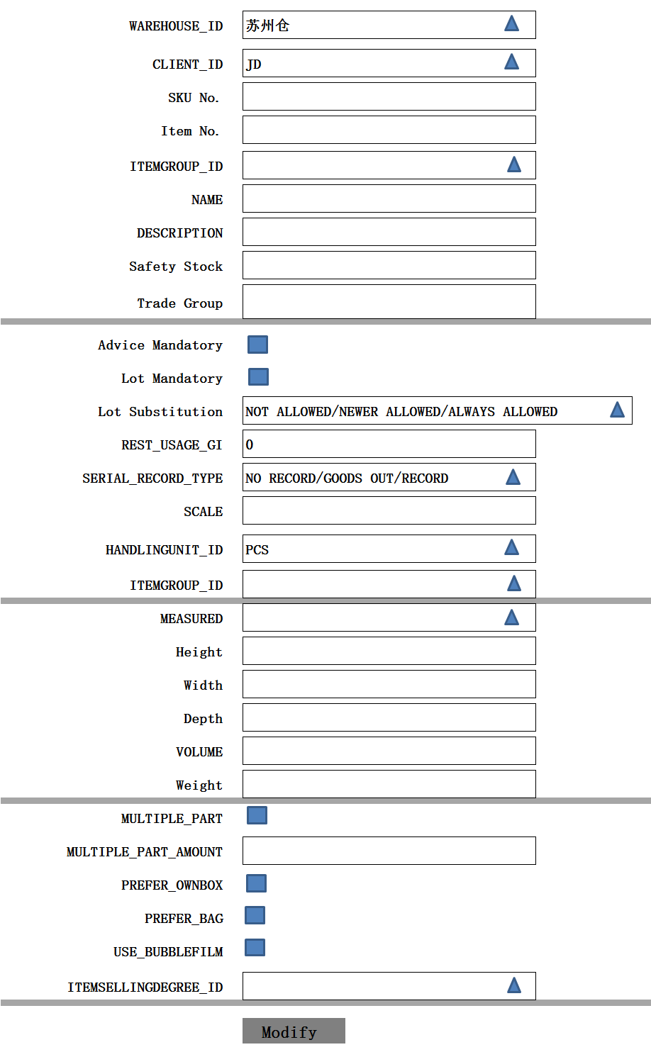

注释：红色框内itemdata与itemdata Group区别点

1. 功能： 新增一条Item Data记录
2. 方法：

|  |
| --- |
| POST /System/ItemData |

1. 输入参数

|  |  |  |  |  |
| --- | --- | --- | --- | --- |
| **参数名称** | **类型** | **是否必须** | **示例值** | **描述** |
| CLIENT_ID | String | 是 | 京东 | 客户名称 |
| WareHouse_ID | String | 是 | 仓库1 | 仓库名称 |
| Name | String | 是 | Screw 6x20 mm | 名称 |
| No | String | 是 | 10002830 | 编号 |
| New No | String | 是 | 10002830 | 牧星编号：  【ITEMDATA_NUMBER】【ITEMDATA_NO】 |
| Description | String | 是 | Screw 6x20 mm | 描述 |
| Default Unit Load Type | String | 是 | Box 60x40 | Unit Load Type |
| Trade Group | String | 否 | -- | 贸易Group |
| ~~EAN-Codes~~ | String | 否 | -- | 英文名称 |
| ~~Zone~~ | ~~String~~ | ~~是~~ | ~~Pallet A01~~ | ~~Zone~~ |
| ~~Advice Mandatory~~ | ~~bit~~ | ~~否~~ |  | ~~建议强制~~ |
| Lot Mandatory | bit | 否 |  | LOT强制性的【改为有效期检查】 |
| Lot Substitution | String | 否 | NOT ALLOWED | 很多替代 |
| S~~erial Record~~ | String | 否 | NO RECORD | 串行记录 |
| Residual term of usage (GI) | decimal | 否 | 0 | 剩余使用期限（地理标志） |
| Number of Decimals | decimal | 否 | 0 | 小数 |
| Handling Unit | String | 否 | KG | Handling Unit |
| Measurement Mandatory | String | 是 | 1 | 0：未测量状态  1：测量完成  2：测量中  3：异常状态 |
| Height | decimal | 否 | 100 | 高度 |
| Width | decimal | 否 | 100 | 宽度 |
| Depth | decimal | 否 | 100 | 深度 |
| Weight | decimal | 否 | 2（吨） | 起重重量 |
| additional content | String | 否 | MEMO | 备注 |
| Flag | String | 是 | S/N | 热销程度 |
| Mark | String | 是 | 0 | 危险程度 |
| Scale | Int |  |  | 规模 |

备注：

Item Data 中的New No，存放到数据表ITEMDATA_NUMBER中的ITEMDATA_NO值

1. 示例：

|  |
| --- |
| {  "id": " 903747BB-57CF-4272-8582-E30E61D67DBC",  "ClientId": {  "id": " 903747BB-57CF-4272-8582-E30E61D67DBC",  "name": "京东"  },  "WarehouseId": {  "id": " 903747BB-57CF-4272-8582-E30E61D67DBC",  "name": "苏州仓"  },  "number": " 10002830",  "name": " Screw 6x20 mm ",  "Description": " Screw 6x20 mm ",  "Safety Stock": " 0",  "Default Unit Load Type": {  "id": " 903747BB-57CF-4272-8582-E30E61D67DBC",  "name": " Box 60x40"  },  " Trade Group ": " Examplematerial ",  " EAN-Codes ": {  "id": " 903747BB-57CF-4272-8582-E30E61D67DBC",  "name": "EN"  },  " Zone ": {  "id": " 903747BB-57CF-4272-8582-E30E61D67DBC",  "name": "Pallet A01 "  },  "Advice Mandatory": False,  "Lot Mandatory ":False,  " Lot Substitution": {  "id": " 903747BB-57CF-4272-8582-E30E61D67DBC",  "name": " NOT ALLOWED "  },  " Residual term of usage (GI)":0,  " Serial Record ": {  "id": " 903747BB-57CF-4272-8582-E30E61D67DBC",  "name": " NO RECORD "  },  "Number of Decimals": 0,  " Handling Unit ": {  "id": " 903747BB-57CF-4272-8582-E30E61D67DBC",  "name": " g "  },  "Height": " 0 "  "Width": " 0 "  "Depth": " 0 "  "Weight": " 0 "  "additional content": "-",  "VERSION" : 1,  “CREATED_BY”: {  “id”: “0123456789abcdef0123456789abcdef”,  “username”: “admin”  },  “MODIFIED_BY”: {  “id”: “0123456789abcdef0123456789abcdef”,  “username”: “admin”  },  “MODIFIED_DATE”: “2012-01-01T12:00:00Z”,  “MODIFIED_ DATE”: “2012-01-01T12:00:00Z”  } |

## Detail

1. Detail页面



1. 功能：获取一条Item Data记录
2. 方法：

|  |
| --- |
| GET /System/ Item Data /{id} |

1. 示例：

|  |
| --- |
| {  "id": " 903747BB-57CF-4272-8582-E30E61D67DBC",  "ClientId": {  "id": " 903747BB-57CF-4272-8582-E30E61D67DBC",  "name": "京东"  },  "WarehouseId": {  "id": " 903747BB-57CF-4272-8582-E30E61D67DBC",  "name": "苏州仓"  },  "number": " 10002830",  "name": " Screw 6x20 mm ",  "Description": " Screw 6x20 mm ",  "Safety Stock": " 0",  "Default Unit Load Type": {  "id": " 903747BB-57CF-4272-8582-E30E61D67DBC",  "name": " Box 60x40"  },  " Trade Group ": " Examplematerial ",  " EAN-Codes ": {  "id": " 903747BB-57CF-4272-8582-E30E61D67DBC",  "name": "EN"  },  " Zone ": {  "id": " 903747BB-57CF-4272-8582-E30E61D67DBC",  "name": "Pallet A01 "  },  "Advice Mandatory": False,  "Lot Mandatory ":False,  " Lot Substitution": {  "id": " 903747BB-57CF-4272-8582-E30E61D67DBC",  "name": " NOT ALLOWED "  },  " Residual term of usage (GI)":0,  " Serial Record ": {  "id": " 903747BB-57CF-4272-8582-E30E61D67DBC",  "name": " NO RECORD "  },  "Number of Decimals": 0,  " Handling Unit ": {  "id": " 903747BB-57CF-4272-8582-E30E61D67DBC",  "name": " g "  },  "Height": " 0 "  "Width": " 0 "  "Depth": " 0 "  "Weight": " 0 "  "additional content": "-",  "VERSION" : 1,  “CREATED_BY”: {  “id”: “0123456789abcdef0123456789abcdef”,  “username”: “admin”  },  “MODIFIED_BY”: {  “id”: “0123456789abcdef0123456789abcdef”,  “username”: “admin”  },  “MODIFIED_DATE”: “2012-01-01T12:00:00Z”,  “MODIFIED_ DATE”: “2012-01-01T12:00:00Z”  } |

## Edit

1. Edit页面



1. 功能：修改一条Item Data记录
2. 方法：

|  |
| --- |
| PUT /System/Item Data/{id} |

1. 输入参数

|  |  |  |  |  |
| --- | --- | --- | --- | --- |
| **参数名称** | **类型** | **是否必须** | **示例值** | **描述** |
| CLIENT_ID | String | 是 | 京东 | 客户名称 |
| WareHouse_ID | String | 是 | 仓库1 | 仓库名称 |
| Name | String | 是 | Screw 6x20 mm | 名称 |
| number | String | 是 | 10002830 | 编号 |
| Description | String | 是 | Screw 6x20 mm | 描述 |
| Default Unit Load Type | String | 是 | Box 60x40 | Unit Load Type |
| Trade Group | String | 否 | -- | Trade Group |
| EAN-Codes | String | 否 | -- | 英文名称 |
| Zone | String | 是 | Pallet A01 | Zone |
| Advice Mandatory | bit | 否 |  | 建议强制 |
| Lot Mandatory | bit | 否 |  | 很多强制性的 |
| Lot Substitution | String | 否 | NOT ALLOWED | 很多替代 |
| Serial Record | String | 否 | NO RECORD | 串行记录 |
| Residual term of usage (GI) | decimal | 否 | 0 | 剩余使用期限（地理标志） |
| Number of Decimals | decimal | 否 | 0 | 小数 |
| Handling Unit | String | 否 | KG | Handling Unit |
| Measurement Mandatory | String | 是 | 1 | 0：未测量状态  1：测量完成  2：测量中  3：异常状态 |
| Height | decimal | 否 | 100 | 高度 |
| Width | decimal | 否 | 100 | 宽度 |
| Depth | decimal | 否 | 100 | 深度 |
| Weight | decimal | 否 | 2（吨） | 起重重量 |
| additional content | String | 否 | MEMO | 备注 |
| Flag | String | 是 | S/N | 热销程度 |
| Mark | String | 是 | 0 | 危险程度 |

1. 示例

|  |
| --- |
| {  "id": " 903747BB-57CF-4272-8582-E30E61D67DBC",  "ClientId": {  "id": " 903747BB-57CF-4272-8582-E30E61D67DBC",  "name": "京东"  },  "WarehouseId": {  "id": " 903747BB-57CF-4272-8582-E30E61D67DBC",  "name": "苏州仓"  },  "number": " 10002830",  "name": " Screw 6x20 mm ",  "Description": " Screw 6x20 mm ",  "Safety Stock": " 0",  "Default Unit Load Type": {  "id": " 903747BB-57CF-4272-8582-E30E61D67DBC",  "name": " Box 60x40"  },  " Trade Group ": " Examplematerial ",  " EAN-Codes ": {  "id": " 903747BB-57CF-4272-8582-E30E61D67DBC",  "name": "EN"  },  " Zone ": {  "id": " 903747BB-57CF-4272-8582-E30E61D67DBC",  "name": "Pallet A01 "  },  "Advice Mandatory": False,  "Lot Mandatory ":False,  " Lot Substitution": {  "id": " 903747BB-57CF-4272-8582-E30E61D67DBC",  "name": " NOT ALLOWED "  },  " Residual term of usage (GI)":0,  " Serial Record ": {  "id": " 903747BB-57CF-4272-8582-E30E61D67DBC",  "name": " NO RECORD "  },  "Number of Decimals": 0,  " Handling Unit ": {  "id": " 903747BB-57CF-4272-8582-E30E61D67DBC",  "name": " g "  },  "Height": " 0 "  "Width": " 0 "  "Depth": " 0 "  "Weight": " 0 "  "additional content": "-",  "VERSION" : VERSION + 1,  “CREATED_BY”: {  “id”: “0123456789abcdef0123456789abcdef”,  “username”: “admin”  },  “MODIFIED_BY”: {  “id”: “0123456789abcdef0123456789abcdef”,  “username”: “admin”  },  “MODIFIED_DATE”: “2012-01-01T12:00:00Z”,  “MODIFIED_ DATE”: “2012-01-01T12:00:00Z”  } |

## Delete

1. 功能：删除一条ItemDate记录
2. 方法：

|  |
| --- |
| DELETE /System/ItemUnits/{id} |

1. 示例：

|  |
| --- |
| {  "id": " 903747BB-57CF-4272-8582-E30E61D67DBC",  "ClientId": {  "id": " 903747BB-57CF-4272-8582-E30E61D67DBC",  "name": "京东"  },  "WarehouseId": {  "id": " 903747BB-57CF-4272-8582-E30E61D67DBC",  "name": "苏州仓"  },  "name": " KG",  "UnitType": {  "id": " 903747BB-57CF-4272-8582-E30E61D67DBC",  "name": "KG"  },  "Type": {  "id": " 903747BB-57CF-4272-8582-E30E61D67DBC",  "name": "Pallet"  },  "Ares": {  "id": " 903747BB-57CF-4272-8582-E30E61D67DBC",  "name": "Store"  },  "Location Cluster": {  "id": " 903747BB-57CF-4272-8582-E30E61D67DBC",  "name": "Big Pallet"  },  "Zone": {  "id": " 903747BB-57CF-4272-8582-E30E61D67DBC",  "name": "Pallet_Zone01"  },  "X": "0",  "Y": "0",  "Z": "0",  "Field": "0",  "Field-Index": "0",  "Order-Index": "0",  "Allocation (%)": "-",  "Capacity": {  "id": " 903747BB-57CF-4272-8582-E30E61D67DBC",  "name": "EURO"  },  "Unit Loads": {  "id": " 903747BB-57CF-4272-8582-E30E61D67DBC",  "name": "000000001"  },  "Last Stocktaking": "-",  "additional content": "-",  "VERSION" : VERSION + 1,  “CREATED_BY”: {  “id”: “0123456789abcdef0123456789abcdef”,  “username”: “admin”  },  “MODIFIED_BY”: {  “id”: “0123456789abcdef0123456789abcdef”,  “username”: “admin”  },  “MODIFIED_DATE”: “2012-01-01T12:00:00Z”,  “MODIFIED_ DATE”: “2012-01-01T12:00:00Z”  } |